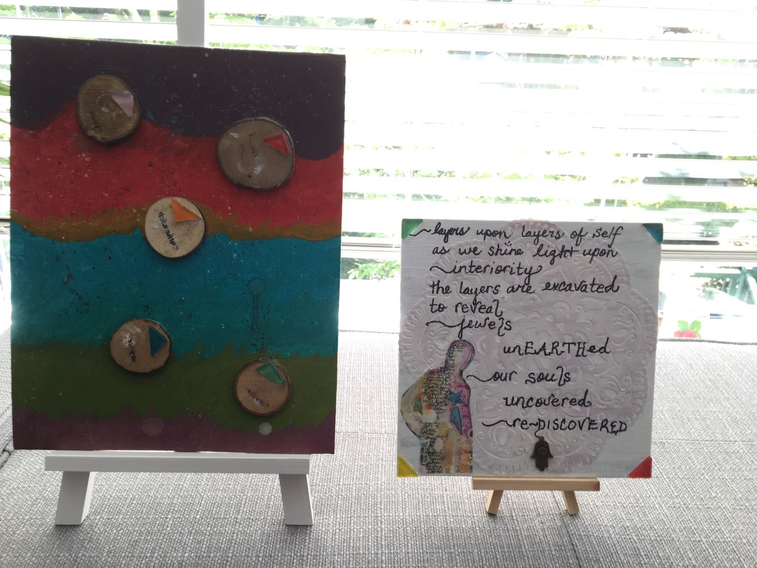

I see layers in ---the
Way you’ve ---written
Your ----words

Shine - an art in writing a word, like Vicki moved them,
writing them can speak them differently.

I see these layers and I think of parallel lines and vectors

In the piece - is that sanskrit? It reminds me of how
I just taught students to reverse words and make “codes.”
The red one looks almost erased. Like it’s meant to be a secret.

I think of the colours of the piece - of how Helen
contemplates the colour of a word before making a stroke for it.
Did you contemplate each colour?

The jewels point in different directions.
Triangles. Curious. Sharp? Translucent. Directions.

Did you take one piece of wood and cut it?
How interesting to stack them back up - interactive sculpture.
The figure has a star at their heart.
A star, that shape that doesn’t really look like a real star,
but looks like a bright light looks when
I look without my glasses.
With squinty eyes. I remember playing with highway lights
on so many car rides. Not tall enough to see anything else.
You make do with what is there.

The paper - did you do the paper cutting?
What a careful and delicate and precise art.

Initially this re-minds me of Shigeru Izumi’s
floating disk in the speckled texture.

I wonder at a connection to Caroline McHugh’s talk.
That talk has captivated me.
I’ve pondered my own layers through it.
The outermost one most confounding me. Perception.

The song the other day,
“Just enough dark to see, that you’re the light over me.” has captivated me.
Mystery and ambiguity, but what is happening in the imagination as I listen.

~ ~ ~ ~ ~ ~ ~ ~ ~ ~ ~ ~ ~
“In the piece - is that sanskrit? It reminds me of how
I just taught students to reverse words and make “codes.”
The red one looks almost erased. Like it’s meant to be a secret.”

My covertly printed words
represent
six layers of Self
care fully excavated
peeled back
as I leaned forward into the murky spaces
embodying the outpouring of emotion and raw sentiment
My precious findings, my jeweled words
Glued on ~ then purposefully
tenderly
r e m o v e d
desrever ~ reversed
hidden in plain sight
from the all-seeing sightless eyes
To be revealed at the behest of my heartsoul friends,
those with inquiring tender full hearts
How insightful you are, my dear friend.
As if lightly perched on the brow of my mind’s eye ~L~

Colours created through
Touch
Texture
Fingers
~ mixing, pausing, listening, responding
My inner heartsong leading me to brush in round, upward strokes
Movement without forethought
Contemplaytive notes sung from within
Textualizing with out
Contextual (i) zing
Wit(h)nessing
With in
My (s)heART
S P L A T T E R E D
Onto canvas.

“ I remember playing with highway lights
on so many car rides. Not tall enough to see anything else.”

Playing with lights during the long quiet nights of dark.
I smile at the image of young little Andrea
creating, squinting, playing, imaginative games only the young at heart can conjure
Connection to family road trips and the gamut of games played
Exhausted only by the body’s need for sleep.

“I wonder at a connection to Caroline McHugh’s talk.
That talk has captivated me.
Yes, again.
My heart
S
R
A
O
S
As it is seen.

Inspiration through lectio divina
Caroline’s TedTalk
Co-inspired this piece
As it replayed
I played
As I listened to the layers between her words
Her pauses became
my springboard
Her message
my action
Contemplation.
Meditation.
Round paint-soaked stroke up.

I’ve pondered my own layers through it.
The outermost one most confounding me. Perception.”

“Every object well contemplated opens a new organ of perception in us”
Yaaaas, Zajonc and Palmer.
Organs are growing.
To perceive.
To be perceived.
So much in the transmission
Lost in the waves of translation
Yet received in admiration
and love
Openness to being viewed
through the lens of Other.
On the
E
D
G
E
of BEing

Yet lingering
Clinging
to the lazy hazy highway lights
the spaces
b e t w e e n
here
there
&
heart pounding
traveling fast
viscerally
on the highway
to
BEcoming
Wke.

Where shall I join the chain I ask?
Choose a little bit from each, you tell me.
A fluid exchange in any way we are moved.
Weaving it all together
However we are inspired to do so,
Poignant,
Exciting conversation to have with you both, you tell me.
Fluid...organic...relaxed,
Whatever moves you,
No right way
You reassure me.

“Layers upon layers of self as we shine light upon Interiority
The layers excavated to reveal jewels”

I notice my attention goes up and down,
Back and forth,
So many jewels to look at.
So many layers within the writing,
So many connections
Rediscovered.

“In the piece - is that sanskrit? It reminds me of how
I just taught students to reverse words and make “codes.”

I am reminded of a game many children have played with me.
Each thinking they are novel and ingenue.
They tell me to watch, then look away,
As they bury treasure,
Glass jewels beneath the surface of the sand,
Then ask me to find them,
To excavate,
They revel in their ability to hide them deep,
Deep beneath,

Can you find what I have hidden?
Can you find me?

“I think of the colours of the piece - of how Helen
contemplates the colour of a word before making a stroke for it.
Did you contemplate each colour?”

This wish to be seen,
How nice to be discovered,
To be witnessed,
To Be-With.

“I wonder at a connection to Caroline McHugh’s talk.
That talk has captivated me.
I’ve pondered my own layers through it.
The outermost one most confounding me. Perception.”

“Yes, again.
My heart
S
R
A
O
S
As it is seen.

Inspiration through lectio divina
Caroline’s TedTalk
Co-inspired this piece
As it replayed
I played”

This wish to be seen,
How nice to be discovered,
To be witnessed,
To Be-With.

What am I missing?
I do not remember the layers in her talk,
So I am inspired to review,
To understand.
But before I do,
I find myself squinting,
Squinting into sunshine,
Rather than highway lights,
Oh yes, Little Andrea,
I see what you mean.

“With squinty eyes. I remember playing with highway lights
on so many car rides. Not tall enough to see anything else.
You make do with what is there.”

“Playing with lights during the long quiet nights of dark.
I smile at the image of young little Andrea
creating, squinting, playing, imaginative games only the young at heart can conjure”

Ah I see!
Interiority!
Perception.
Persona
Ego
Self
Like layers of an everlasting Gobstopper

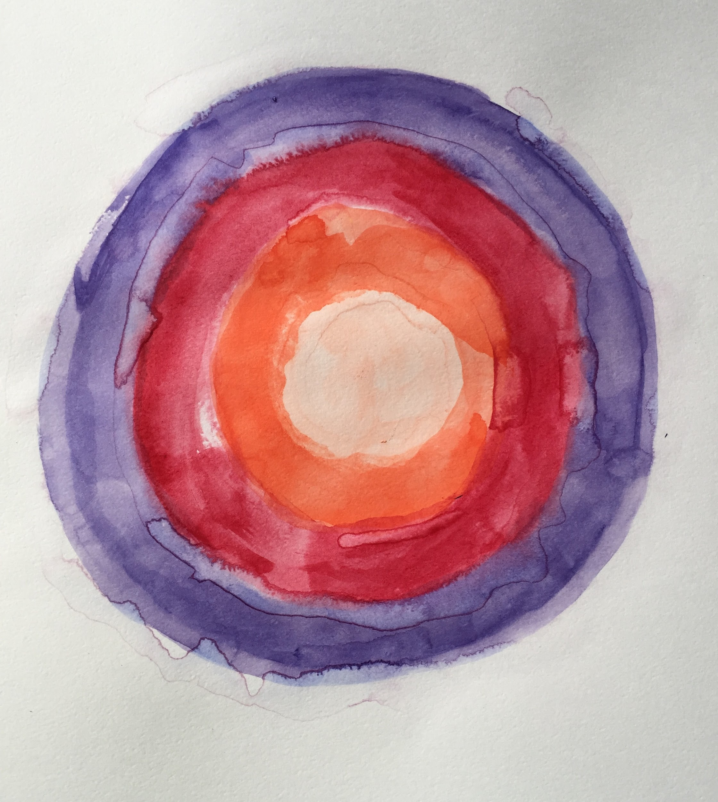

Or perhaps an everlasting mirror.
True Mirror
Two Mirror,
Right angled and no seam,
Images bounce off one another,
See what others see,
When they look at me,
Disorientating,
Not straight.
Fix it.
Look for reassurance,
Don’t look at yourself,
Look for yourself,
Look for revelation.

This wish to be seen.
How nice to be discovered,
To be witnessed,
To Be-With.

“Openness to being viewed
through the lens of Other.
On the
E
D
G
E
of BEing”

~ ~ ~ ~ ~ ~ ~ ~ ~ ~ ~ ~ ~

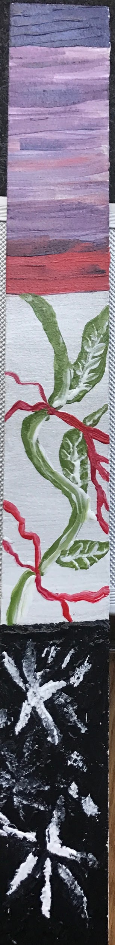
Colours created through
Touch
Texture
Fingers
~ mixing, pausing, listening, responding
Contemplaytive notes sung from within
Textualizing with out
Contextual (i) zing
Wit(h)nessing
With in
My (s)heART
S P L A T T E R E D
Onto canvas.

Yes, again.
My heart
S
R
A
O
S
As it is seen.

“Every object well contemplated opens a new organ of perception in us”

To perceive.
To be perceived.
So much in the transmission
Lost in the waves of translation
Yet received in admiration
and love
Openness to being viewed
through the lens of Other.
On the
E
D
G
E
of BEing

Each thinking they are novel and ingenue.
They tell me to watch, then look away,
As they bury treasure,
I’m reminded of a book we read recently
The character performs a magic trick
“Close your eyes.”
Reaches into pocket.
“Open them!”
“I pulled this from behind your ear.”
Delight,
As one by one I find them,

This wish to be seen,
To be discovered,
To be witnessed,
To Be-With.

“Yes, again.
My heart
S
R
A
O
S
As it is seen.
I’m thinking of this memory of
Riding in the car
Looking at lights
Playing this way for years.

And I’ve been thinking of this concept
Of the young
Dancing-
Twirling girls

And I never danced
That was really never
My jam.
But I sang
And sang and sang
In big empty houses

I’ve been thinking about
This way of playing-
Of singing
And how I lost it.
And how I sing Others’ songs now.
And I tried to sing the other day
My own songs.
And it was so hard to do
But it was exhilarating.

And I’m wondering what moments
My girls are awake to
When the memory will burn strongly

I remember getting picked up in first grade
There was something in the air
It had an electric quality
Windows down
I’ve always wondered why this one
Moment
This quality of being there
Burned in so brightly

To perceive.
To be perceived.
So much in the transmission
Lost in the waves of translation
Yet received in admiration
and love
Openness to being viewed
through the lens of Other.
On the
E
D
G
E
of BEing

This art of writing words
How they take up space
On the page
I have a confession:
I haven’t been writing
By hand.
I did for days and days.
But I’ve been
At the computer lately.
Naturally, I’d been writing by hand.
But it’s almost as if
Given the rule
I want to break it.
I rebel.

Look for reassurance,
Don’t look at yourself,
Look for yourself,
Look for revelation.
I take this with me
Into my work
Contemplaytive notes sung from within

This week.
Thank you friends.

~ ~ ~ ~ ~ ~ ~ ~ ~ ~ ~ ~ ~

