Metissage
of
Helen Kennett-Bacon

#301294529

Masters of Education in Contemplative Inquiry and Approaches to Education
Cohort 2015-2017

Education 823-5
Curriculum and Instruction in an Individual Teaching Speciality
Dr. Vicki Kelly

Dedicated to my Grandma, Audrey Davison.

July 22nd 2016
Rest in Peace Audrey Davison. Wife of George Davison (Deceased). Mother of Vicky, Peter, Janet and George. Grandmother of Elizabeth, Andrew, Adele, Katy, Adrian, Helen, James and Martin. Great-grandmother too.
May you rest in peace from your suffering. May you have relief and calm wherever you may be.
“How many kisses?” as Grandad used to say.
Love
Helen
P.S
By the way- did you set off the fire alarm in my building at 2am this morning? The fire alarm that woke me from deep sleep, made me put on mismatched clothes, pick up my keys and phone and head outside to the curb. The fire alarm that woke me, so that I might look at my phone and read the message from your daughter, my mother. The message sent at 00.19 that simply read “muMs just died”. Was that you? If it was, I can imagine you chuckling at your mischief. Hah! Love you.

Braid 1-The Ceremony

“The ceremony of art touches the deepest realms of the psyche and the sacred dimension of the artistic creative process. This is the level that not only transforms something into art, but also transforms the artist at the very core of being. This way of doing and relating to art makes the process and context of art making infinitely more important than the product.” Cajete (1994 p.g.155)

Too Personal?
When I finish they are silent and it is hard to read their reactions. Did I share too much? Was I too truthful? Should I have held back? Did I overestimate their ability to hold it when I put it out there?

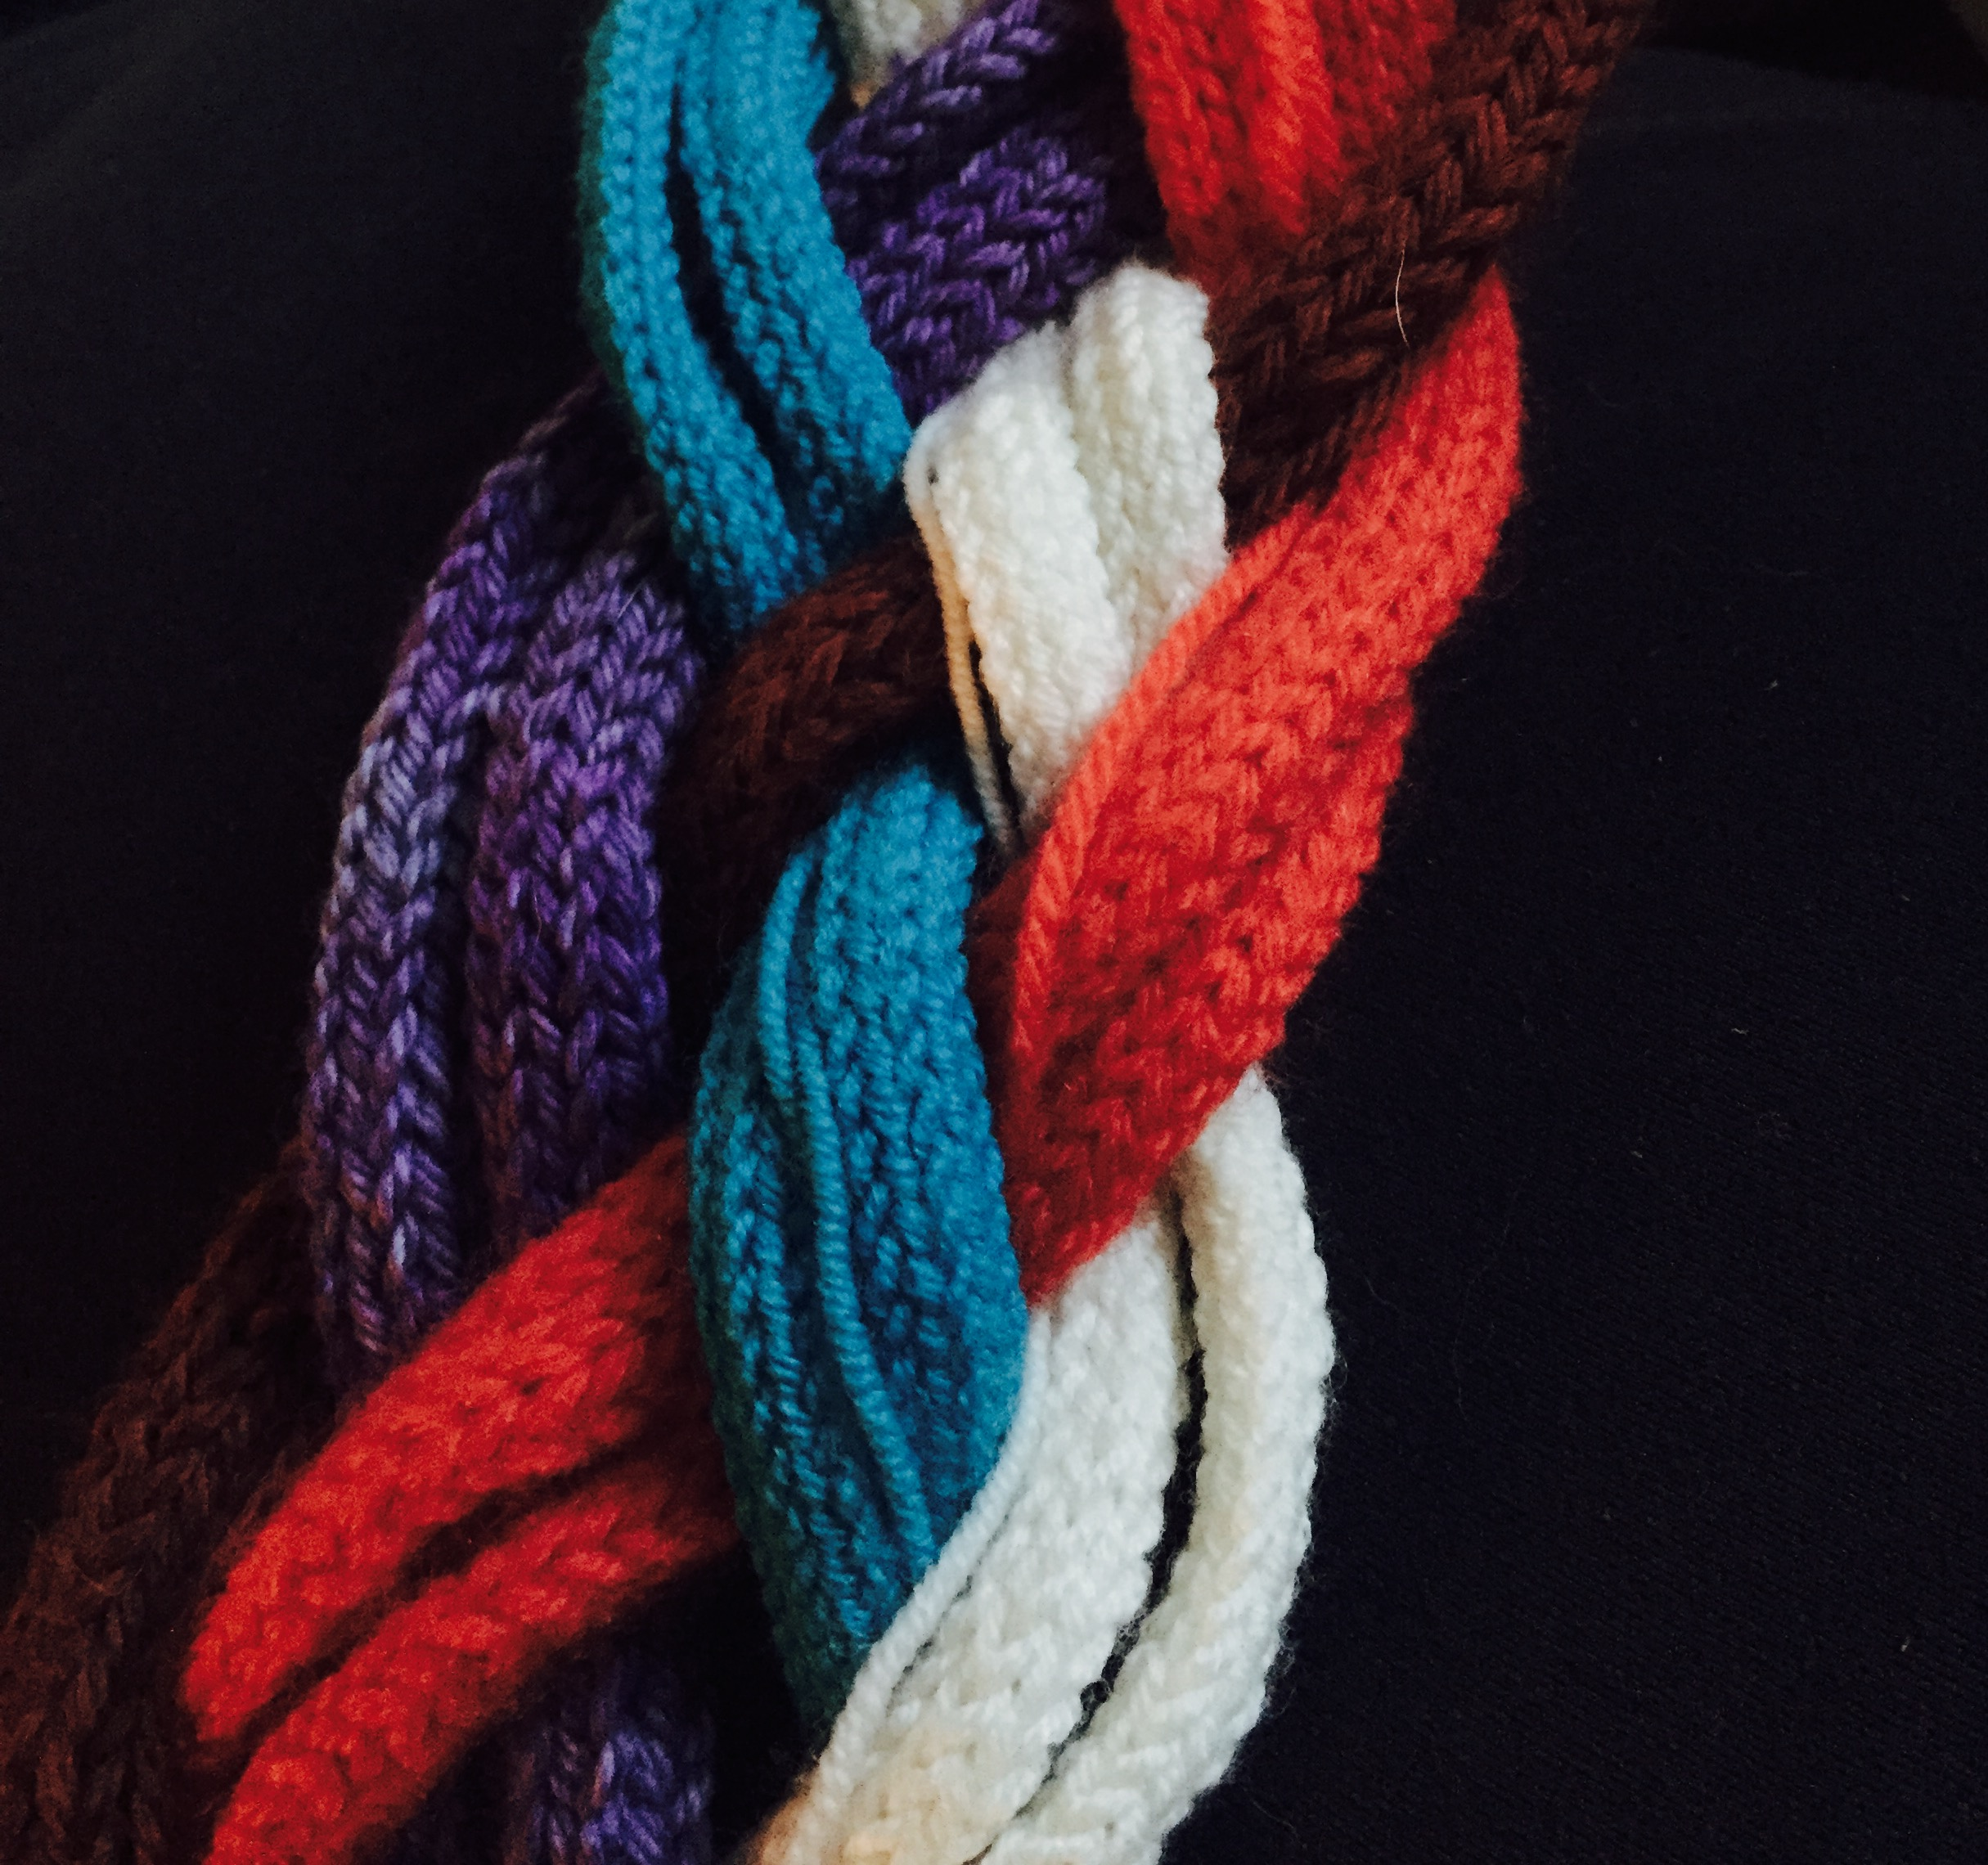
“Writing a woman’s life is a feminist practice”. Chambers in Hasebe-Ludt, Chambers & Leggo (2009 p.g. 70)

I have knitted chords for each of the women in my family who have influenced me. These are my people, my ancestors. For many, because they are women their voices have not been heard. I wanted to give them a voice. So I told their stories to the circle.and as I spoke, their voices and stories braided together. A matriarchal chord formed in front of my eyes. As I created, I tracked their journey and my journey, noticing the parallels.

“To write I have to stalk these passions, track the stories to those places where anger was born, stay on the trail of the people who witnessed it’s birth, haunt the mythical places where all these events took place. Once found I have to kill the stories, consume their flesh and ask for forgiveness.” Chambers (2009) in Hasebe-Ludt, Chambers and Leggo (2009 p.g. 70)
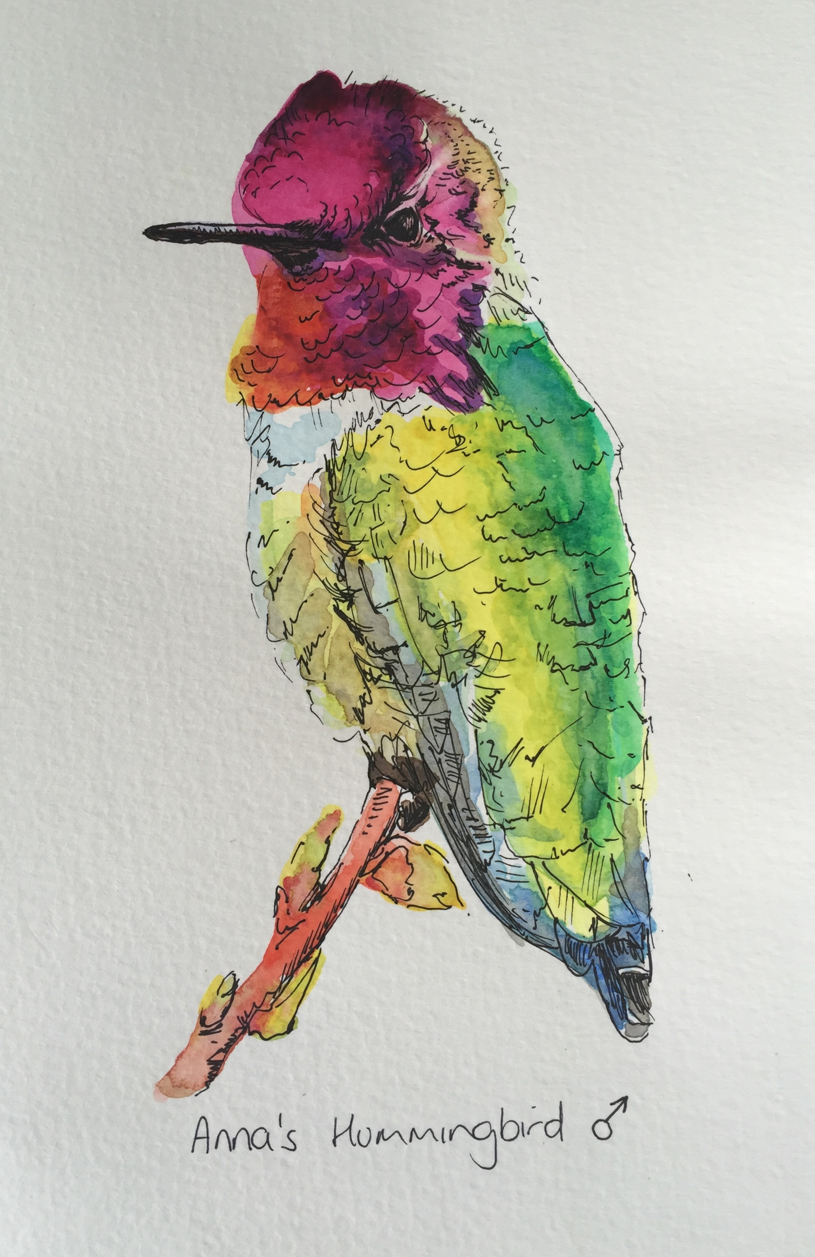

Hummingbird

Flighty little fighter,
Works so hard just to survive,
But no-one would know it just by looking at her,
Spunky,
Defending her territory,
Single-minded about her goal,

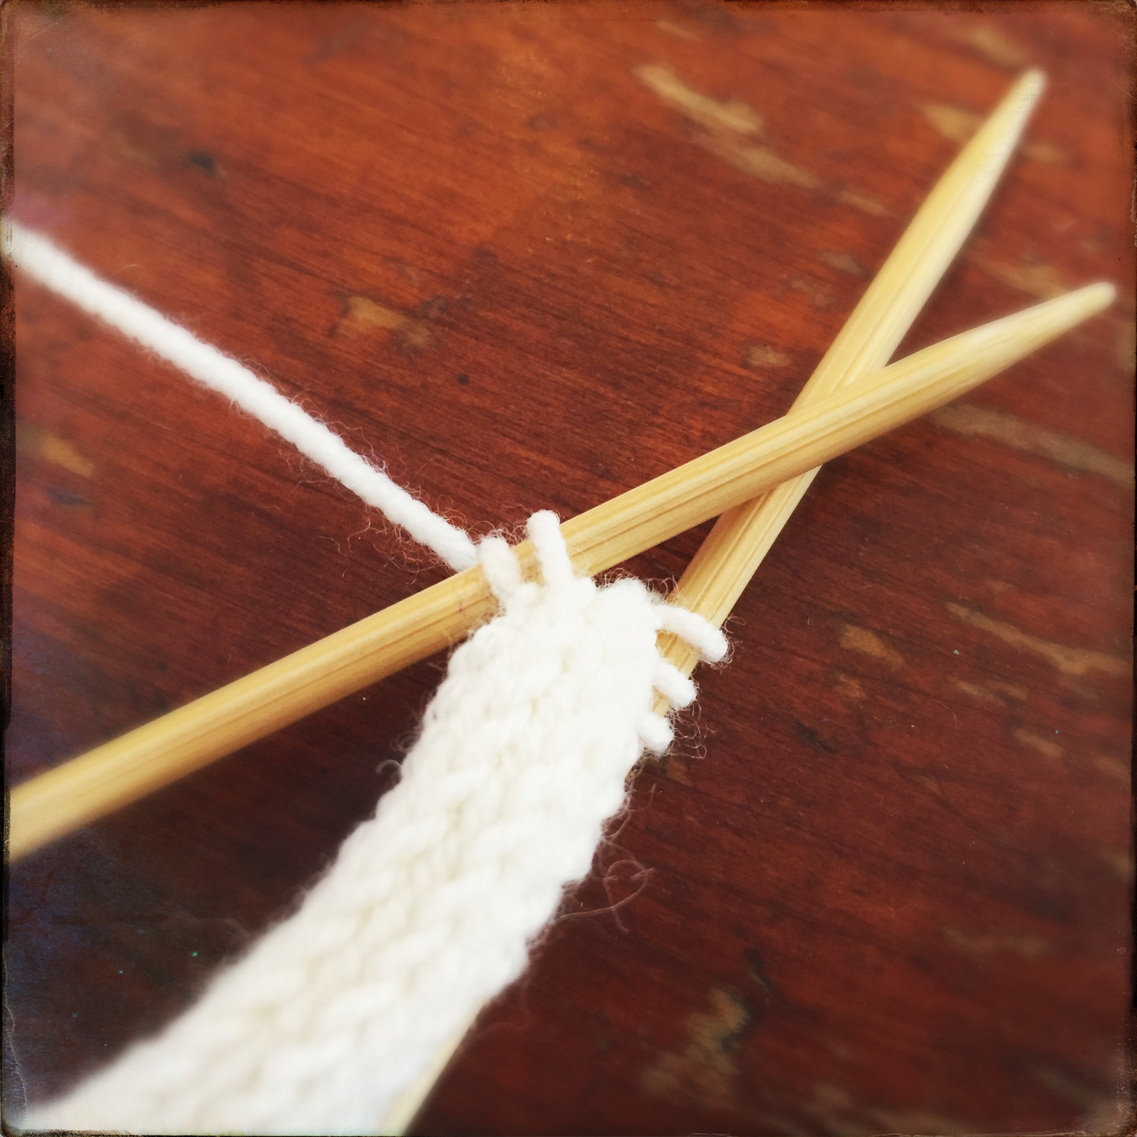

What colour shall my Great-Grandmother Lily be? Ladylike. Contorted into etiquette. Pristine white gloves. Colonial. Lily White. Maybe?

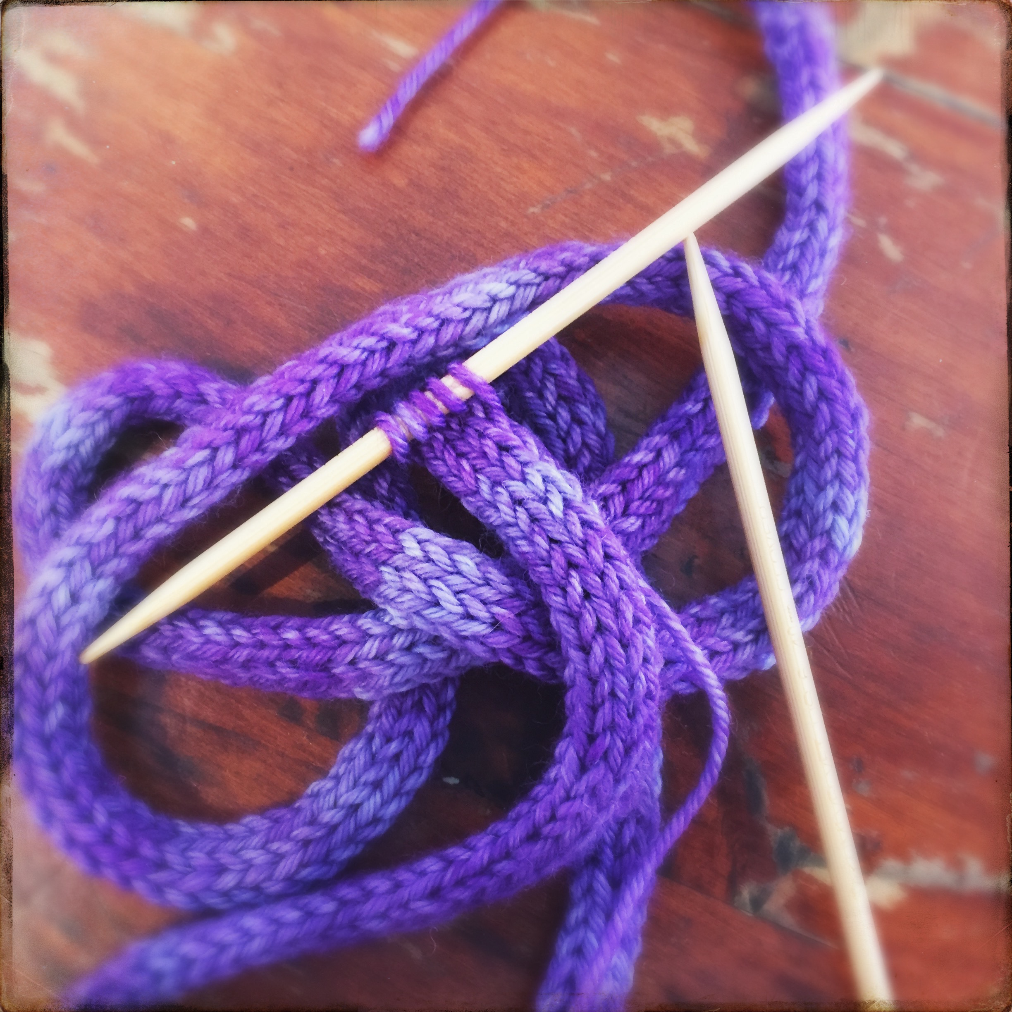
What colour will my great-grandmother be? Christiana. Burns. Auburn. Fiery creature. Scary. Still. Unmoved. Scarred. Rust. Maybe.

What colour shall my Grandma be? Audrey.Lavender. Contrary. Muted mauve. Unhappy. Sad. Repressed. Lost. Bitter. Vengeful Violet. Maybe?

What colour will my Nana be? Vera. Wispy little bird of a thing. Slight and steely. Twinkly. Blue eyed. Sky. Breath of fresh air. Turquoise. Maybe

What colour will my mother be? Janet. Brightest Red. Scarlet A. Shirley Valentine. Brightest Red for the shade of No.7 lipstick she has worn since the ‘80’s. Maybe?
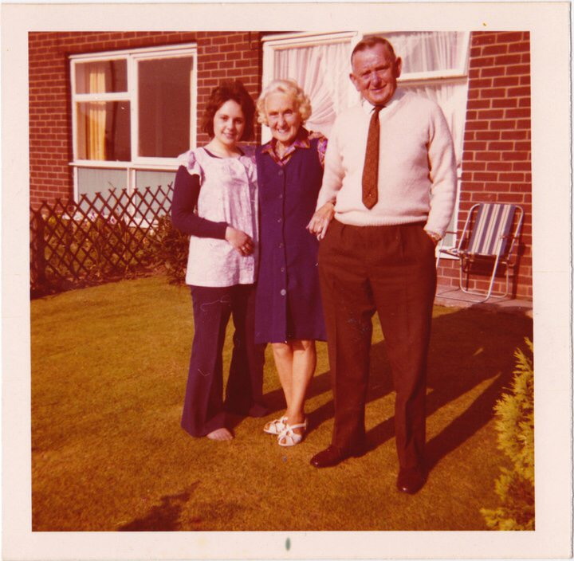
Lily
Lemon drops,
Fizzy sherberts,
Humbugs and chocolate limes.
Chrystals on the window ledge
Making rainbow spectrum shadows on the ceiling
Amber beads and a second husband resembling the BFG.

Christiana
One Eyed Scarred Creature with Hair the Colour of Flame
Great-Grandma Burns sat on her throne,
One eye with glass implant,
Missing eye was taken when she was a little girl,
Ran into a rose bush.
One leg half torn,
Legend has it, she was on her way to my aunt’s wedding on the bus,
Slipped and dragged under it.
Tore flesh to the bone.

Visits were infrequent and filled with scared anticipation,
Anticipation of this one eyed scarred creature with hair the colour of flame,
Sat on her throne, she did not move.
Held a stash of sweets in an ivory handled knitting bag by her knee,
The offered sweets coaxed me to come closer,
Or else I would not have come near,
Would have peered from behind my mother’s leg,

Visiting with Nana
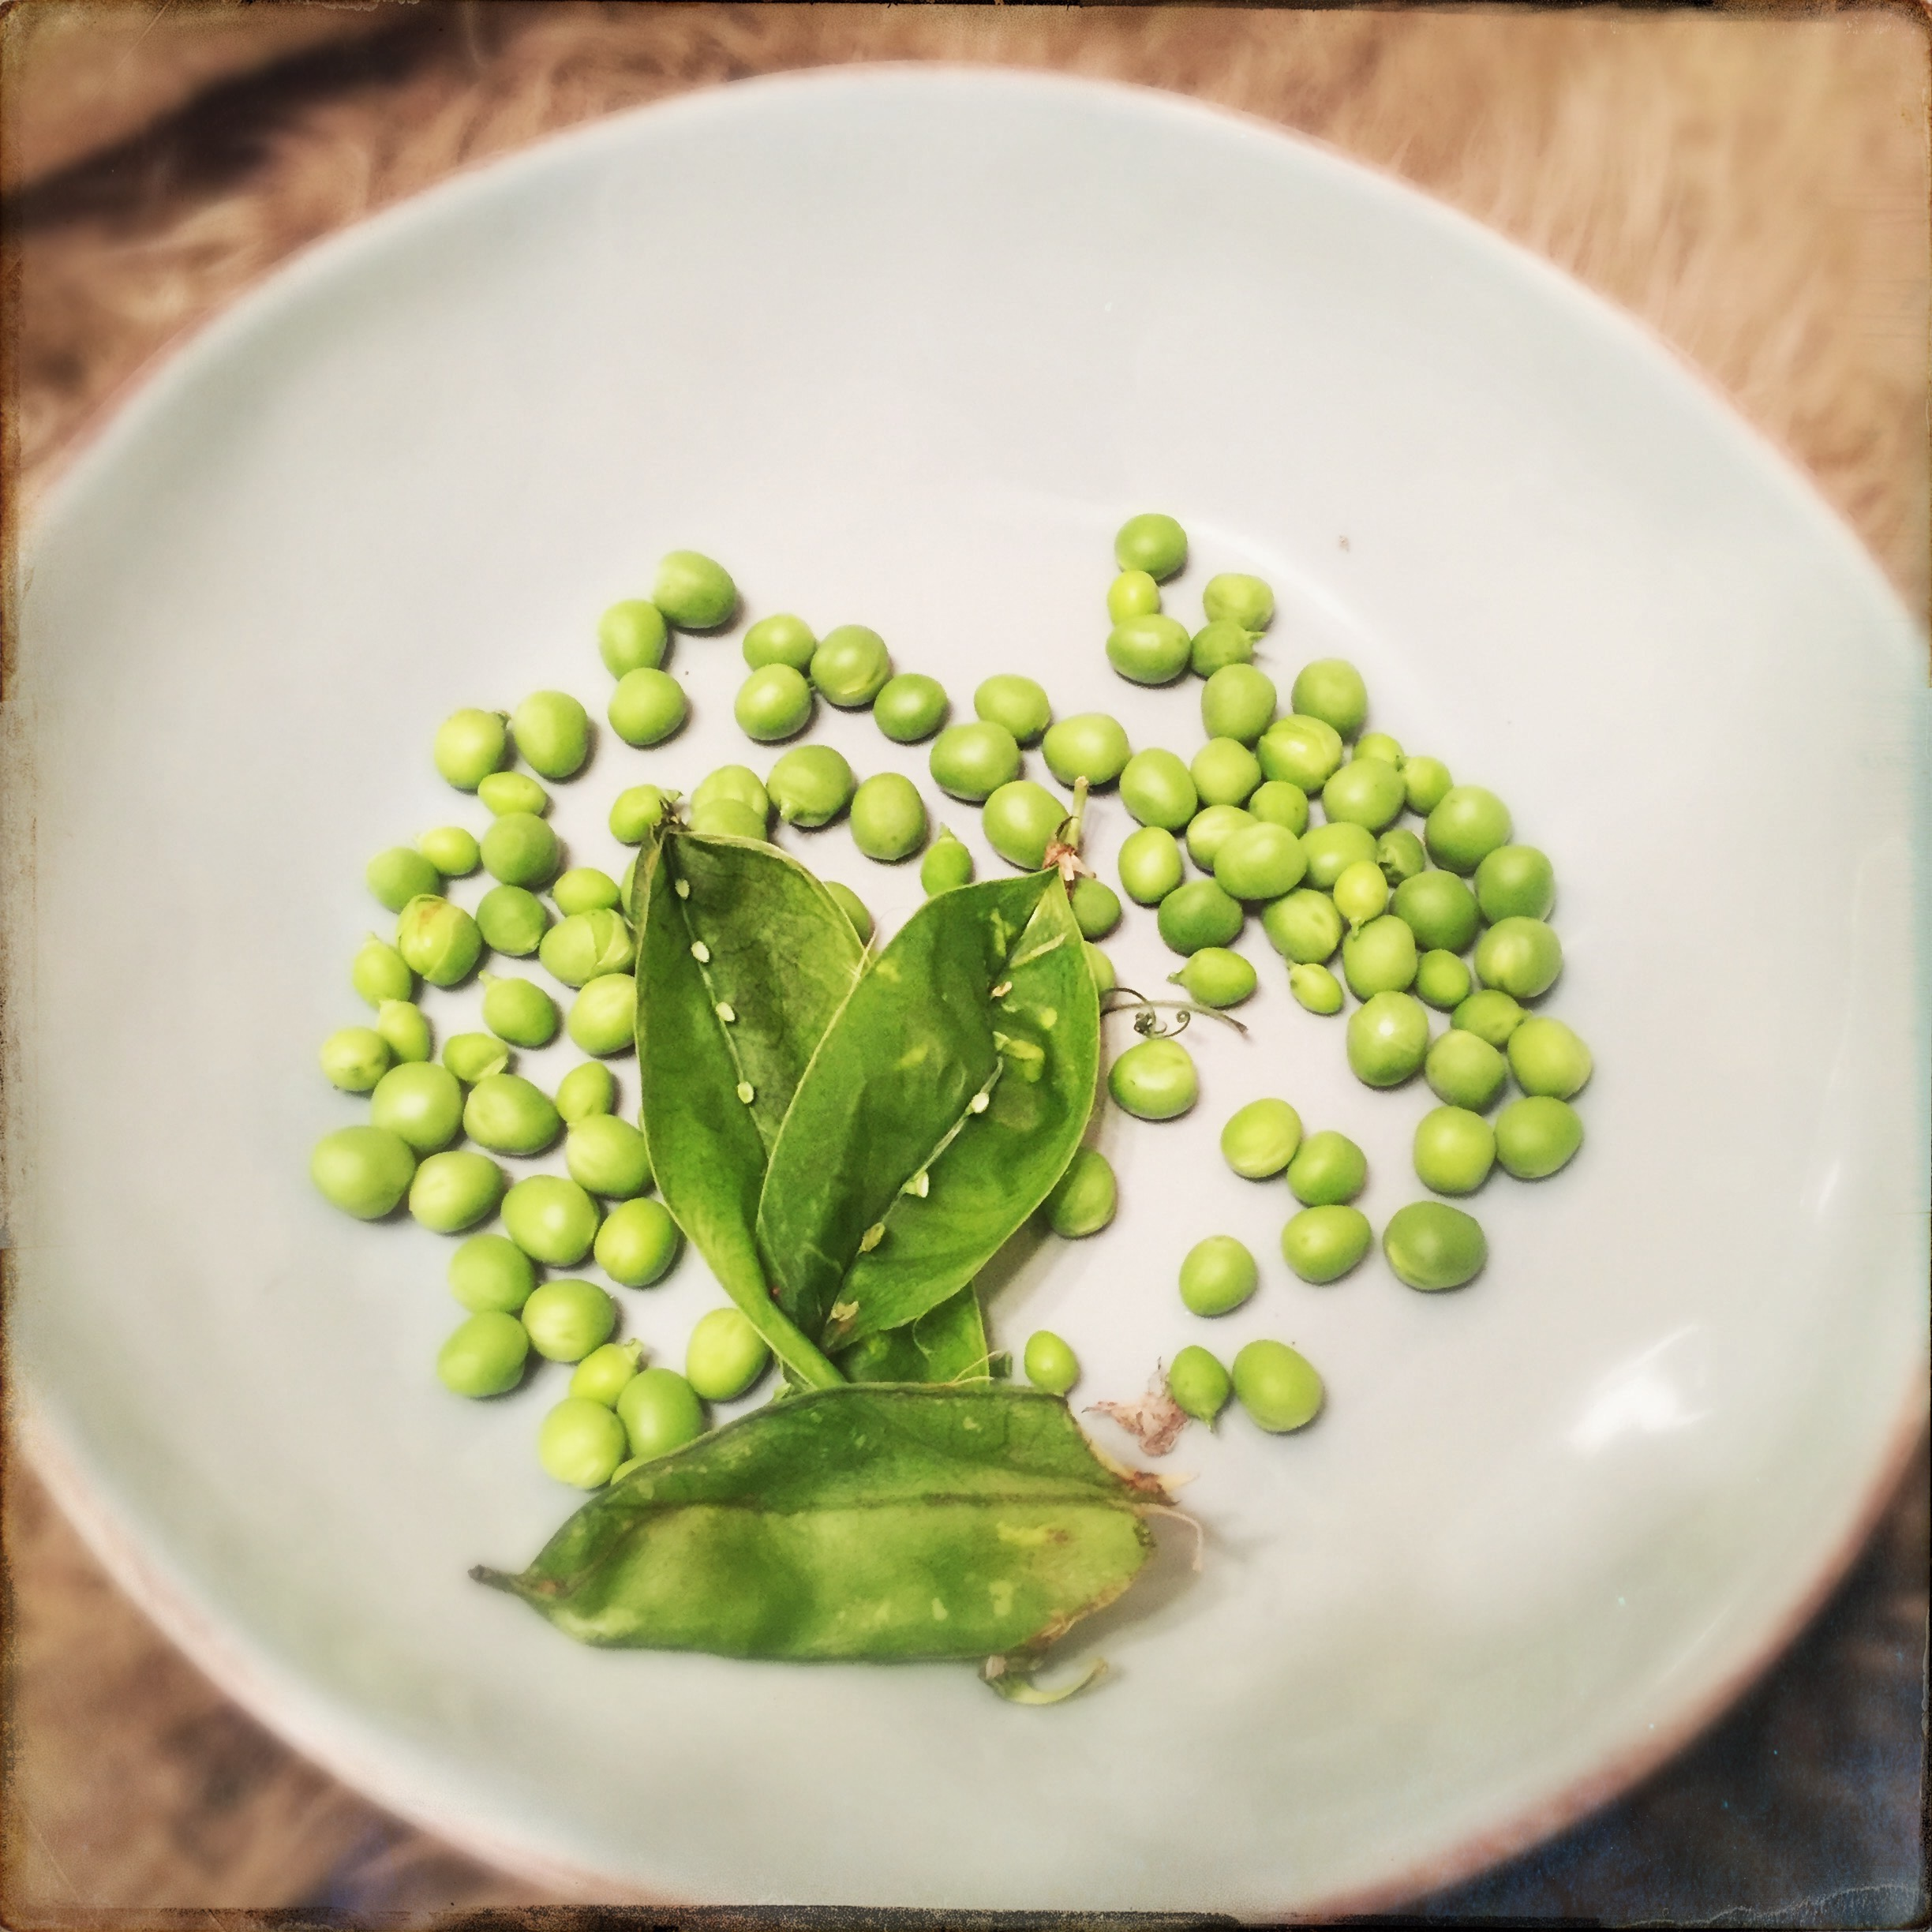
Sweet lady of few words,
Sparrow-like little bird,
Tiny with steely strength,
Bearer of seven,
Sits with me in silence,
Punctuated with “Do it like this”,
Then a snap, pop of pod,
Thumb nudging peas from seam,
One…two….three…
Collected in chipped china bowl
“Taste one”. Sweet, green, earthy.
Twinkly eye, knowing smile,
“Your grandad grew those.”
“From t’allotment”

LeGuin (1989) states that “it is a woman’s messy life, in all it’s monotony and tedium, it’s fragmentation and discontent desire, that gives her stories the authority and truthfulness they possess” (cited in Hasebe-Ludt, Chambers & Leggo 2009 p.g.70)

I Knit and I wonder
Left handed like my brother,
She showed me how to knit,
Hands moving over yarn and needle,
Lightning fast from repetition,
Did she select yarn,
Or pick up whatever thread she could lay her hands on,
Desperate to keep going,
I wonder…..?
Knitted, crocheted, multi-many coloured cushions,
Doilies, pillows and throws,
Even cushions for his car,
Occupational therapy I wonder…..?
For days sat at home,
Staring at the TV,
Side by side,
Listening to him tell the same stories,
I wonder…..?

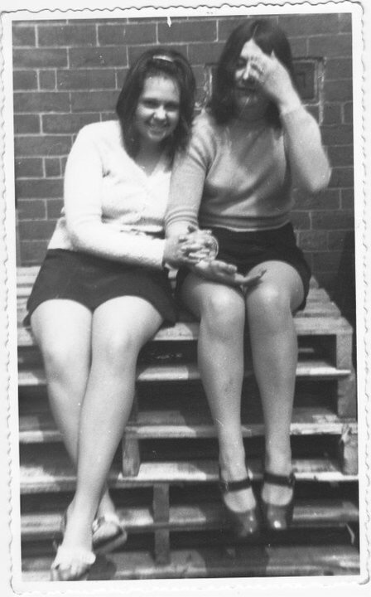
My mother. A bit of a bugger, by all accounts.

Simone de Beauvoir argued that writing our lives allows us to “tell ourselves our own history, archive our memory, create a document of our time. Moves memory beyond a personal and private artifact to a social and public history of our times.” (Cited in Hasebe-Ludt, Chambers & Leggo 2009 p.g.29)

Legend
Legends of born in India,
Father in the British Army.
I would like to trace her steps
Close to the Taj Mahal
A great gift of love
I want to know, what did she see?
What was it like?
How does one adjust, re-acclimate?
Records say 1 of 10
Returning a lone survivor but not for sure

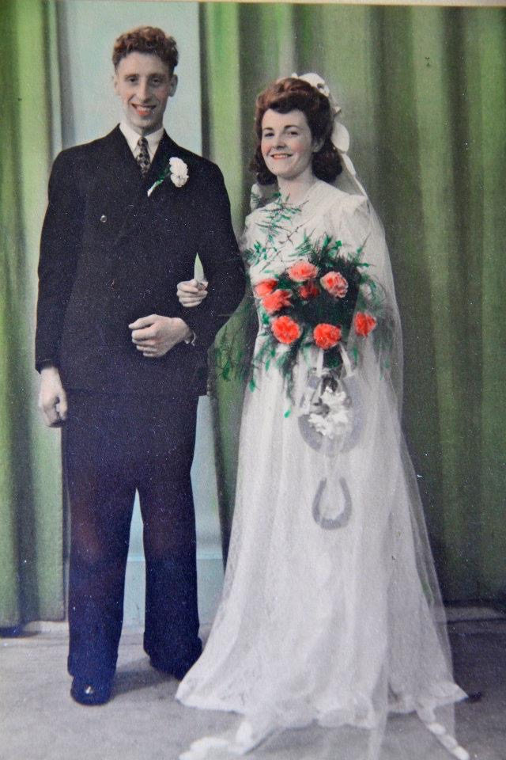
The Pantry
A vestige of wartime hard times
Of make do and mend
A cold cave, larder, pantry,
Collections of jars and cans,
Homemade pickles from the allotment,
Beetroots and pickled onions,
Bootleg potato wine and homemade brew
A thin film of flour and sugar dust
A distinct smell of cold tile, baking flour and earth,
As a small child I could not see above the shelves,
Then, neither could she at 4foot 11 and a spit
Older, I am in awe,
Forethought and readiness for a rainy day or tough week
When wages don’t cover groceries and my Grandad’s bet.
A vestige of be prepared
Waste not want not
Make do and mend
A lost art not passed on,
Appreciated too late
For a generation spoiled by excess.

“I write to tell stories that need to be told and never have been”.
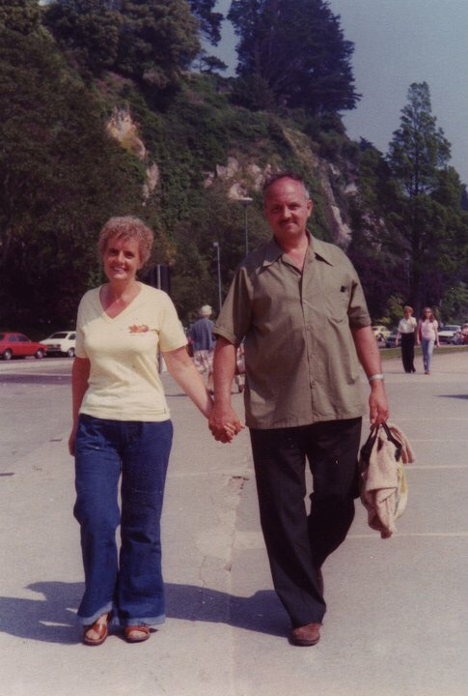
Chambers (2009 in Hasebe-Ludt, Chambers & Leggo 2009 p.g 85)

Enigma
“She never let me in the kitchen” my mother says. “Didn’t want us in her way”. Never told her “I love you” until a time when she is confused and my mother does not know if she is talking to her or someone else in her distant memory. “She’s cold” says my father, “Not happy unless someone else is unhappy”. Harsh words. Hurtful as she is still my blood. Legend has it that she has been visiting a psychiatrist for as long as I am old. I found this out when she cracked. Left the house in her nightie in the middle of the night. They found her wandering, confused in nearby fields. Another night. Crisis. Lost it. Picked up a knife and stabbed my granddad in the back of the neck, as he fixed the washing machine. A sharp inch from his spine. I don’t know why. Story goes that my uncle took my granddad to the home of a doctor that lived nearby. Afraid of scandal and police. Scary stuff this. Don’t get it. Don’t understand why. What am I missing? Grandad D, always loving and gentle to me. “Controlling and suffocating” others report. She was admitted to a psychiatric ward. I was going through my mental health nurse training at the time. Awkward, as a friend and fellow trainee worked on the unit she was admitted to. Not keen on her knowing family business. Knowing what happened. Probably knowing more than me.. When I visited Grandma, she was there but wasn’t. My mother told me she was having visions of her dead father. A man I know nothing about and have never met. I don’t know if the visions that came to her scared her or comforted her. On visiting I took her for blood work one day. Startled saw the doctor had written “psychotic depression” on the blood requisition. Angered, why did the blood technician need to know that? Were they issuing a warning? Psychotic Depression. That is big and scary. How did this happen? Was she always like that? What did this mean for me, for my genes? What had this meant for my mother?
Grandma returned home after tweaks of medication, with promises of respite and breaks from my Grandad. I don’t understand why.

“I Made This For You”
Handmade gifts.
Thoughtful.
Vulnerable.
Unappreciated.
He carved a bowl out of wood.
A solid piece imagined into a hollow circle.
Smooth and even,
Grain on show,
How long it took,
An offering from his man cave in the garage,
Presented with pride to her,
“What’s that!?” she said

“We often write about family, always seeking to know who we are, to gain a clear sense of identity and positionality in the midst of memory, desire, heart and imagination, especially in relation to others” Hasebe-Ludt, Chambers & Leggo (2009 p.g.152)
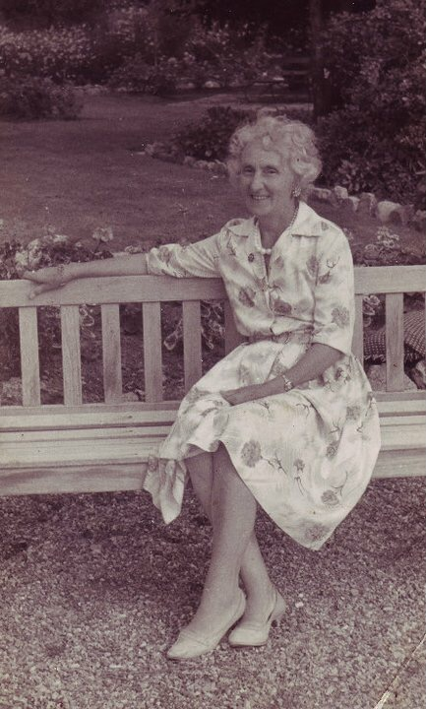
A lady,
Handbag never left her side
Oil of Ulay everyday until her 81st year
Coiffured until she began to slip away
Boiled sweets sticky and forgotten at the bottom of her purse
Retrieved by a son who idolized her.

Betty Davis Eyes
Legend has it, the creature did not see or speak to the daughter she bore,
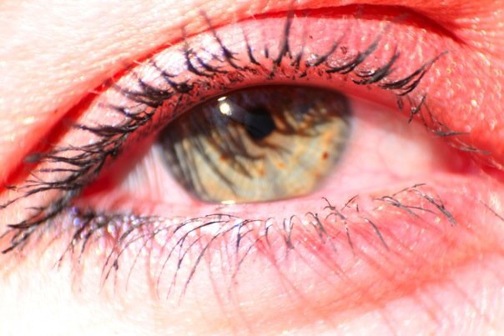
One daughter of ten, some full and some half,
Girl with the Betty Davis eyes,
Thrown out in shame,
When pregnant out of wedlock,
I don’t know the rest

Vera-We’ll Meet Again
On my birthday my aunt sent a bittersweet message, lamenting the anniversary of my birth but also the anniversary of my grandmother passing away on my 21st. I thought about her in the weeks following. More than once sensed her visiting. “Look to the Mountains” Vicki said. And I did. Too shy to tell my father about the sense of her presence, I asked him to tell me about her. “She was always happy. Always smiling. Always singing” he said. “Never stopped singing”. And just like that, where before I remembered silence, now I recalled her voice. Her trills and non-descript tra-la-la-las, as she went about her way. Wartime music “We’ll meet again” dancedover me
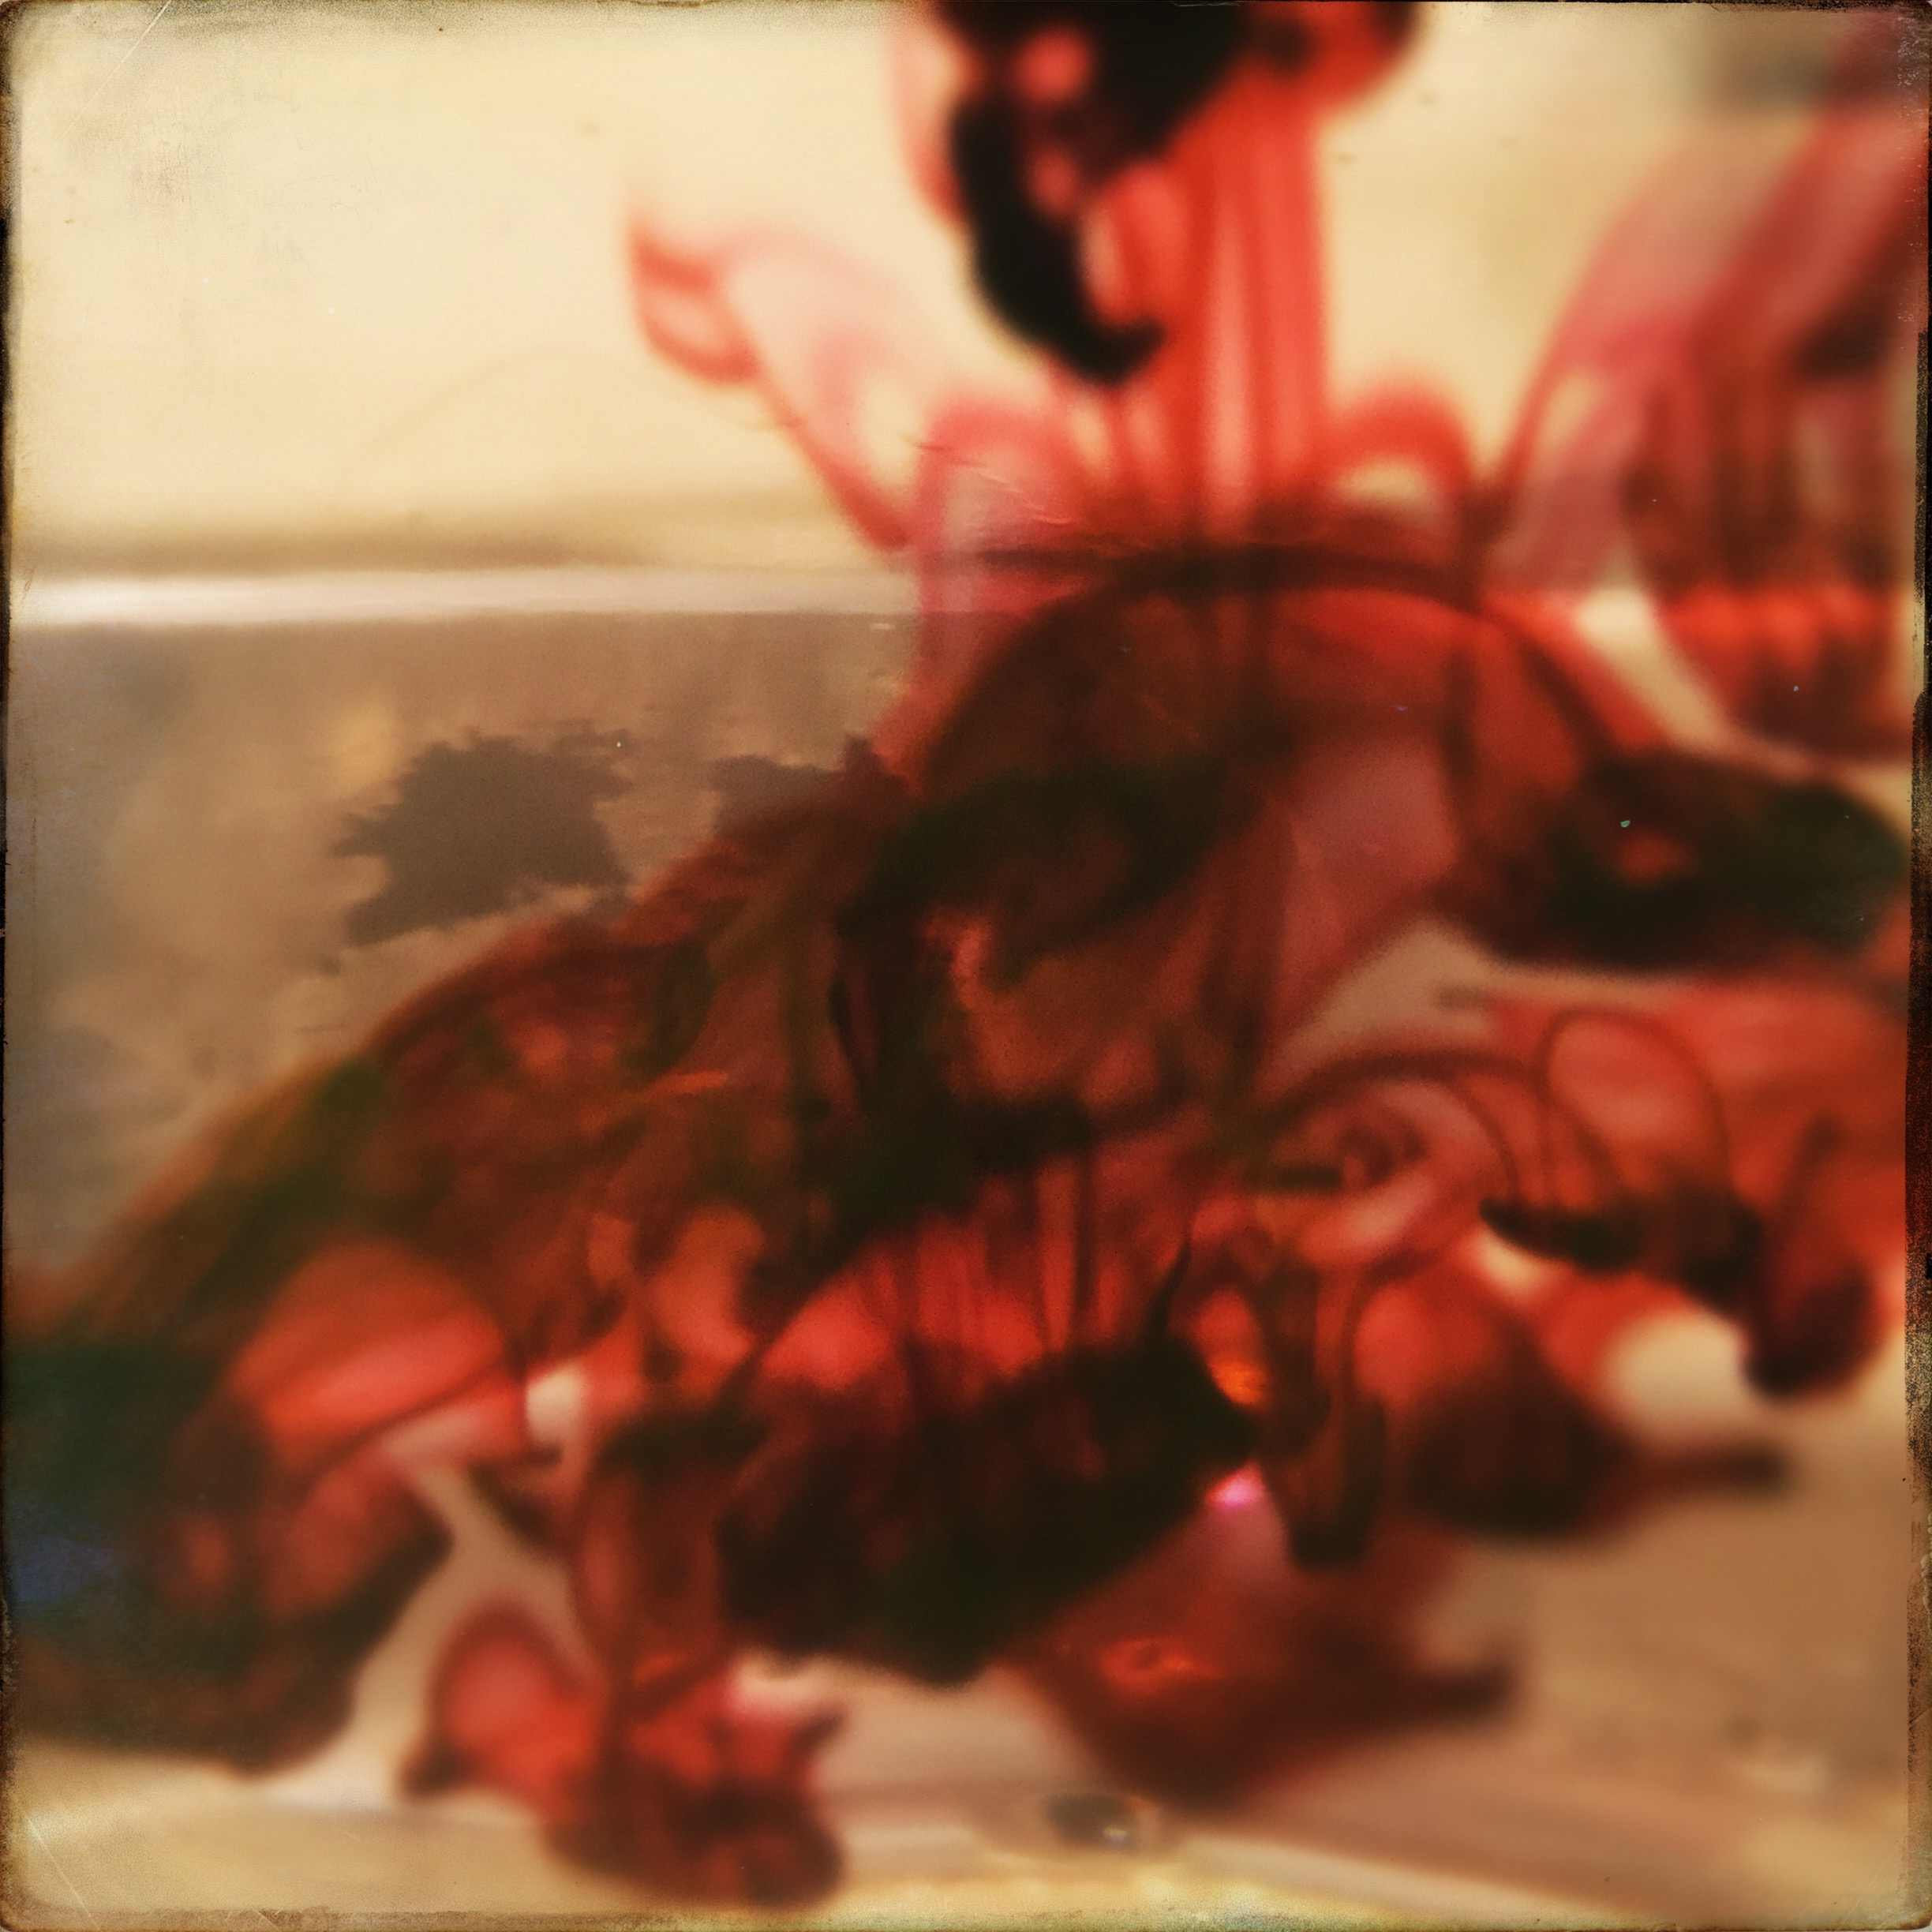

Chambers calls on us to “write with the blood of an actual life.”. She quotes Walter Wellesley “Red” Smith who said; “There is nothing to writing. All you do is sit down at the typewriter and open up a vein”. Like Chambers, “Sometimes I am afraid I will bleed to death” (2009 in Hasebe-Ludt, Chambers & Leggo 2009 p.g. 85).

Fissures
Help! Help me! Help! She screams. She’s disturbing the other residents they say.
Legend has it she didn’t love him. Told my mother she wished she had the guts to do what she had done and leave him years ago. Shame, sadness and anger at this. Sad broken family of fissures. Two of four children have broken ties. Did not speak with them for 20 plus years. Don’t know why. Sadness, anger, fissures. Invited to the hospital when Grandad was sick and withered. Declined and did not show. Denied and deceived of one last goodbye by the publishing of the wrong funeral date. My Uncle’s idea. Intentional bitterness. I don’t know why. Sad. Anger. Fissures. Alien to me. My mum says “I never want that to happen to us!”. It won’t, I say.

The stories of our lives create “a geography of scars”.
(Berry 1990 p.g 7 cited in Hasebe-Ludt, Chambers and Leggo 2009 p.g 98)

How Dare He!
I can’t sleep.
I’m hot with rage.
Raaaaaggggee.
Like cinders in my belly that won’t extinguish.
Where a single gust of memory can re-ignite them, making them white hot.
Rage.
Like a deep howl from a primordial mother.
From deep down in the sacrum rising up to the solar plexus.
Raaaaaaagggge. Throat. Voice.
How dare he!
How dare he entice and pluck her from the cold boring comfort of her husband and children.
Rage that I knew she was looking to be plucked. Rhymes with ………
How dare he!
How dare he raise his fist, slam, squeeze her throat.
How dare he!
How dare he take my breath,
Unable to gasp for pain,
Guttural, real, hard, sore pain.
How dare he!
How dare he sneer at me with knowing arrogance.
I know you know and there’s nothing you can do about it.
She’s mine. No-one elses.
He made sure of that.
Waited until the deal is clinched and the rent contract signed,
Before launching the first punch.
Sealing the first bloody lip.
How dare he!
How dare he make her beg for mercy,
Then later beg for forgiveness.
How dare he!
How dare he shame her with bruises that she can’t explain to her children,
So she hides from them. “I can’t see you this week”.
How dare he terrorize, exploit, dominate, isolate, shame her.
Leave her on tenterhooks awaiting his return.
How dare he manipulate so she loves him even still.
How dare he!
How dare he slander, shame, coerce, threaten and scar.
She’s a drunk. She’s mad. She’s a liar.
How dare he draw her back after leaving once, twice, too many times.
How dare he!
How dare he shrug and move on to his next
Victim, prey, woman, wife, mother, child, daughter.
How dare he!

The Bear
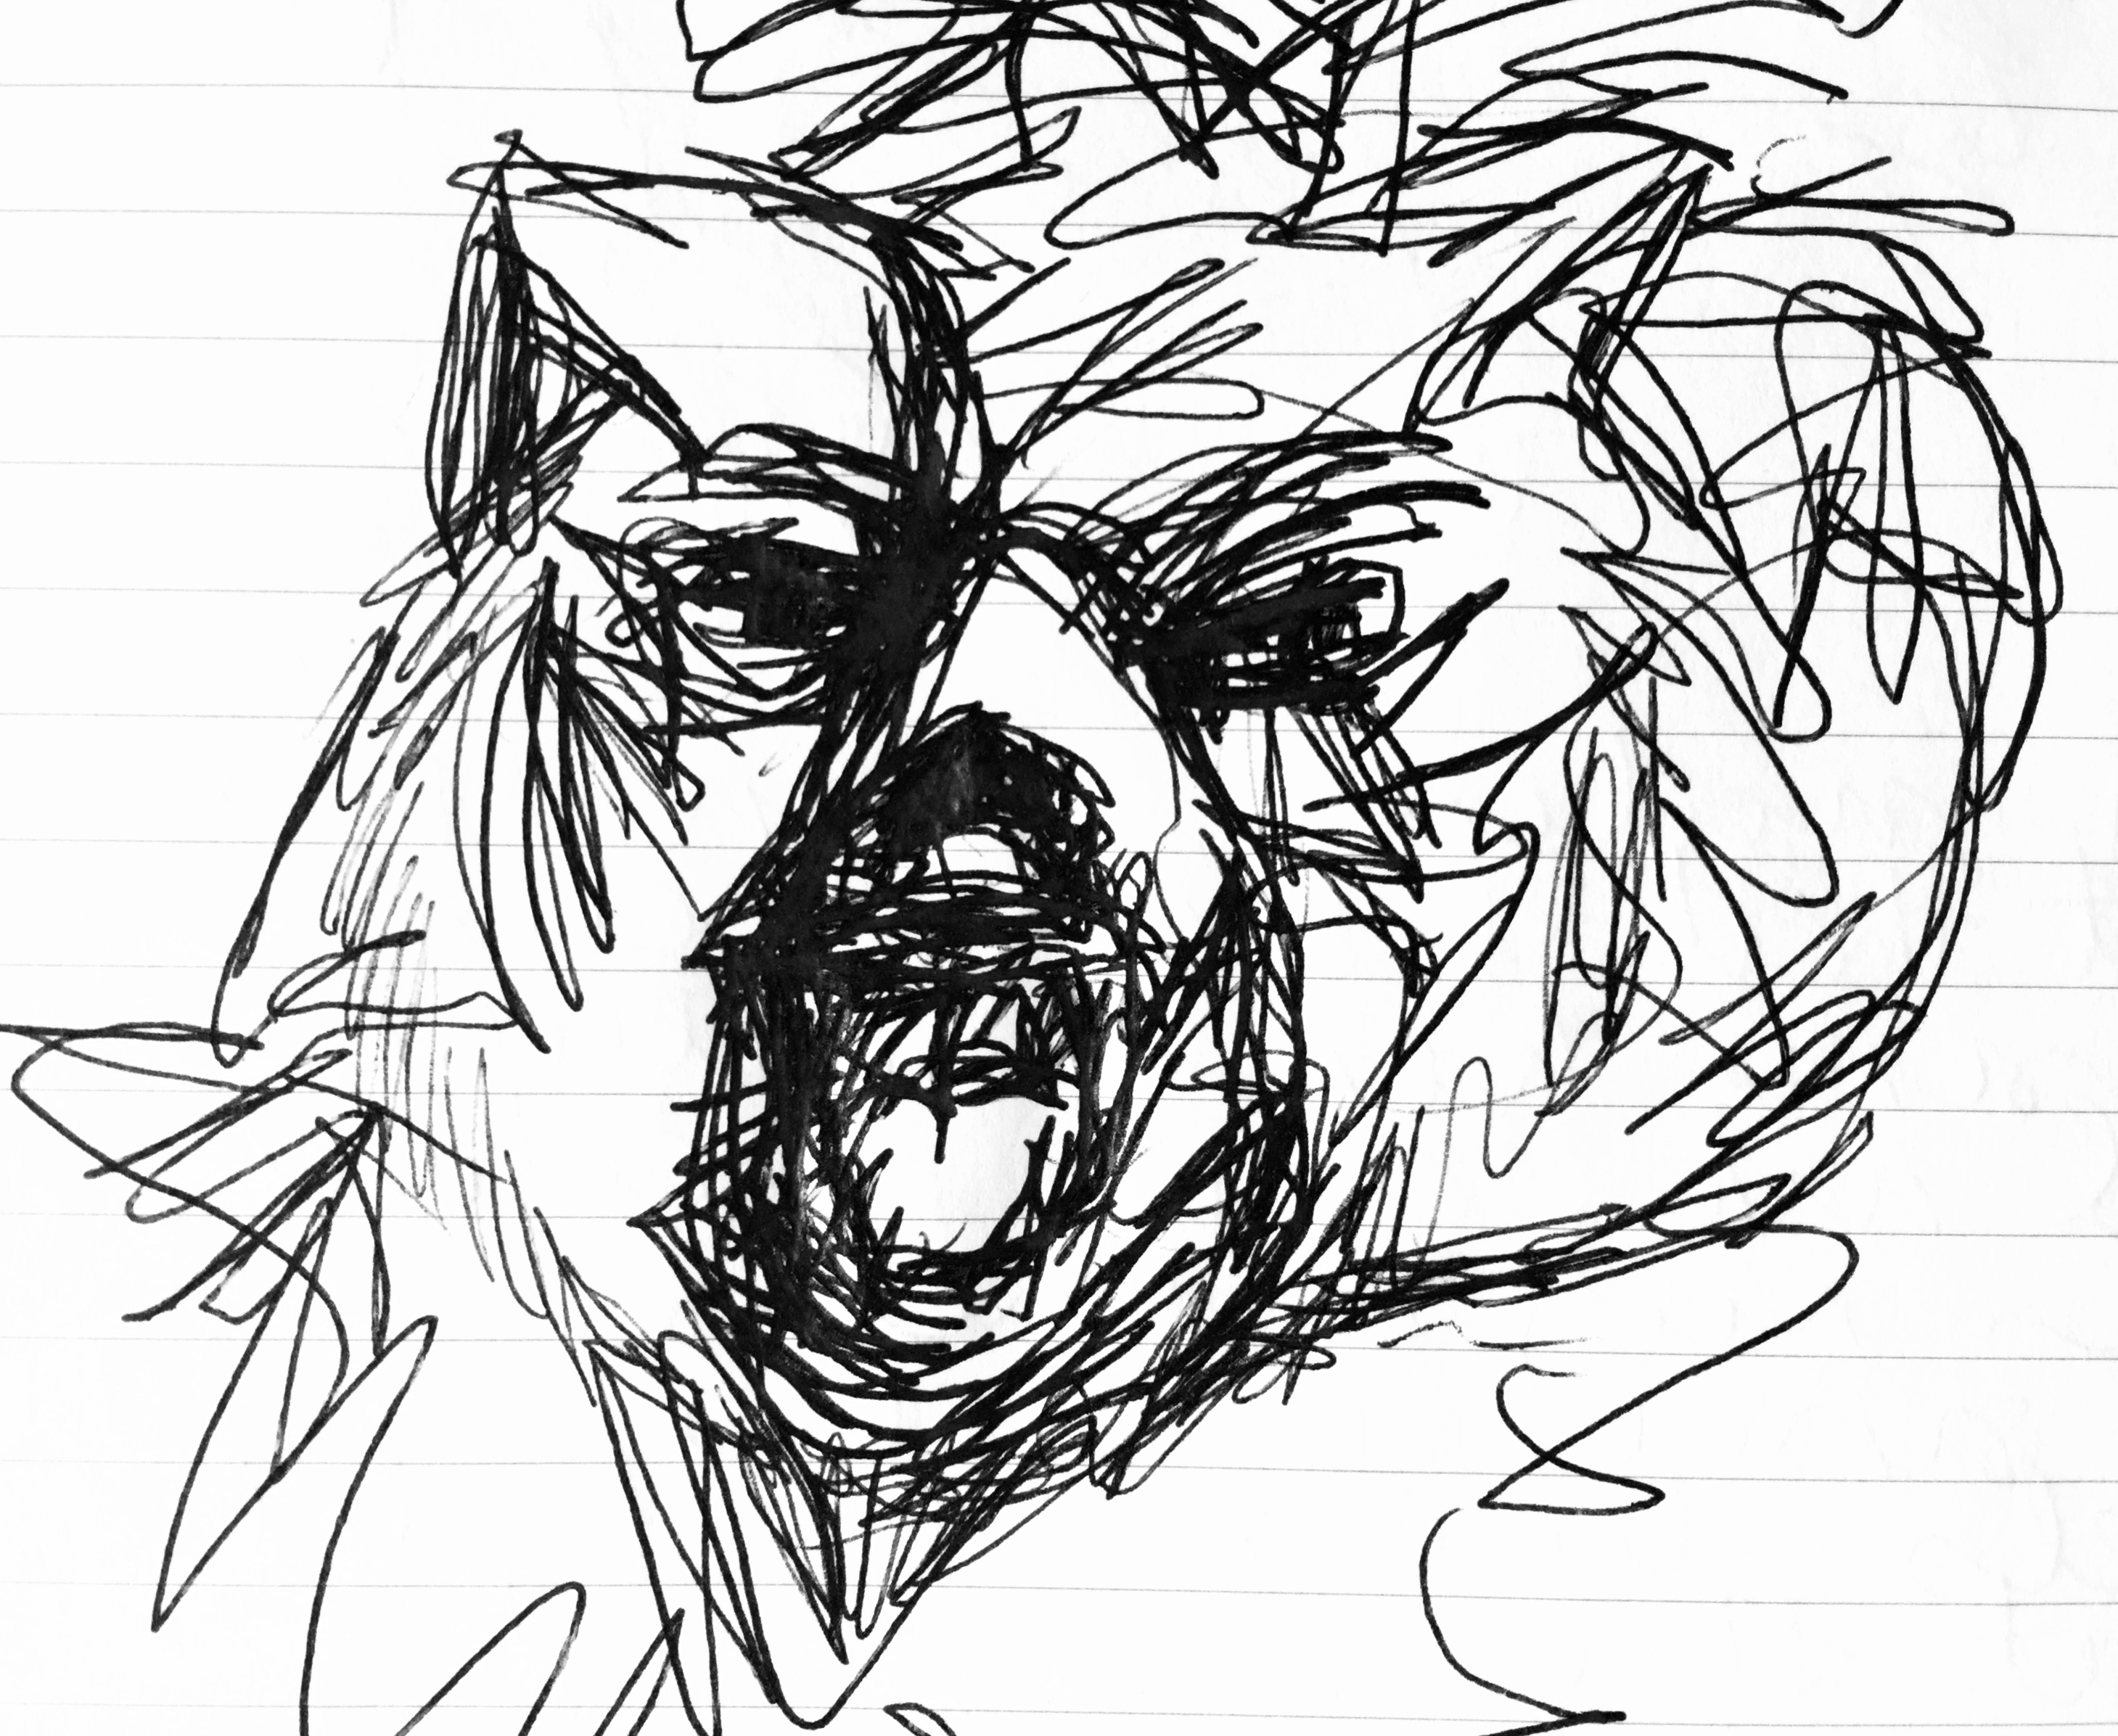
The bear frequents my dreams,
Follows, chases, pursues me,
Sometimes vicious,
Other times placid,
Poses as threat or protector,
Warn off threat,
Or devour me,
Crunching up my bones,
Sucking on lament.

“Part of the power of words- of telling and listening to stories- is that lives can be changed by what is told and heard, what is written and read” (Chambers 2009 in Hasebe-Ludt, Chambers & Leggo 2009 p.g. 78)

She woke up
After 14 years of beatings, she woke up. She contacted a solicitor, told them her plan. She told her father what had been happening. The next day they found a small flat across from the park, away from Him. Her father put down a deposit and the first month’s rent. The Landlord said “No Pets”. So she tearfully advertised for a new home for her beloved Pitbull-Staffy Cross. She contacted the estate agent. “I’m leaving you” she told him. “You’ll never dare” he sneered. But she did. The house went up for sale. Finally, she walked across town with rubbish bags of her few possessions. She walked to freedom, past the statue where my great uncle died for freedom, past the hospital where I was born and the park where I used to play with my cousins. Finally, she walked away. My Brave Mum.

Holding Hummingbirds in my hands
I asked my husband if I could share my writing with him. After all these words, it seems odd that this man, who I have come to be even more thankful for, has not heard them. Yes, he said, but first, let me tell you about a dream I had last night. I dreamt you were catching hummingbirds. They came to you and I watched you hold each one in cupped hands. Then, one by one, you released them gently.

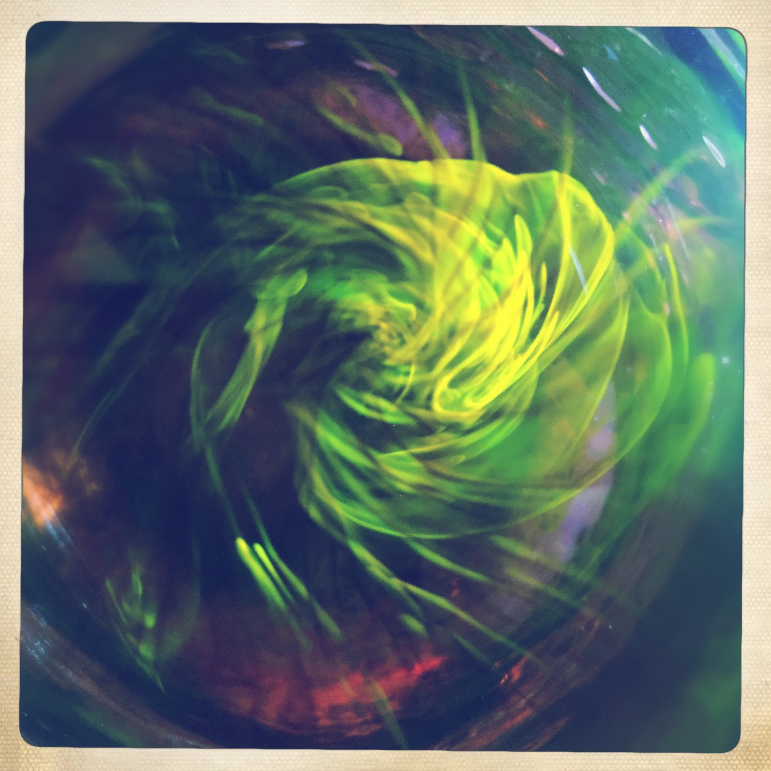
Cajete (1994) states “Visions always mirror what we deem sacred and intimately important to us” (p.g.146). Visions and dreams are means of making connections and reflecting on The Great Mystery.
The Exorcism
Afterward, I am exhausted but I feel cleansed, like I have been exorcised of my demons. Where is this religious iconography and language coming from? I do not believe in God and I do not practice Christianity. Yet when I look at the effigy I have created in my presentation, I can not deny it looks like the cross that Christ died upon. Did this image reach out through the genes of my ancestors, jumble my neurones and fire the idea into my hands? Interesting thought.

“Both reconciliation and healing require a capacity to link and hold together the experience of the past which is still available in the present while finding mechanism to move in a healthy way toward a yet-to-be-lived future. Linear approaches to this challenge tend to see the past as holding the difficulties that must be laid to rest, the present as somehow needing to free itself from the grip of the past, and the future as something that calls to us and that we are to shape and more narrowly, find ways to control. Time falls on a line.” Lederach & Lederach (2010 p.g.136)
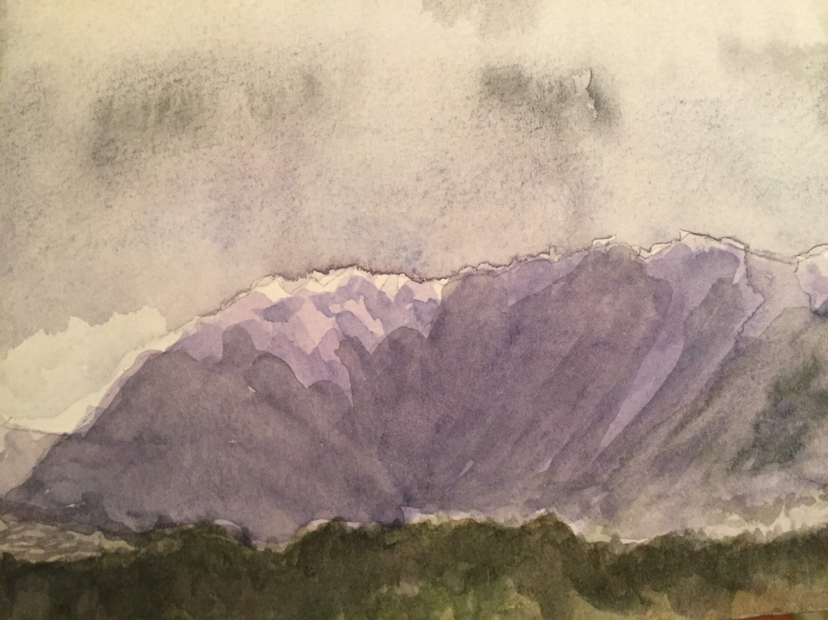
“Look to the mountain” Vicki said (personal communication July 9th, 2016). This is a metaphor used by indigenous cultures. It is an invocation for us to take a meta-view of our lives so that we may “see where one has been, is and may wish to go” (Cajete 1994 p.g 92). It invites us to “seek life” by engaging in the process of developing and expressing our innate character and potential and to find out and express our inner passions. As we progress through this process of “finding face, finding heart and finding a foundation” we move toward becoming complete (Cajete 1994 p.g.33)
Once, I thought the tracks of this braid were the only ones that existed. They defined me because I had not spoken of them. Now as I go to the mountain, clouds of pain clear for fleeting moments and I see that they do not.define me.
“Yes, this is part of your metissage but there are other tracks that run alongside it” Vicki Kelly (personal communication, July 9th 2016).

“We learn to practice this generosity of spirit in relation to ourselves and others, acknowledging how we are inextricably and ecologically connected, all of us needing to be heard and appreciated as human beings.” Hasebe-Ludt, Chambers & Leggo (2009 p.g. 154)

Elders in indigenous communities are revered as they are further along the process to becoming complete. Before this work, I looked upon these women, my ancestors with judgement. Why did they not go to school, get an education or get a job? Why did they have so many children, when perhaps they did not want one? Why did they stay in that one place dominated by a man? Why didn’t they travel the world? Did they yearn for these things or were they happy with their lot? As I look down from the mountain, it occurs to me that I am a product of my place and time. These questions are mine to ask because I have the freedom to do so. I can stand here now and ask these questions because of the strength and resiliency of these women, my elders. Because I am here, standing on their shoulders.

Relations previously unrecognized become visible and audible for the writer in what is referred to as “a self-reflexive and self-critical act” (Hasebe-Ludt, Chambers & Leggo 2009 p.g. 29)

Firsts
I am the first girl on both sides of my family to go to university.
I am the first woman in my family to have a profession
I am the first woman in my family to choose not the bare children
I am the first woman on my mother’s side , who has not experienced violence from their husband

Braid 2- Nature is sacred
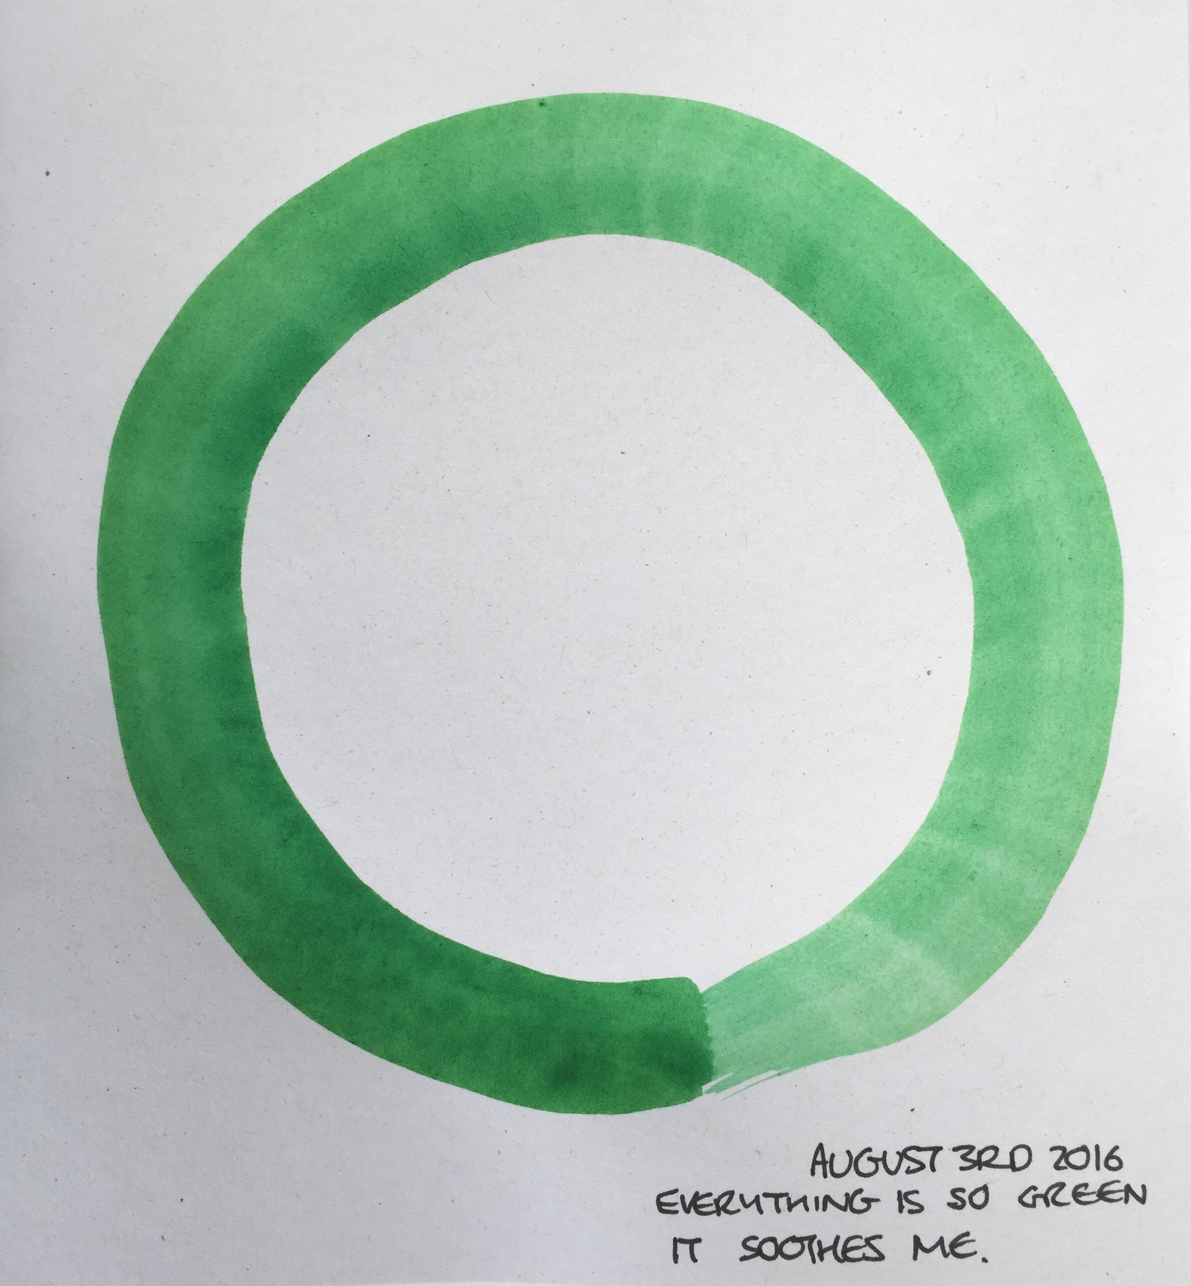
Within indigenous education there are no churches or doctrine, as all that can be learned can be learned from nature. “Nature is the true ground of spiritual reality”. (Cajete p.g 44). Opportunities for teaching and learning exist in everyday moments. Indigenous education uses experiential and multi-sensory pedagogy. Praxis include sacred art and breath through storytelling and music. Indigenous people believe the soul is intricately connected to the nature of the land, people and place where they are from. We can trace back how our worldview came to be as it is, by remembering to remember where we are from Understanding how our worldview influences us is an integral part of becoming a contemplative educator and healer.

When I close my eyes
Shade, trees, green,
Earthy smell of soil and moss,
Cool dew on damp marshland,
Tree stumps and roots,
Toadstool, puffball and mushroom,
Bluebell, foxglove, ladydie
Helicopter and conker,
Or Sycamore and Horse Chestnut,
Birds, sparrow, tit, starling and crow,
Red squirrel, pidgeon coo
Steep path down into woods,
Fields of tall grass and a pylon in the distance,
Enter Marshland and bull rush,
Spider web and pond skater,
Bog, mud, pool
Lane and road,
Park perimeter, manicured grass,
Pitch and putt, tennis court and bandstand,
Rosehill, Rawmarsh and Thorogate.

“The Praxis is what we reach through. Through the praxis we are opened to the teaching. The praxis is a contemplation. It is an inquiry. The discipline is the sacred learning. By tracking through life writing we can learn about what we are doing. The discipline is the instrument for the learning spirit to reach to become our elegant sufficiency” Vicki Kelly (Personal communication May 14th 2016)

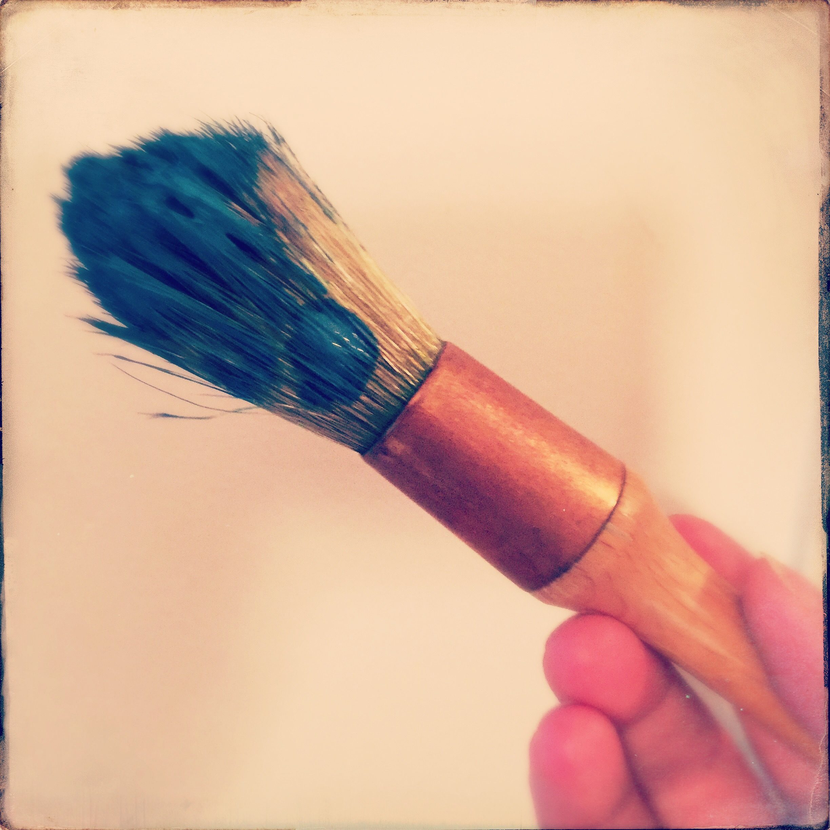
Paint
Who am I thinking of? What am I thinking of? How am I feeling? Color? Stroke? Envision. What will it look like? Can I see it? Alchemy. Paint. A little of this and a bit of that. Color wheel. Water and mix. Smooth. Smell of pigment. Smooth. Dip bristles into water. Once. Twice. Mix. Smooth. Coat the bristles. Feel the handle in my fingers. Heavy and solid. Wood and brass. Smooth. Fingertips. Light touch. Tentative. Paper with grain. Smooth and cool beneath my hand. Breathe. Close eyes. Imagine. Envision. Press bristles to paper. Let go. Glide. Swoosh. Press. Lighter, lighter, lighter. Lift off. Trail. Tip. Look. Notice. Admire. Was it as I imagined.

Thank you Mrs Barker
Mrs Barker read the best stories from beautiful illustrated books. My favourites were The Hobbit and The Neverending Story.My bum on the carpet, my chin in hands, I listened intently, enthralled. I couldn’t wait for the next day to hear what happened next. Afterward, we would draw and paint images, our imaginations inspired by the stories. “What does Bilbo Baggins look like?”. What does Gollum look like?
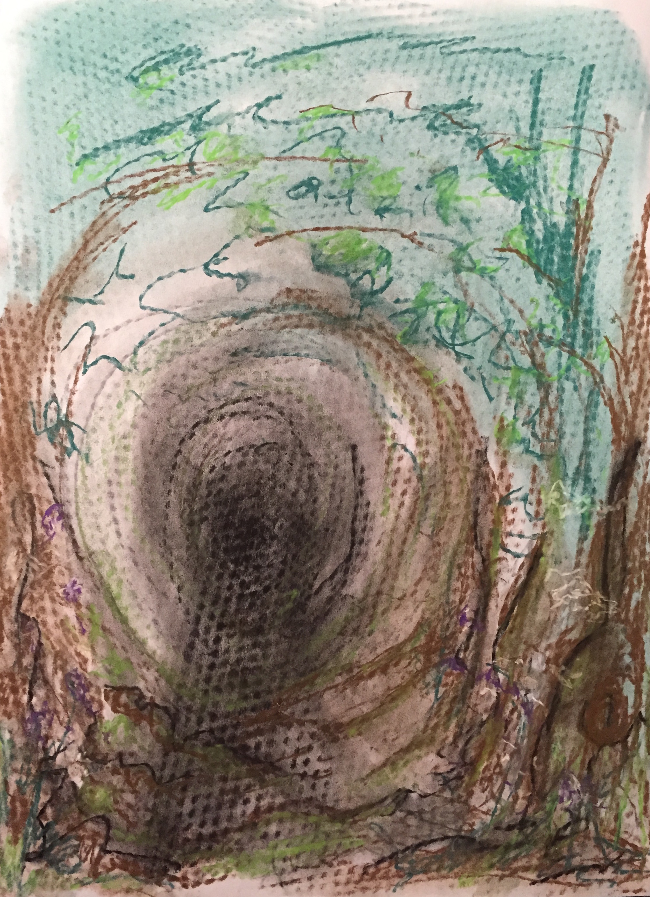
Mrs Barker was firm but fair. She was one of the few teachers to tell me off. She saw my potential and she pushed me. “keep going, you can do more”. She fostered my love of nature and art. During class, she would lead us into the woods and marshes, where she would tell us to study what we saw there. She taught me how to pay attention, notice and remember the wildlife we encountered. Insects, birds, grasses, trees, flowers and animals. We would collect and take our wares and specimens back to the classroom, where we would draw them. “What did you see?” She asked me. Each time I took my painting of a woodland scene to show her, she told me “it’s not finished yet, it needs more detail”. Again and again. It was an exercise in perception and depth, as I painted layer upon layer of detail. Foreground, mid-ground and distance. Grasses, spider web….. “You can do more. Keep going” she told me. She taught me persistence and that there is always room to do better. I was so proud of that painting when she finally said. “Yes! Excellent. Put it over there to dry”.
Mrs Barker challenged me and scared me at the same time. She made me feel safe, secure and protected. I believe she saw my potential and pushed me to achieve it. I wonder where you are now, Mrs Barker? I would like to thank you for pushing me and for being hard on me. Thank you for showing me that even though I found it all easy, I shouldn’t rest on my laurels. I should strive to be the best that I can be. Thank you for showing me I can gain satisfaction from pursuing my best. Thank you for showing me that hard work is rewarding. Thank you for pushing me to strive, to be ambitious, to not accept the status quo and to not accept “No” for an answer. Thank you for showing me that I can figure it out and make it happen if I want to. Thank you for believing in me and for showing me I can do anything I want to do if I put my mind to it.

“Affirmative No” says Safer (2015) “is the the refusal to pursue a course of action that on serious reflection you discover is not right for you” ( p.g.177)

I don’t want to
I don’t want to settle here,
I don’t want to buy a house that’s too small with no garden,
I don’t want to settle down and have 2.4 kids like everyone else,
I want to go places, see things,
Push myself, push limits and boundaries and norms,
I want to travel,
I want to see the world,
Exceed my expectations,
I want to do better,
More.

“I had to work through the implications of being radically different from most other women in a fundamental way, that my requirements for happiness and fulfillment actually precluded the things they found crucial”. Safer (2015 p.g 175)

Making things
My grandma Davison was the first person to teach me how to knit. I remember sitting on the arm of her chair, watching over her shoulder as she made loops. After that, I remember sitting as part of a small group of girls, making things with the mother of my teacher, Mrs Barker. There was alternate chatter and deep concentration as she showed us how to knit, crochet and make embroidery swatches. The embroidery samples were beautiful. Concentric circles of a colourful dictionary of stitches. Then there were the crochet circles made up of as many stitches as she could remember. The doilies reminiscent of those my grandma crocheted and placed on every surface and the arms of the settee to keep them clean.
I felt special, one of a privileged few chosen to spend time with the visitor, a guest at the school. That was a care-free time. Time passed slowly, with no goal and no end-point.

Things that people have said to me about knitting.

“Knitting…mmmm..it’s a Dark Art. Did you know?” (Psychotherapist)

“You gotta be suspicious of a craft that makes something out of nothing. Out of knots” (Occupational Therapist)

One of the things I love about knitting, is that if I make a mistake, I can retrace my stitches, undo the mistake and start again.

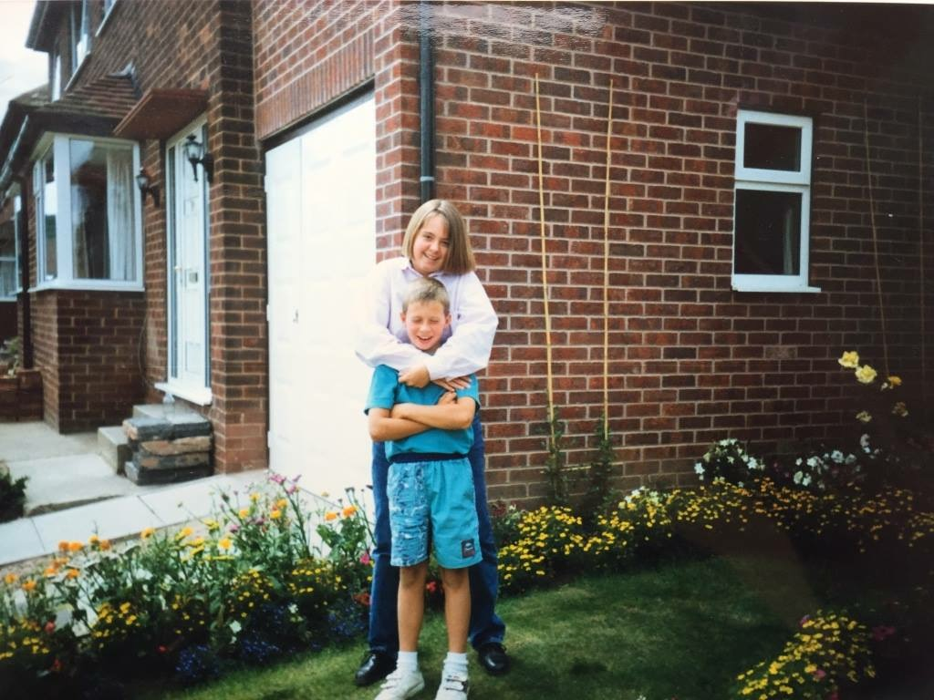
I took up my knitting needles again to knit a scarf for my brother. He was diagnosed with cancer, Non-Hodgkins Lymphoma, at the age of 23. Aggressive stage 4 with lumps in his neck and chest. I imagined sitting with him in waiting rooms and rooms that smelled of chemicals. I needed to keep my hands busy and my thoughts occupied. Pre-occupied I imagined the thick chunky cream wool scarf hugging his neck, keeping him warm, protecting him when his immune system was weak. Keeping him safe and warm and healthy. I could not be with him while he had his hospital visits and treatment. I am bereft at the thought of him sitting alone, needle in his hand. I am broken thinking about him travelling to and from treatments at the hospital on the bus or in a taxi, nauseated and weak. Green with poison. So I knitted. As I knitted I thought of him with each stitch.
Each knot had a blessing to him from me. My baby brother.
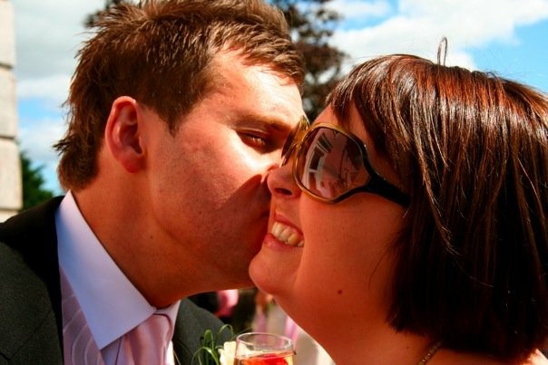
Again I picked up the knitting needles for my brother. This time for his wedding. He had survived the cancer and found a new lease of life, and with it a sense of direction of how he would like his life to be. His wife to be had nursed him and supported him. I had since moved away to Vancouver overlooking the Pacific. I missed him. So I knitted. I decided to knit a blanket for his wedding bed. Thick natural wool undyed and in the hue of the previous owner. Grey like English skies. I knitted cables and chords through it. I carried it everywhere with me. Catching a moment here and there to do a few stitches or rows. It came with me to the coffee shop, to work, on the bus. It kept me company in the first few lonely months of immigration. to Canada. I bundled it gently into my case and carried it oversees back to England for the wedding. On the note attached I wrote
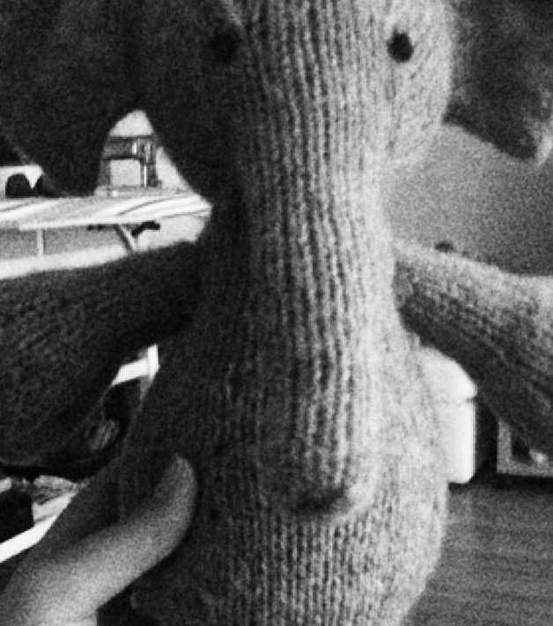
“Each stitch a wish. Each knot a blessing”.
I picked up the knitting needles again for the birth of my brother’s first child. I saved the same yarn from their wedding blanket and used it to knit a soft toy for the baby. An elephant I named Ella. She was beautiful, complicated, challenging and testing of patience. Constructed with thought and precision while pouring over the complex pattern. Made piece by piece then sewn and bound together. Ella for Lila, my niece, my blood. Lila who is a miracle, considering not long ago her young daddy was facing his own mortality at an age when he thought he was immortal.
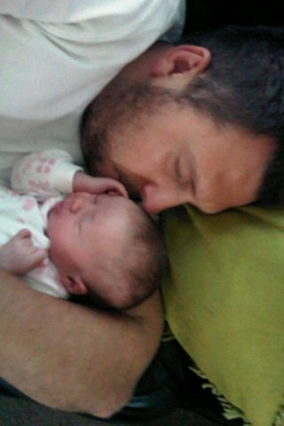
My niece. My brother. Knit together.

“An artist overwhelmed by emotion cannot continue to imagine, or to compose the lines that allow others to share in his or her feeling. The great artist is sensitive, but imperturbable; battered, yet centered.” (Zajonc 2009, p.g.75)

The Impressionists
My first trip alone happened this year. After I finished a visit to see my family and friends in England, I visited Paris for a couple of days. All by myself. It was scary and amazing and life affirming. I sat in the Musee L’Orangerie looking at the Monet paintings I had poured over as a teenage art student. Back then I had dreamed of seeing them in the flesh in Paris. Then, when life felt it’s heaviest, I escaped into Art. I poured over my projects and devoted hours to the work. I stayed after school to avoid the bullies at the gate, the absence of my mother at home and the oppressive responsibility of caring for my little brother and father. Art was there for me. The impressionists were there for me. Monet, Degas, Manet, Pissaro, Renoir, Lautrec….. They were there in their beauty and attention to detail. They were there in their humor and bemused observation. They were there and I was there with them. As I sat and gazed at Les Nympheas, my eyes brimmed with tears and I said to myself “You made it”.

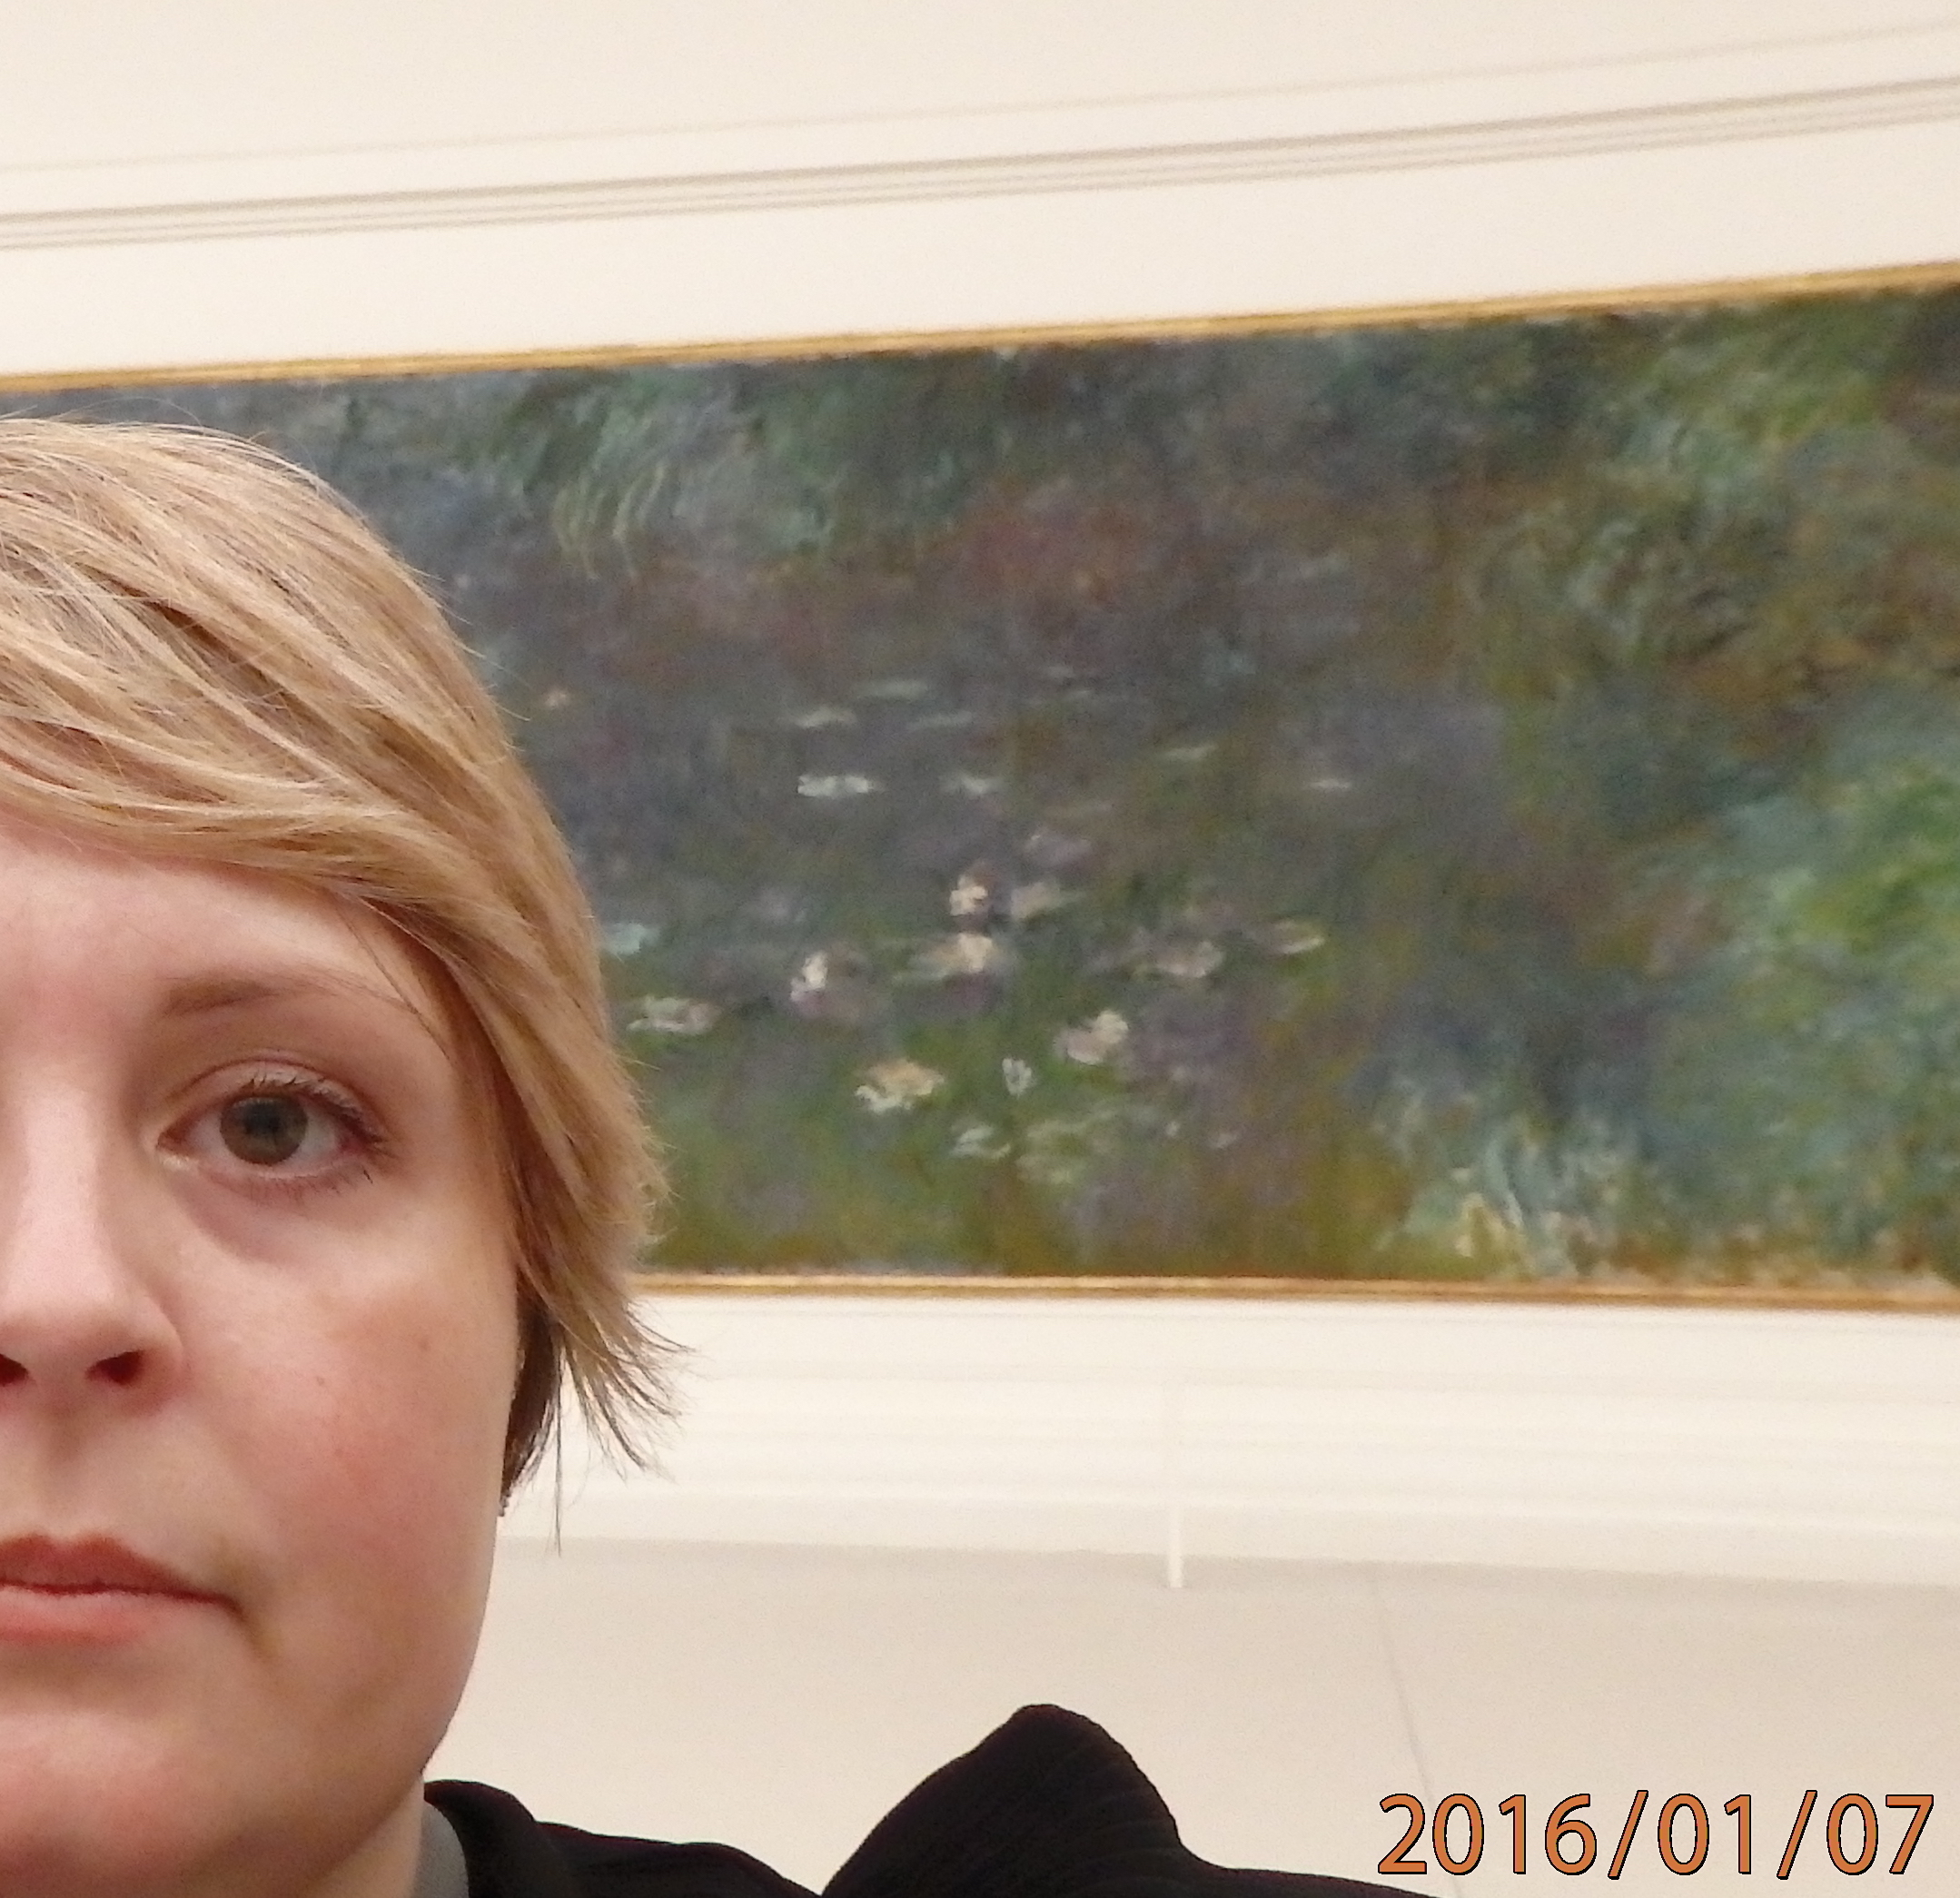

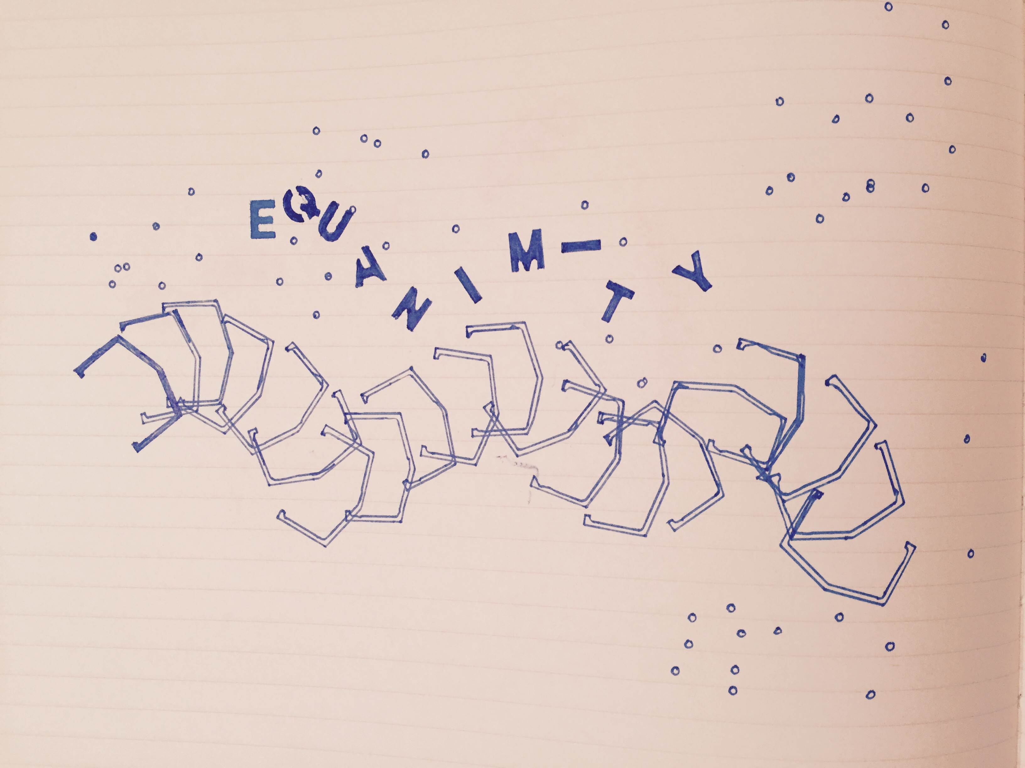
Braid 3- Equanimity

“Life’s sorrows and joys surround us. They move us, sometimes gently and other times like an earthquake that steals the very ground of our existence from beneath us. In undertaking contemplative practice our feeling life becomes more and more sensitive. Our heart awakens to feelings we knew only fleetingly or not at all. And yet, if this enhanced life of feeling is not to overwhelm or incapacitate us, we need simultaneously to cultivate equanimity………..Even when beset by the most difficult trials of life we should not abandon our inner center; we should seek peace in every tumult”. Zajonc (2009 p.g.74)

June 19th 2016. Father’s Day.
It’s been a hell of a week. Mass shooting and attack on the LGBTQU community in Orlando, a child taken by alligator, singer shot by fanatic, beloved British MP killed by a bigot racist nationalist. Just when your heart thinks it can’t take anymore and it will explode. So much pain and love for those affected. My heart is making two beats… Lub-dub-lub-dub-lub-dub. One pain, one love, one pain, one love, one pain, one love. But then The News on June 17th. The news delivered in the remote voice of my brother. Too far away to be accompanied by a hug. My little brother should not have to deliver such news to his big sister. Summoning all the strength he can muster to deliver the news in a calm voice. Not letting his voice crack, break or roll off into tears. The News about my father. My father, invincible, immortal rock.
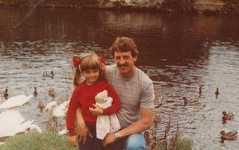
When I was 7 years old, my Dad told me I would go to university. He thought I would become a writer because I loved to read so much. He told me he had wanted to be a draftsman but when he met my Mum, he had to give up college and take a paid apprenticeship as an electrician, so he could afford to get married.

June 17th 2016
“Dad got his results back”. Gulp. “He has cancer of the oesophagus”.
“What?” My voice small and distant. “Are you kidding?”.
Of course he would not joke about that. Tests two weeks ago. Biopsy was undisclosed. Phone call. Still went on holiday to the south of France. Shocked. My brother-
“Sis, you know how I was when I had it?” Pause. “You know what got me through, was being positive”. Pause. “My Dad wants to be like that. He just wants to get his head down and get on with it”. (My words or his?)“He wants to keep going to work and being as normal as possible”. (My words or his).
“Did he ask you to tell me?” I ask.
“He didn’t know how to tell you. I said I would.”
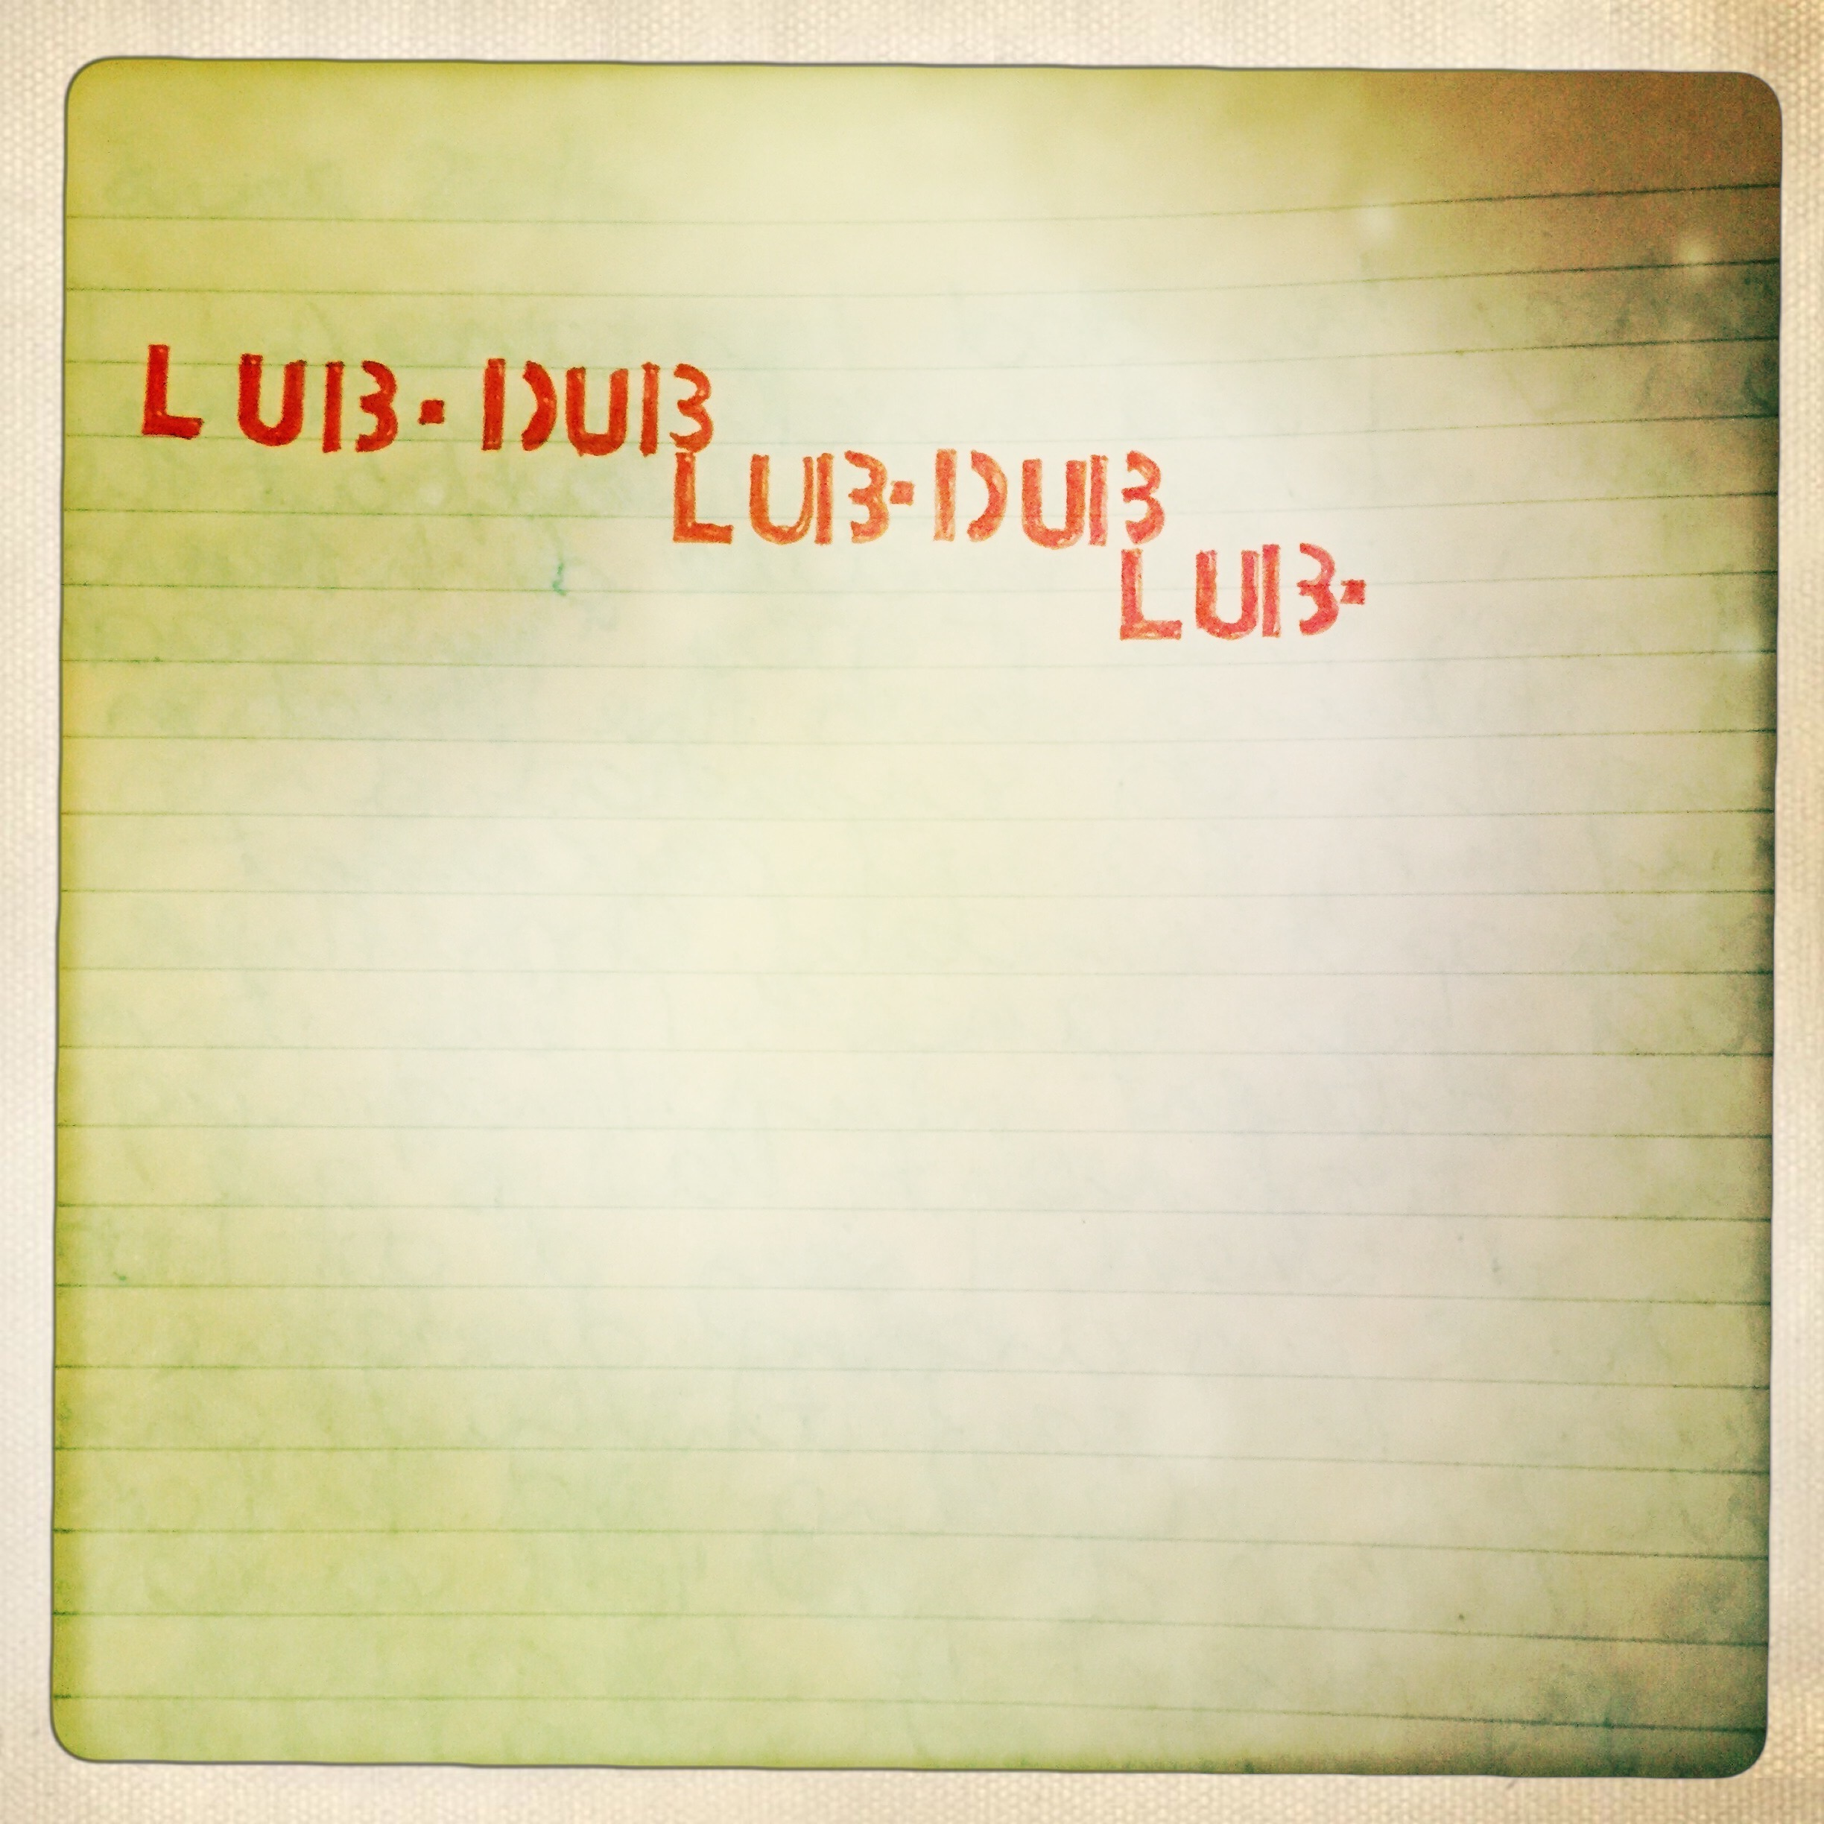
As I write, Radiohead “Full Stop” blasting, raling, coasting, rushing, pushing everything out. Instrumental drowning out. Rushing in my ears. Not real.
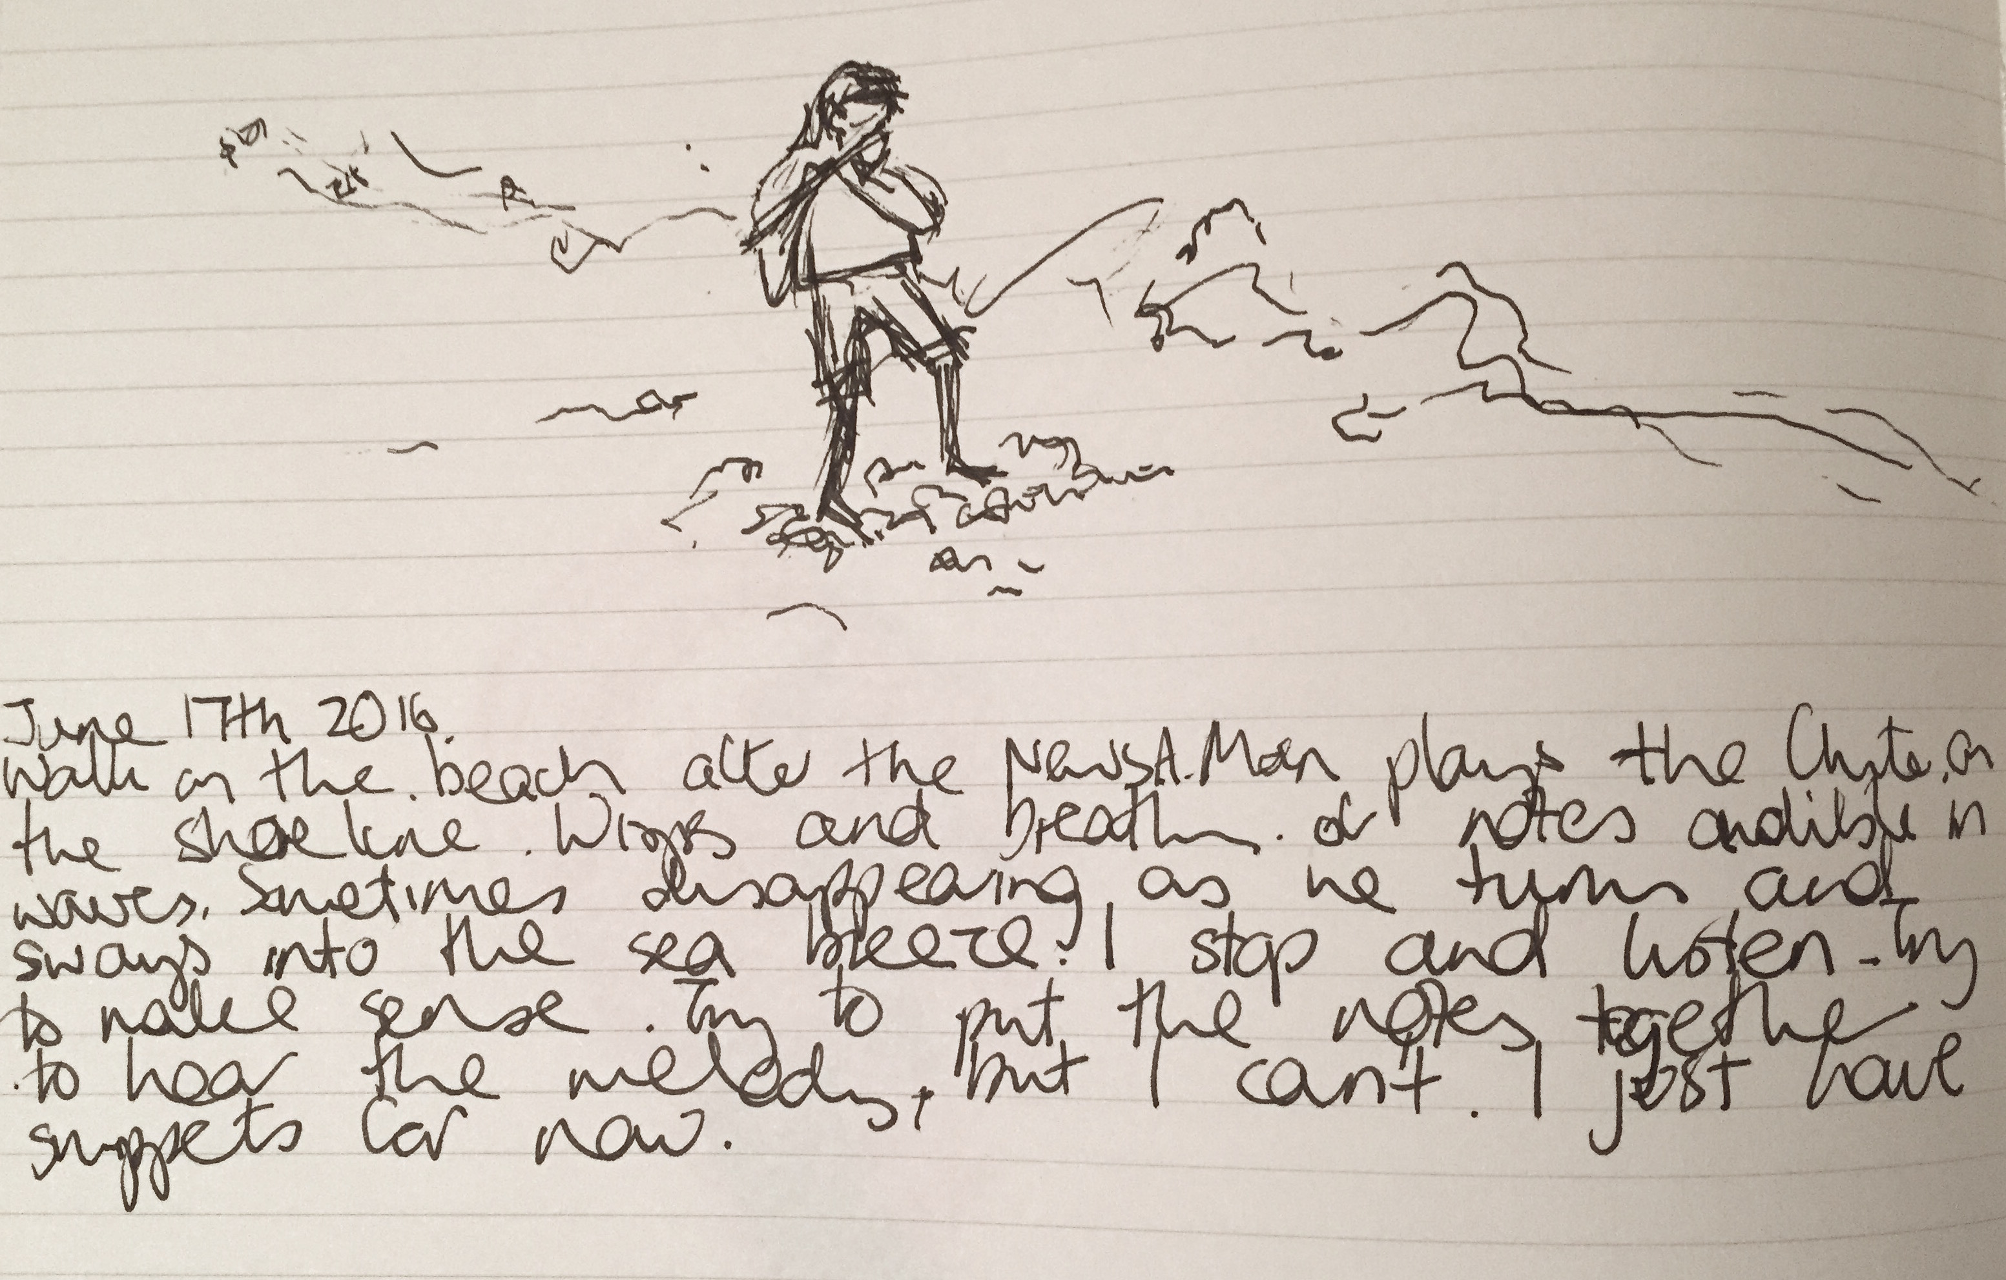
“Sound evokes. It evokes sensations, memory and experiences from the past as if they were present in the here and now and also, curiously, it evokes the capacity to see visions of what could be, a sensation of living forward in time.” Lederach & Lederach (2010 p.g.134)
Drum, My Heart
After I told her,
What happened that day,
She handed me the drum,
Skin stretched taught across the frame,
Twisted fibres webbed across the back,
Like a shield,
Like the sun,
Fingers curled upon the web,
Stick with swaddled tip in other hand,
I close my eyes,
Feel the vibrations once again,
Each strike reverberates across my body,
Bounces off the bodies around me,
Back to me,
Boom……Boom……Boom,
Hit me in the chest,
Into the heart, ribcage, solar plexus,
Boom…….Boom…….Boom,
Deep vibrations through my soul,
In and out, around and back again,
Boom…….Boom……..Boom,
Deeply grounding,
Connecting me to the earth,
To my roots,
Boom……Boom…….Boom,
Breathe…….Boom,
Breathe……..Boom,
Breathe……..Boom,
Boom. Feel your heartbeat,
Boom……Boom…….Boom,
Notice how your heart aches,
Yet continues to beat,
Boom……Boom…….Boom.

“Through regular contemplative practice we can develop a right relationship with feelings. So practice feeling, but do so with high intent. Brooding merely exploits old emotions, whereas a centered wakefulness in our feelings allows them to inform us concerning deep mysteries about ourselves.” (Zajonc 2009, p.g. 75)

June 22nd 2016.
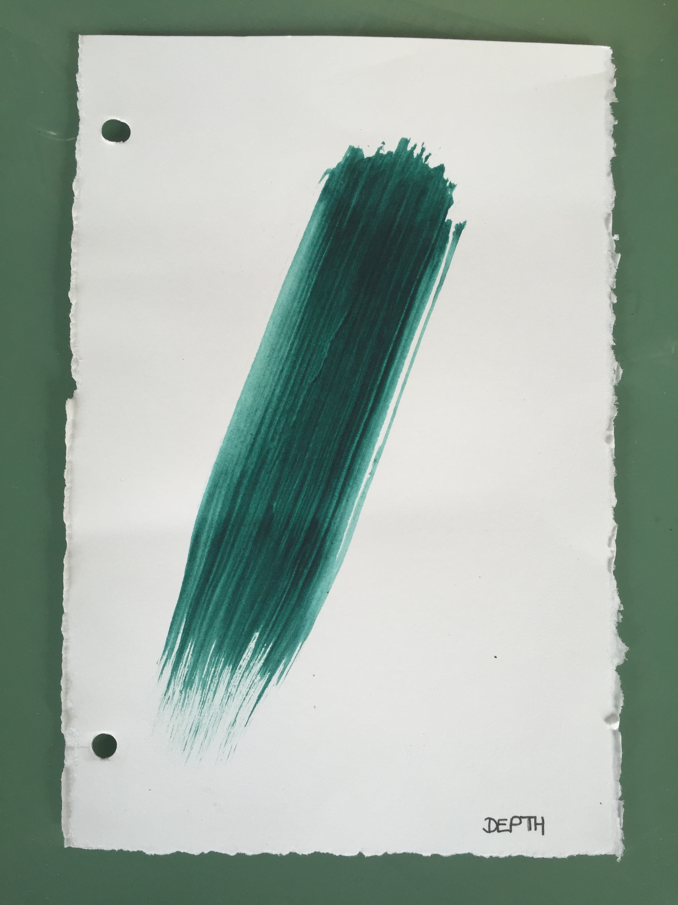
‘My Dad has cancer. My Dad has Cancer. My Dad has cancer.’ I find myself saying this to myself, with my internal voice. Throughout the day. Each day. I’m in the middle of listening to someone and Oops! there is goes “My Dad has cancer”. I’m walking down the street in the rain, enjoying the cool sensation of the raindrops on my skin, the wet pavement between my toes and Oops! “My Dad has cancer”. I say it in different tones, in different ways. I find myself imagining the emotion that goes with the statement. How is one supposed to say it? When I say it out loud to tell people, I have an ongoing dialogue with myself as I am speaking. If I say it without crying, will they think me unfeeling, cold? If I cry, can they handle it? How do you tell someone , in order to explain why you might be distracted, disorganized and scattered without pulling “the cancer card”. Should I tell people now or wait until I know more? Will I give a ?%*! if I know more. Will I even care what they think? I find myself weighing up when and how to tell people. My friends who will support me. I feel awkward. They have enough on their plate. How do I explain that I want them to know but want to be alone. I want to watch from the sidelines. I want to observe life happening but don’t want to participate. I’ll just stand over here. I’ll stand over here and think to myself “My Dad has Cancer”. Maybe if I keep saying it over and over again to myself, I will believe it.

According to Cajete, Indigenous people such as the Lakota view dreams as “an alternative avenue for knowing”(p.g.144). Dreams are used for problem solving and coming to know oneself.

June 22nd/23rd 2016
I wake from a dream. One of those dreams where I want to go back to sleep, to resume the dream, and get resolution. I tried but it didn’t work. I roused to the sound of heavy rain outside and a full bladder. You know what happens when you need to pee and you hear running water, right?
In my dream, I am at my father’s house. I am waiting for him to come home. When he gets home, he has a pager with him. Then he gets a message from his doctor with the results of his test. He doesn’t have his glasses on and he is struggling to read the text. He can’t figure out how to read this letter on this really small screen. He passes it to me. I am the same and have the same difficulty reading it. The letter from the doctor is too “wordy”. It talks about diet first so I skim through this. I am searching for the word “Grade” as I know this will tell us on a scale of 1 to 4, how serious it is and the prognosis. I just get to the section that explains this when my Dad’s family arrives. A hoard of aunts, uncles, cousins, kids and teens all turn up, on mass. It’s noisy and I can’t concentrate. I am frustrated. I tell them that we are just looking at my Dad’s results and need time to read and digest them. I want to ask them to leave us alone while we are reading but there are so many of them. They’re everywhere. They’ve taken over the house and they are preparing food. I take him upstairs to his room. My Dad is silent which is unusual. Again, I try to figure out the pager to get more information. I turn this dial and press that button. Then my cousins and their teen children come into the room, looking for a place to hang out. I am frustrated and tell them to leave. I tell them I want to read the results. I wake up.

“Through song and sound we experience a sense of transportability, that is, we have moments when the past, present and future merge, when we are capable of holding at the same time a sensations of being in more than one spatial and temporal sphere.” Lederach &Lederach (2010 p.g. 135)

She’ll be coming round the mountain
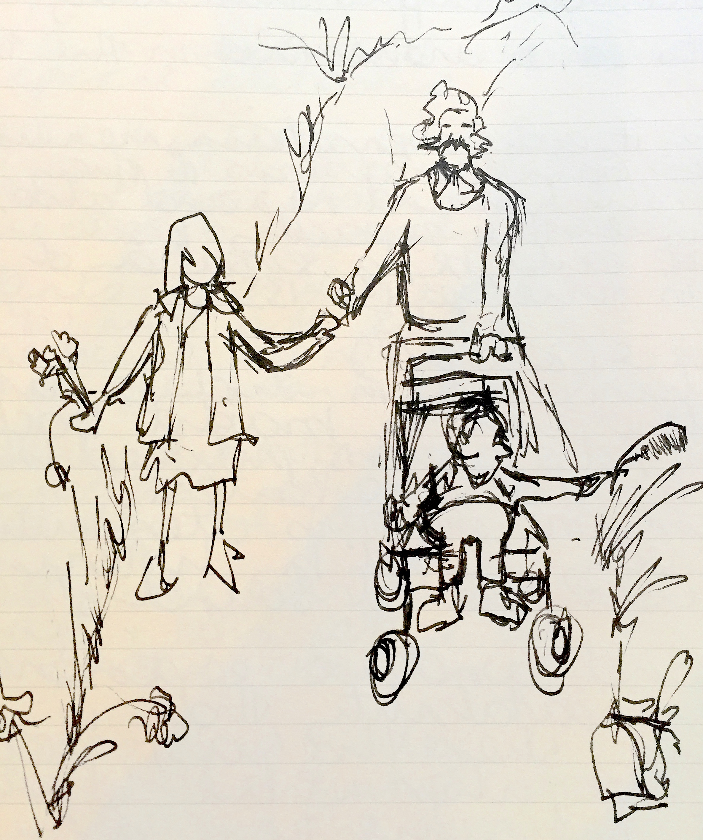
When I remember I flit between being there next to them and flying overheard, like a bird soaring over them. We are walking side by side on the dusty path along the side of the road. Me, my Dad and my little brother. My little brother in his pushchair. He’s not quite steady enough on his feet or trustworthy enough to not dart off into the road, giggling. We walk beside the dusty ditch and past surrounding fields. It is quiet and the sun is shining. Occasionally cars drive by, whipping up the wind and silence. We are singing. My Dad would often make us do this. He would teach us songs and have us singing at the top of our lungs. Without inhibition. Now I’m shocked that I didn’t care what others would think if they heard us. What would they think of this grown man, his 10 year old daughter and 3 year old son, singing at the top of their lungs. Singing “She’ll be coming round the mountain when she comes. She’ll be coming round the mountain….” making up silly lyrics as we went along. songs of peace, progression and social activism. I wonder where he learned them. It felt so good. He would walk us for miles and we didn’t notice. Over the years he has walked us across fields, up hills and down lanes in the sunshine and pouring rain. We talked as we walked and set the world to rights. We had his undivided attention. As we walked he would listen. As I grew older, he would listen, wax lyrical, have philosophical debates about the world. Many a lesson in morals and ethics. How to treat people. As we walked he would point out things in nature. He would name trees, plants, flowers and birds. Taught me their latin names. We would revel in the awe of it all. Afterward we felt cleansed, exorcised and calm. Sometimes a quandary was discussed, we left resolute with what action to take next. My Dad, my saje, my shaman. Us three. Indivisable. A unit. My family. Over the years we grew up and grew out of those walks. Now I feel a pang of jealousy as he tells me he is going for a walk with my 6 year old niece and I am not invited along. I want to walk with him, sing without inhibition and have his undivided attention.
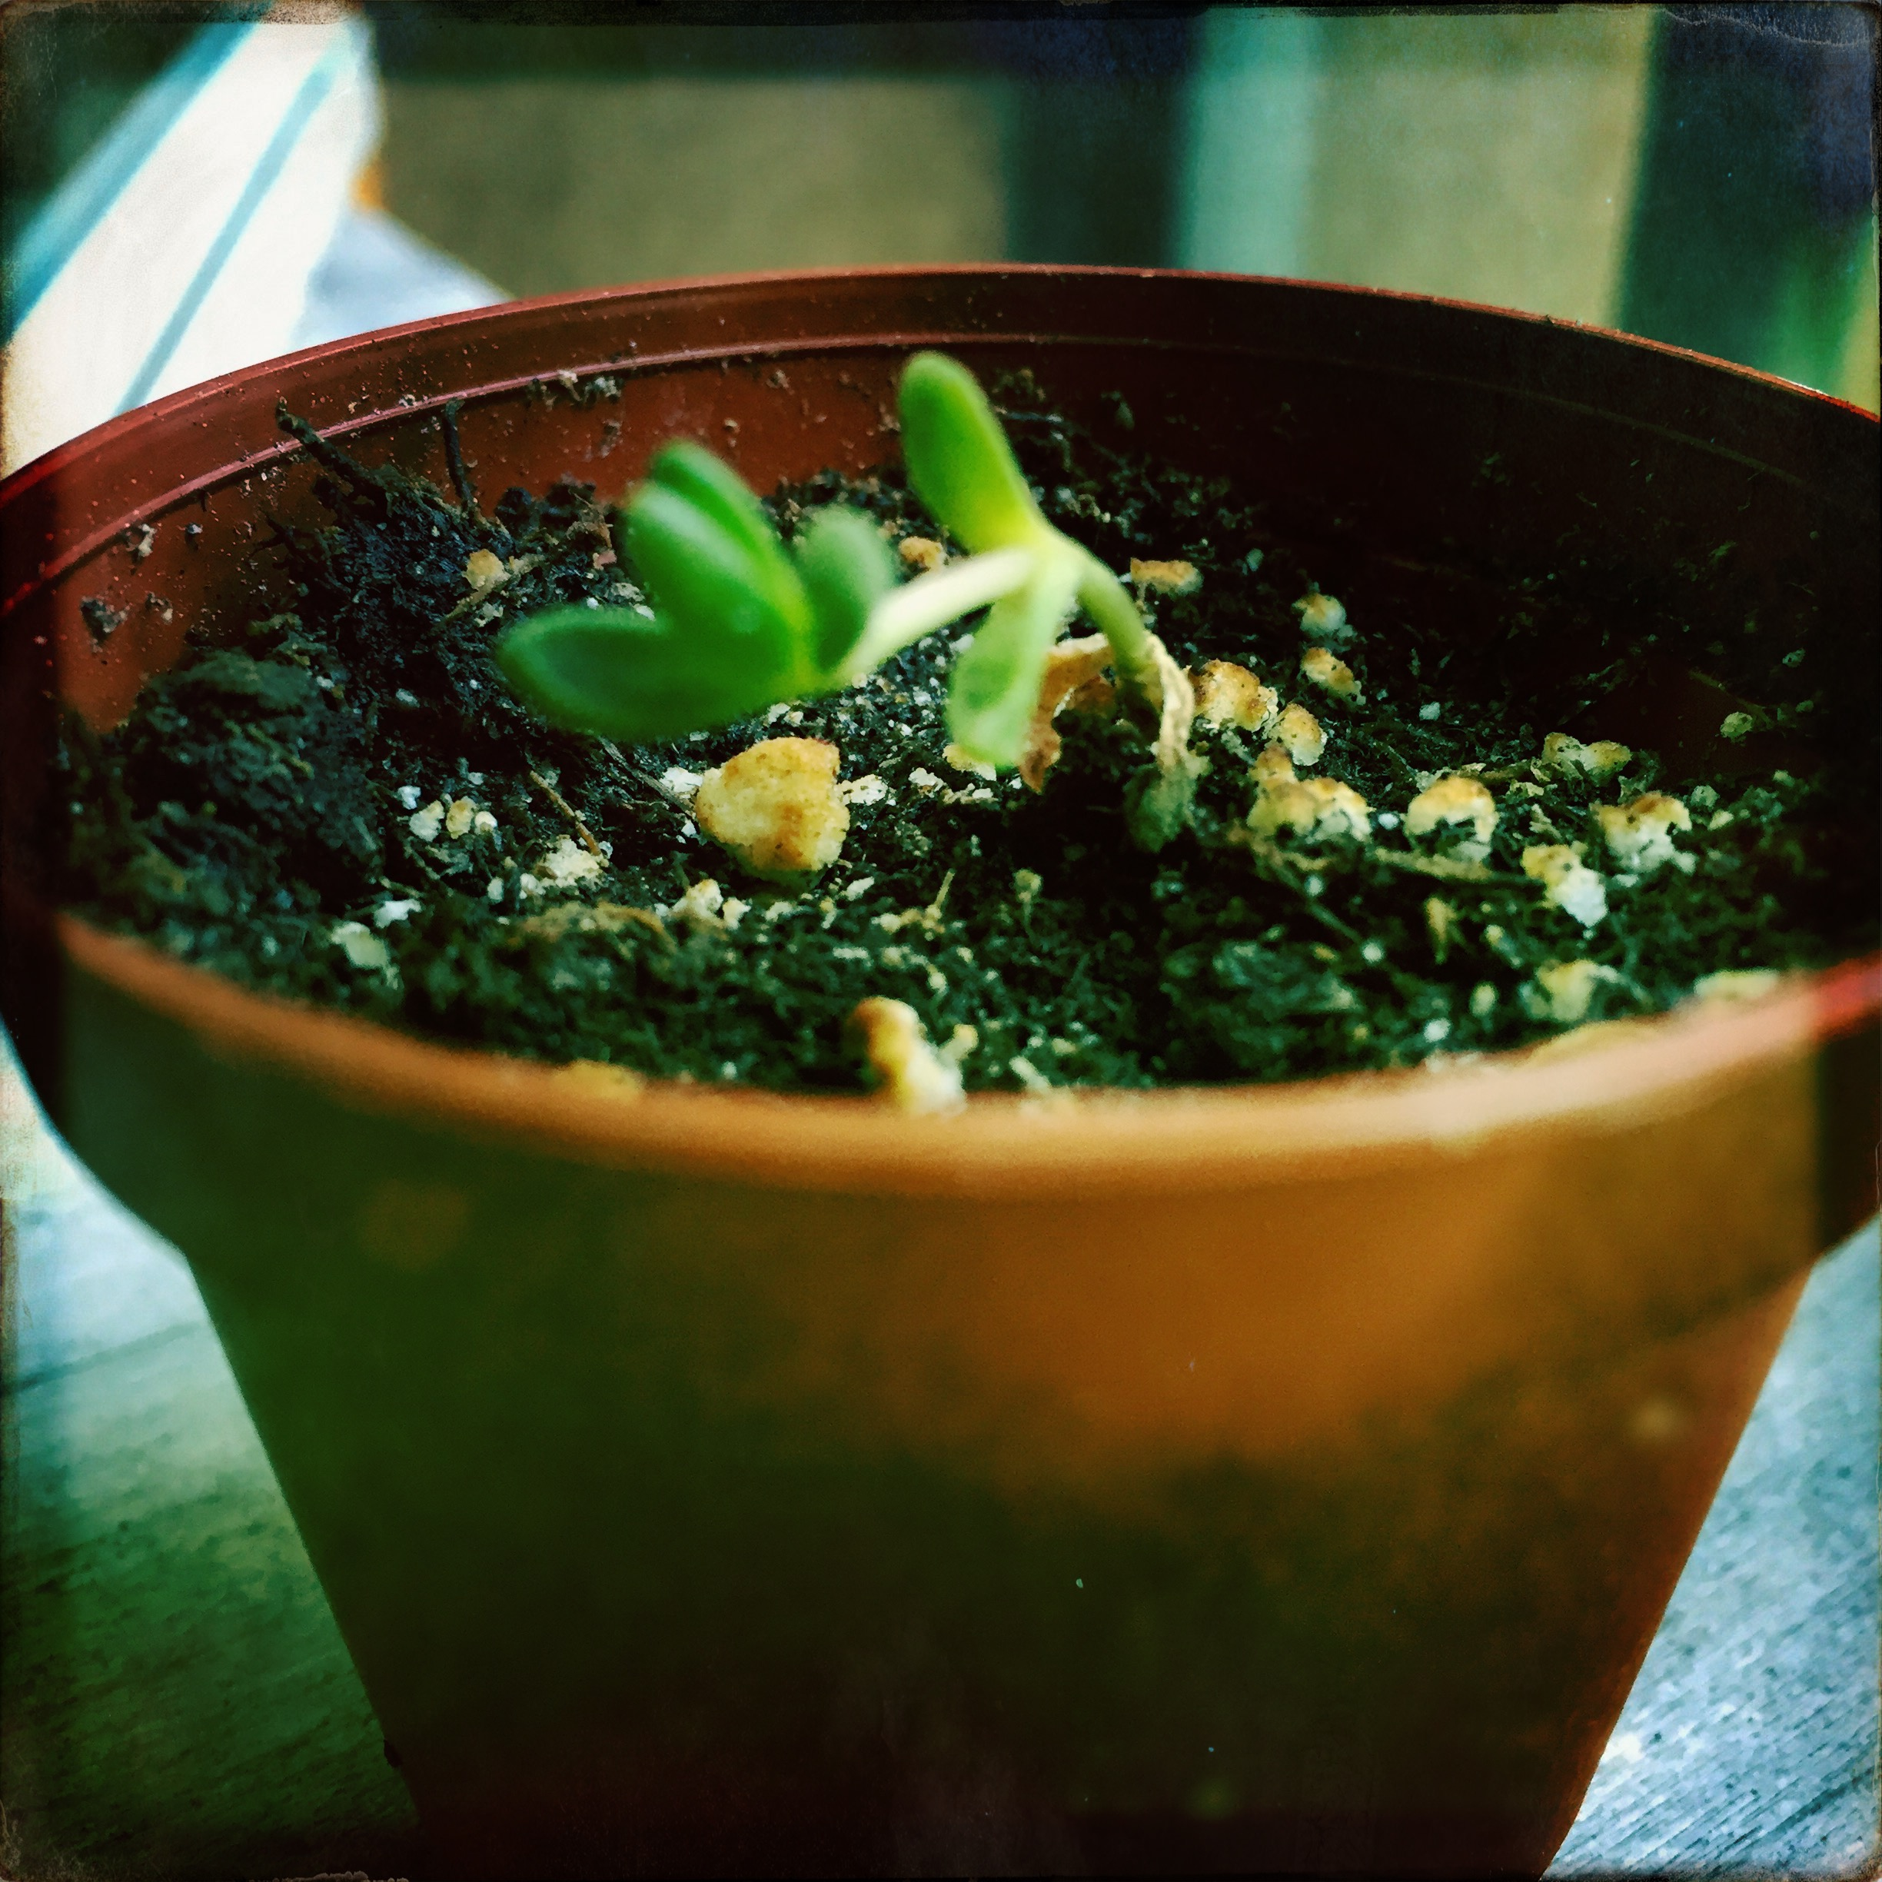
Seedlings
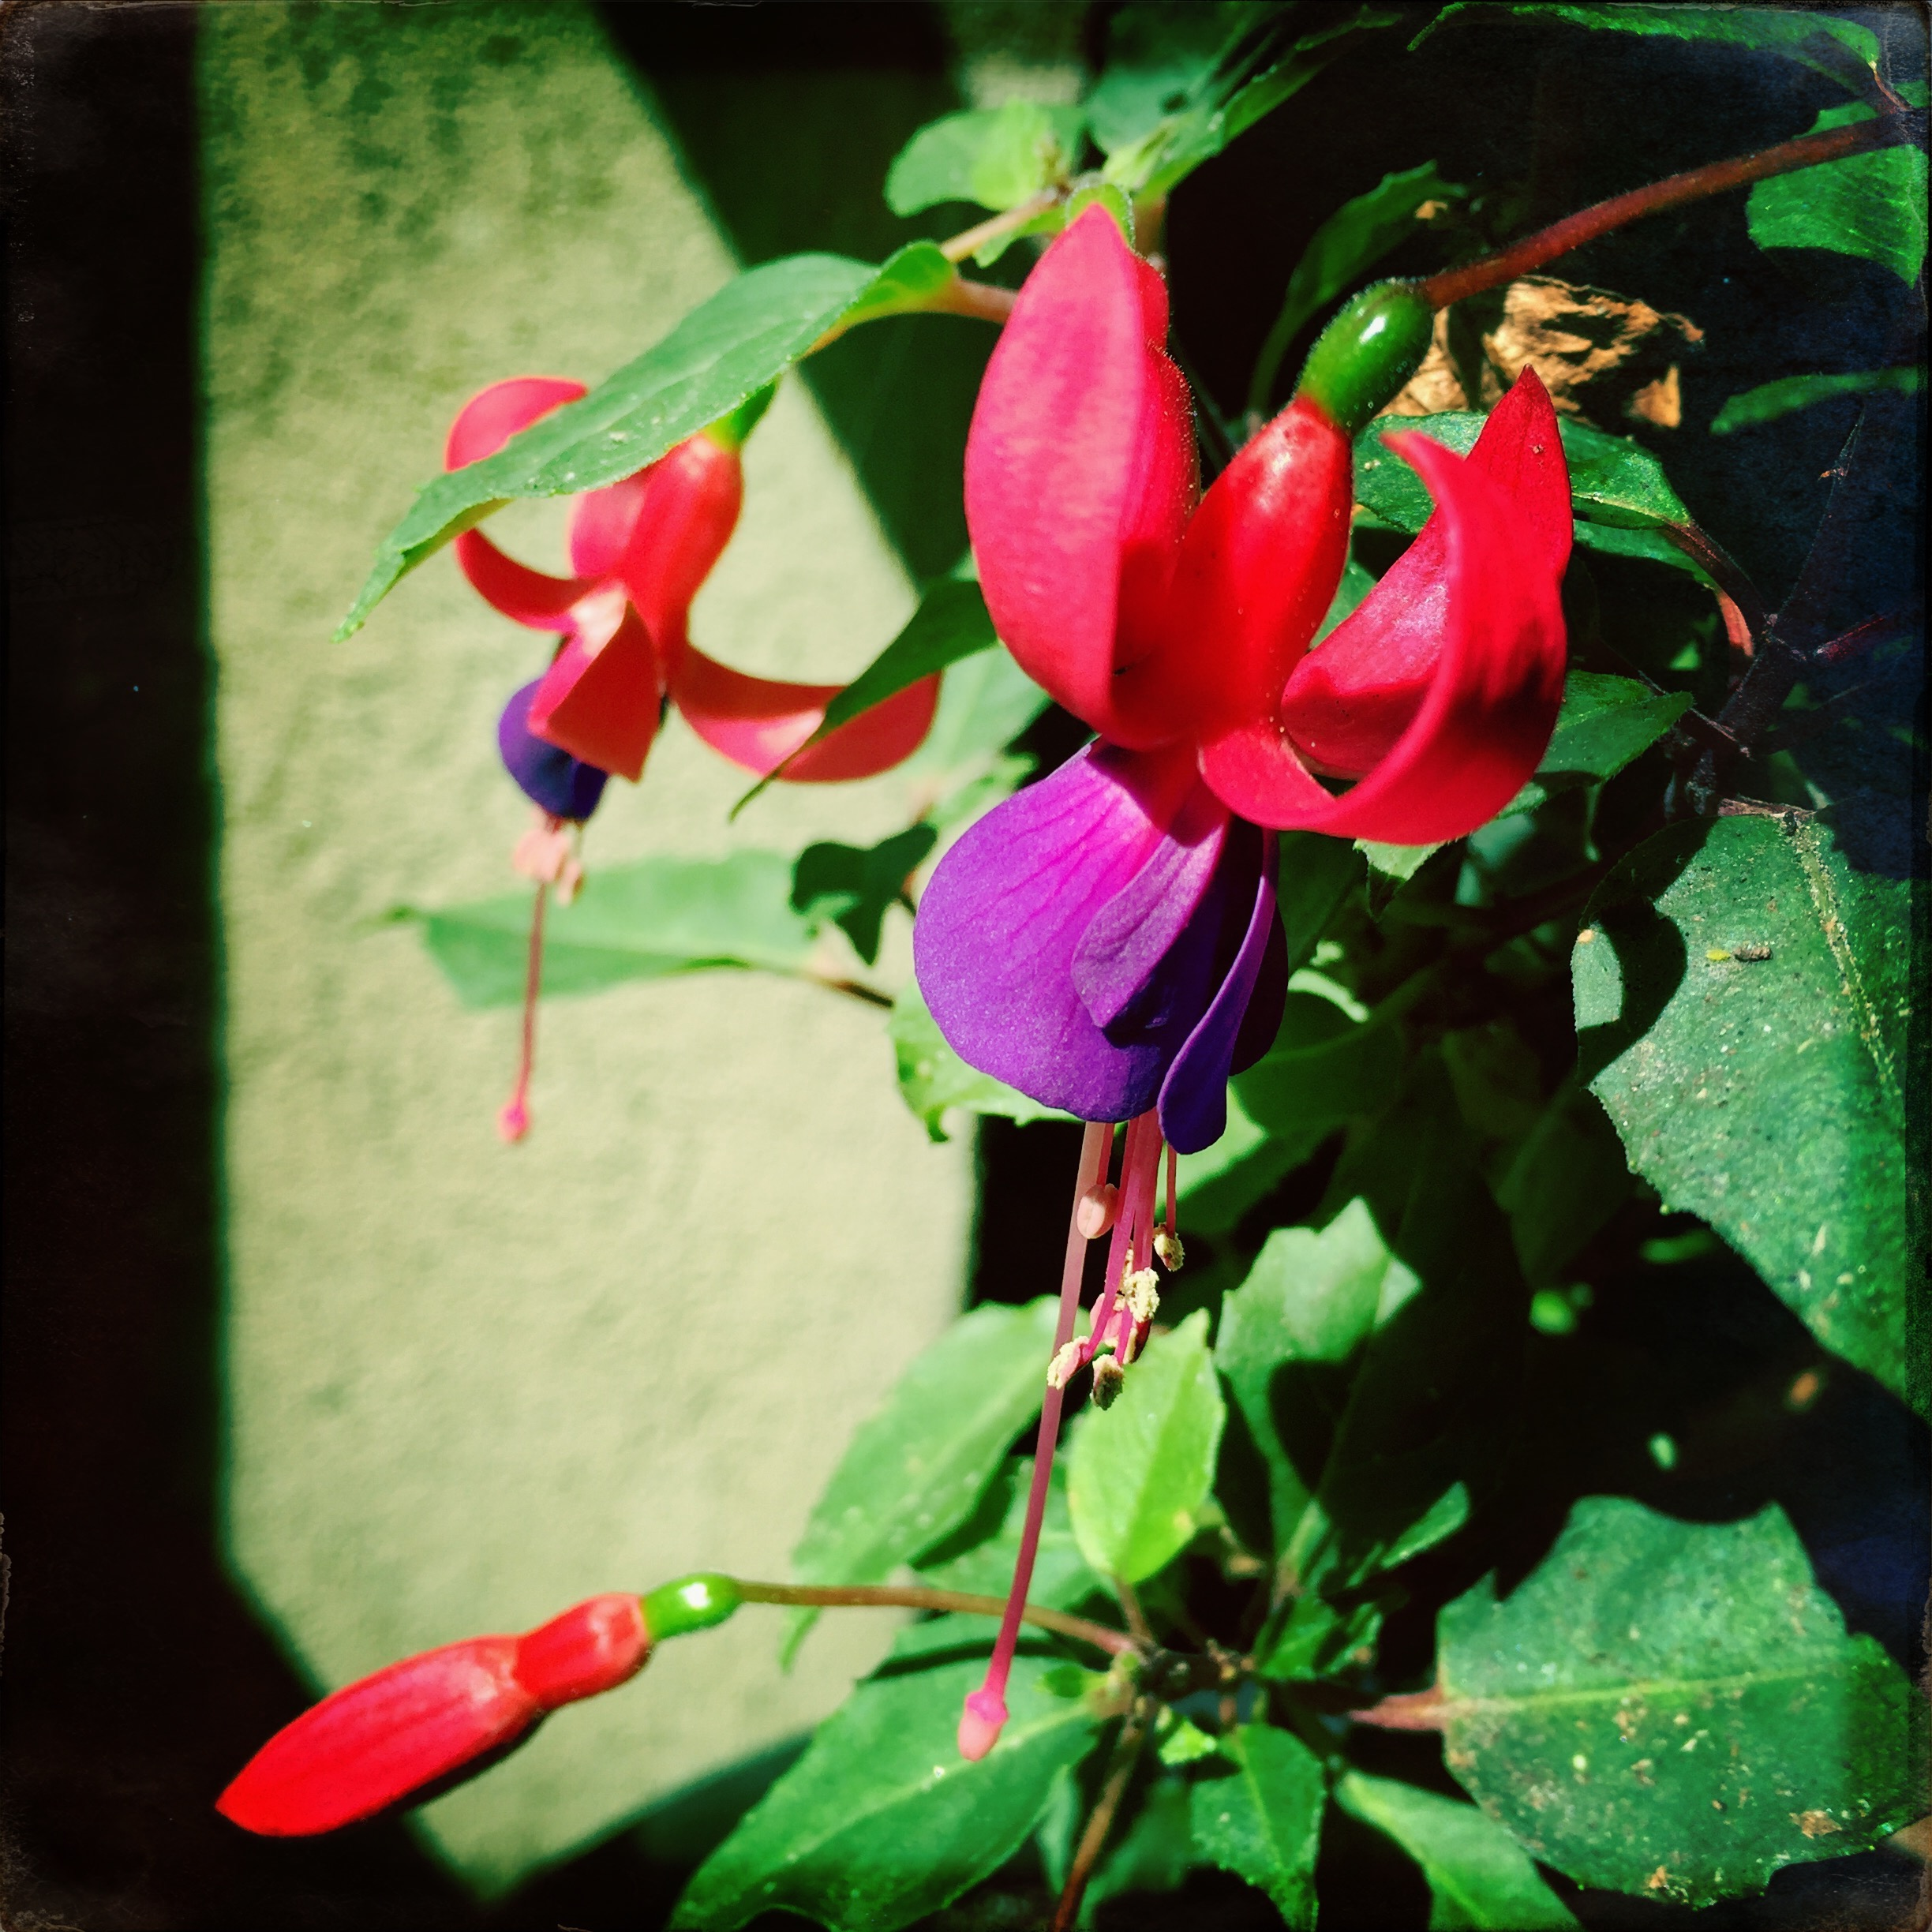
I haven’t been able to find the perfect pot or the perfect size container for them. I have searched and can’t find the perfect one. Delayed putting them in a new home until I found the perfect one. But today I realized it does not have to be perfect. I can put them in the not-so-perfect pot that is not quite the right size and they will be ok. I don’t want to delay anymore. I want to enjoy them now. So I rip open the bag of soil and reach in. The smell of soil and it’s softness in my hand take me back. Standing beside my Dad in his greenhouse, pricking out his seedlings. Planting baby plants for his garden. Like he showed me I place soil 1/3 of the way up the pot, moving it against the sides to make room. I pour a dash of water to comfort the root. I gently hold the pot in one hand while holding the seedling between finger and thumb of the other. I tip the pot upside down and pat its bottom, gently squeezing the sides of the pot to release the soil and root into my hand. I place the pot shaped mound into the center of the soil in the new container. I scoop up some fresh soil and place it around the seedling. I push the soil down around the edges, like I am tucking the seedling into bed. Like he told me, I am careful not to break the root or leaf, while I scoop, drop, prod and press down gently with my fingertips. I press down the soil down so it is firm enough to support the stalk and stands upright. Now I will watch them grow and tend to them in their imperfect pots . I hope they will be ok. Later as I write this , I am soothed, close my eyes and nod with sleepiness.

“A woman must have money and a room of her own if she is to write fiction” Virginia Woolfe (1989 p.g 4)
A Room of one’s own
have created a space that belongs to me in my home. Still shared and accessible but still claimed. It’s not easy to find space in the one bedroom apartment I share with my husband and french bulldog in Vancouver. You see to think, paint and breathe, I need to be alone or away. I need quiet away from the TV or radio that my husband prefers as white noise. I need a place to put the objects I use for contemplation. A place to leave them out where I can see them, a reminder to not forget my practice. I had put off clearing a space, too much clutter and not quite right. Now I felt the urge, the pressure and itch to create. I felt claustrophobia from no space to think and breathe. I began to clear a space on the balcony. I planted succulents in pretty coloured pots and placed them where I can watch them grow and thrive. On impulse, I bought a bench easel for myself for my birthday. I placed the less than perfect chairs where I can sit and watch the wind in the trees and feel the sun on my skin. As there is shelter, I will be able to watch the leaves change colour through the seasons. I place my paints, pencils and brushes on the table nearby. I found a weathered looking singing bowl. I placed it on a mat with an embroidered image of Ganesh, remover of obstacles, upon it. I place my smiling Buddha statue at the door to greet me as I walk outside. And so I sit in my place, my space and I begin. I invite the sound of the singing bowl, asking for forgiveness from my neighbours, my dog and my husband who sleeps nearby. The sounds resonates in my chest and invites me to breathe deeply and go inward. I feel the sun on my skin and hear the breeze in the trees. When I open my eyes, I look over the grass, tree, roof top and sky. I move over to my easel. I mix paint with a brush. I breathe in, then out. I move my brush across the paper. I create.
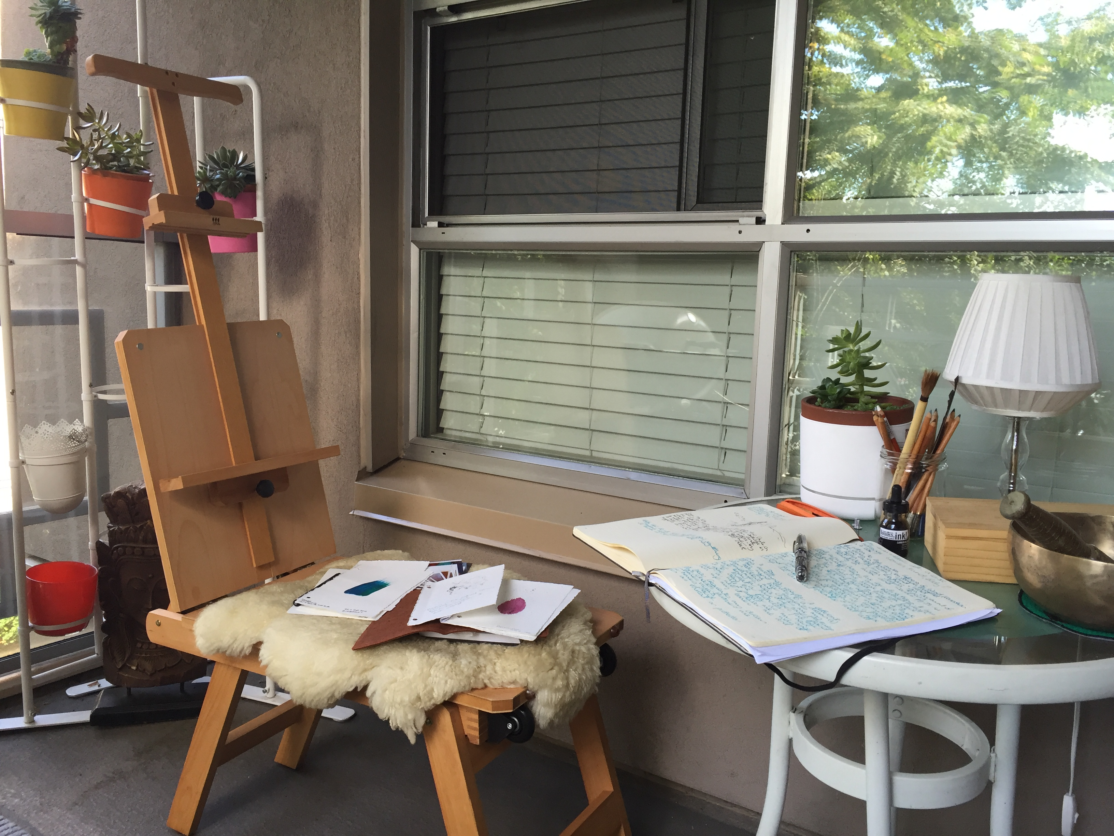
August 14th 2016
Today is the first time I saw my Dad after his operation. The wonders of technology, that it allows me to see him from all these miles away. He looks well, in fact not much different than before the news. I am surprised and grateful that my imagination was wrong. He is keen to show me his scars. I inwardly grimace as I look at them, not wanting him to read the dread on my face. He calls the scars his roadmap, as they run down his chest, across his belly and under his arm. Tracks. I see that he is healing well. He proudly shows me he can now move his arm above his head and tells me he is walking 1 mile everyday. Although, today he admits is a bad day because he’s run out of painkillers and hasn’t been for his walk. There are a few moments when breathlessness and grimaces interrrupt the conversation. Otherwise, he tells me he is doing well and the nurse has told him she is her best patient because of his positive attitude and how he is recovering. As he says this, he shows me he is having his first glass of wine since the operation. Inside I simultaneously rejoice and chastise him but decide to say nothing. There is a moment where he acknowledges the odds he was given and the opportunity the operation has given him. There is a brief pause when the gravity of that sinks into both of us. He quickly moves on to tell me about his upcoming plans and we talk about my visit in the fall.

The Little Hummingbird
In The Little Hummingbird, Michael Nicoll Yahgulanaas (2010) recounts the story told by the Quechua people of Equador and Peru. There is great forest fire and all the creatures are scared and run away to watch from the edge of the forest. All except the little hummingbird.
“Little Hummingbird did not abandon the forest. She flew as fast as she could to the stream. She picked up a single drop of water in her beak.
Little Hummingbird flew back and let the water fall onto the ferocious fire.
She dashed to the stream and brought another drop, and she continued, back and forth, back and forth.”
Meanwhile, the other creatures look on afraid and express their helplessness. “Finally, Big Bear said, “Little Hummingbird, what are you doing?”
Little Hummingbird looked at the other animals. She said, “I’m doing what I can.”

References
Cajete, Gregory, (1994) Look to the mountain: An Ecology of Indigenous Education. Rio Rancho, NM:Kivaki Press
Hasebe-Ludt, E., Chambers, C. Leggo, C. (2009) Life Writing and Literary Metissage as an Ethos for Our Times. New York, NY: Peter Lang.
Lederach, J.P. and Lederach, A.J. (2010) When Blood and Bones Cry Out: Journeys through the Soundscape of Healing & Reconciliation. New York, NY: Oxford University Press, Inc
Safer, J. (2015) Beyond Beyond Motherhood. In M.Daum (Ed) Selfish, Shallow, and Self-Absorbed: Sixteen writers on the decision not to have kids. New York, NY:Picador
Woolfe, V. (1989) A Room of One’s Own. Orlando, FL:Harcourt, Inc
Yahgulanaas, M.N. (2010) The Little Hummingbird. Vancouver, BC: Greystone Books Ltd
Zajonc, A. (2009) Meditation as a Contemplative Inquiry: When Knowledge Becomes Love. Great Barrington,MA: Lindisfarne Books.

