FAT
A Bodygraphy
Helen Kennett-Bacon
#301294529
Cohort 2015-2017

MEd Curriculum Inquiry and Approaches to Education
Embodiment and Curriculum Inquiry
EDUC 843 (G031)
Dr. Celeste Snowber
A note about process
I have previously used paint on canvas to convey my ideas and concepts. Embodiment, to me, called for three-dimensional art such as sculpture. I chose clay because I wanted to have direct contact with the medium, unlike painting where the brush or tool is between me and the paint. I wanted to transform into form on the outside what is inside. Each sculpture is a vision that came to me after a movement class in the dance studio with Celeste. I saw of how my body felt. Once created, the sculptures showed me how I thought about and experienced my body. They showed the progression of my embodiment process as I embarked upon a journey toward acceptance and self-compassion.

Rumi spoke of welcoming all guests into your home. I invite you to consider Acceptance as a guest. How will you welcome them?
Resist- You shut the door
Explore- You peak through the peephole
Tolerate- “Come in but leave your shoes on”
Allow- “Come in. Take your shoes off”
Befriend “Come in. Sit down.”
(Taken from stages of acceptance in Mindful Self-Compassion by Germer and Neff 2016)

To See
“Sometimes artists experience profound moments of grace when with insight, they seem to see into the heart of things.”
Kelly (2015, p.55)

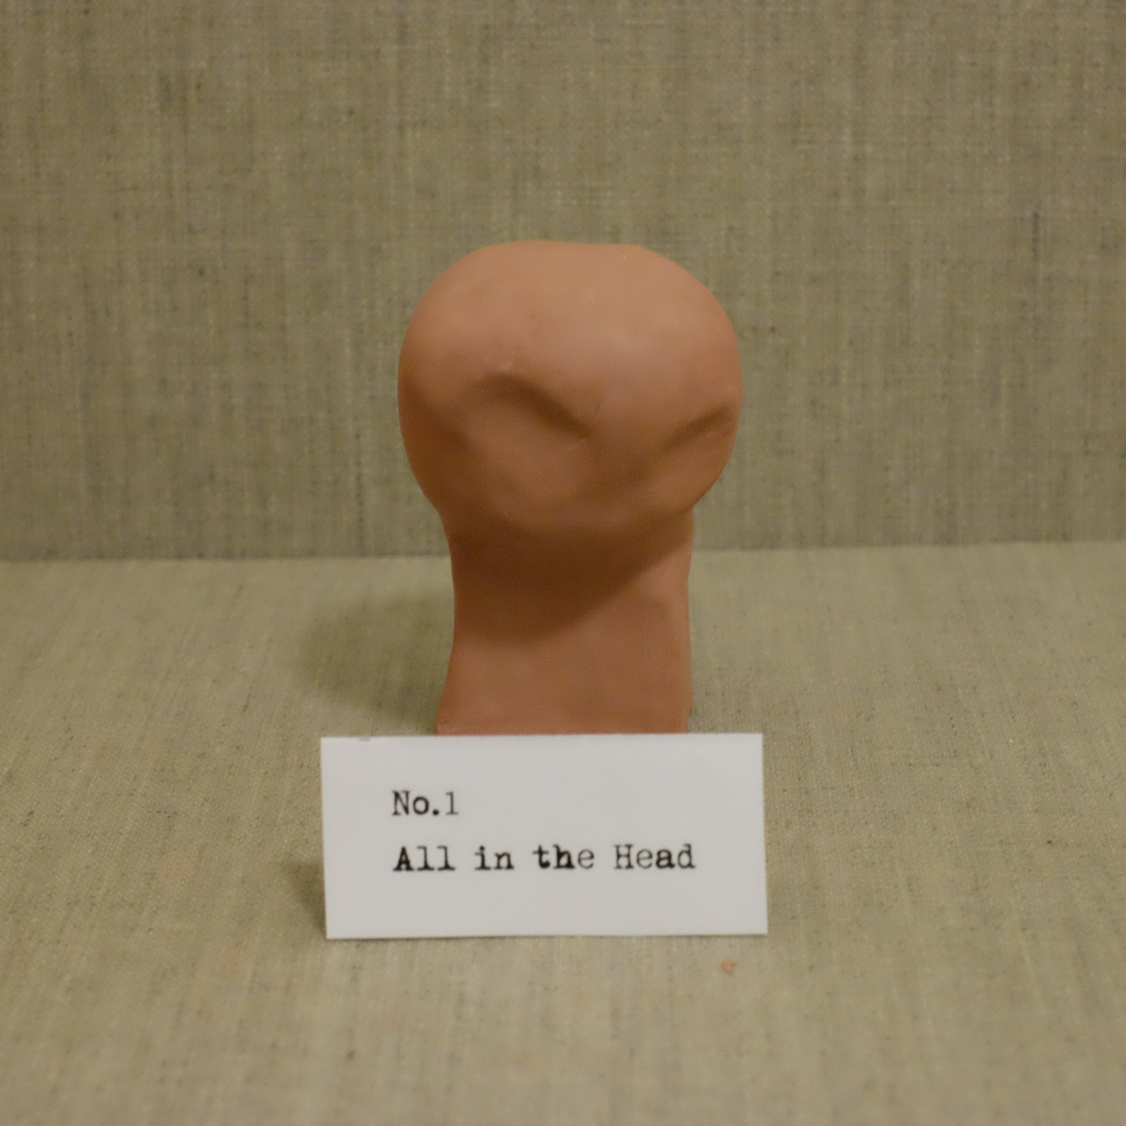
Part 1- All in the Head
Sculpture by Helen Kennett-Bacon. Red Mexican Clay
All in the Head
I imagine myself as this geometric shape.
A square,
Small in comparison
To the big round sphere on top.
Perched on the edge,
As if it will roll, loll, or tumble.
Unbalanced.
Weight in the head.
A Head too big for a body.
All focus is on this sphere.
Heavy,
Unbalanced awareness,
Lolling.
Careful!
It looks like it could topple.
Surprising, For beneath there is a square
Squat and sturdy
Unisex and strong,
Defined edges.
Oblique.
Wishfully symmetrical.
You see, it’s all about the head.
All in the head.

When we had our first class I was nervous. I didn’t know what to expect. What if I couldn’t do it, physically I mean? What if I looked stupid? What if I looked like a hot sweaty mess! All in my head. When we got to the dance studio and I saw the mirrors everywhere, my heart sank. I didn’t want to see what I looked like. I didn’t want to be reminded again and again of my size. I tried to move to another part of the studio where the mirror was covered up but I couldn’t avoid the mirrors no matter where I moved. What was she going to make us do?
In the first class I had moments of losing myself in the moment, a movement feeling good in my body then I would catch sight of myself in the mirror and I would freeze. My attention would immediately shift back into my head and out of my body. Thank goodness there was laughter in the class and a sense that I wasn’t alone in my awkwardness and discomfort. I looked around me and saw others who seemed so at ease in their body. Graceful and lithe. Like all of this was second nature to them.
I had flashes back to movement class at primary school. To a time where, the headmaster in his grey pants and white plimsoles would take us into the assembly hall. He would put Vivaldi’s Four Seasons on the record player and simply tell us to move to the music. And I did. It was so natural to me then to swirl, to sway, to roll on the floor. Where did that go? What happened to me? When did I become so self-conscious and worry about what others saw on the outside instead of what I felt inside. I grieve for that little girl. The little girl who used to dance alone in the living room to ABBA’s Dancing Queen

Part 2- Crushed, Twisted and Numb
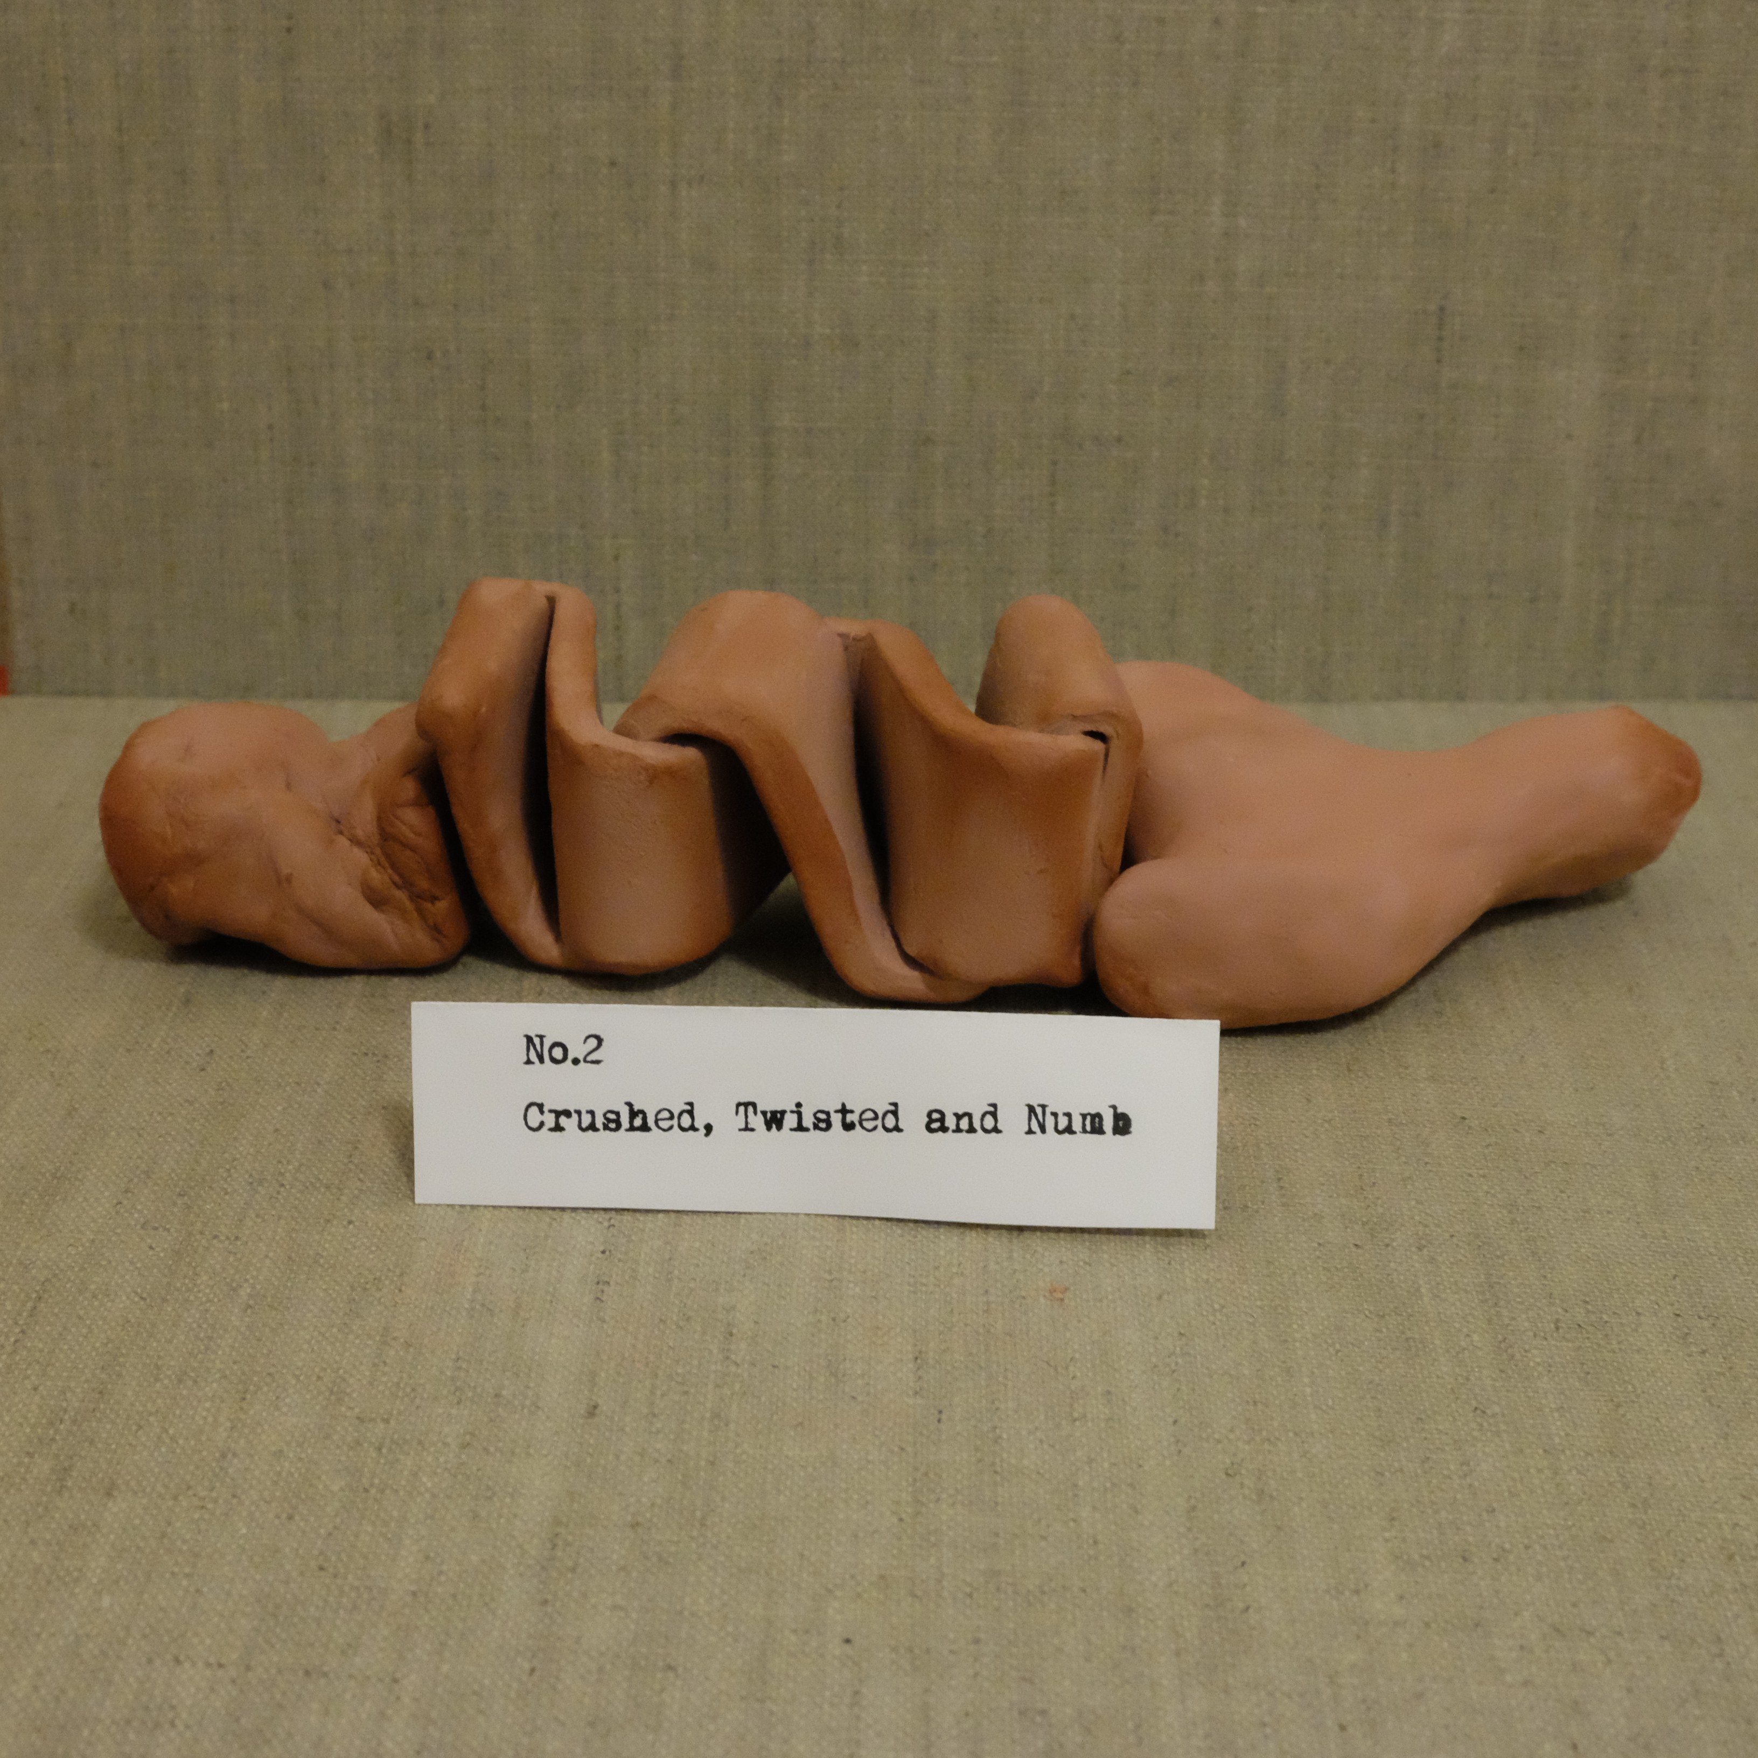
Sculpture by Helen Kennett-Bacon. Red Mexican Clay

“The deep attending to hard knots of holding is a powerfully compassionate act of turning toward rejected parts of being. As this newly compassionate observing occurs, the object of observation, the body/self is transformed and we move from denial to acceptance, from rejection to inclusion. This is the beginning of meta practice, loving kindness for the self.”
Thanas (1997, p.44)

In the gym I hear Celeste telling us to “live sensuously through the hips. Imagine what it feels like to live through the hips. Experience life through the hips. Live life as if making love to life. Walking, moving, experiencing.”

To walk
I walk and tell myself to bring my attention back, back to the body and breath. Fill lungs deeply with an audible whoosh and blow. Feel the mind settle and land in my skin, flesh and bone. Muscle, cartilage and fat. I notice I am compressed like a concertina. All head and shoulders and arms and chest. Then squashed from rib to knee. What would it feel like to lift, raise and release, to create space and air. To notice the gap of attention/intention about the belly, hips, pelvis and thighs. What would it feel like to expand the concertina. Feel depth and breadth between. What would it feel like to walk like a child imitating a queen walking down the aisle to her throne. To walk from pelvis and hip stretched out, to point toe and and arch, taking up space, rather a rotary hobbling along, compressed, ashamed, shy, and hiding behind fat. What would it feel like to lengthen neck, drop shoulders, and relax muscles. To breathe deeply and squarely. What would it feel like to adjust, notice and change how rib to knee feels. To release. To notice. To be aware. To be slow, deliberate and confident in movement. To take up this space as mine. Gliding, reaching, stretching and extending. To be graceful and lithe in this body. In this body, what would it feel like?

“Intuition resides in the sinews of the flesh where tissue can be transformed to wonder.”
Snowber (2013 cited in Snowber 2016 p.39)

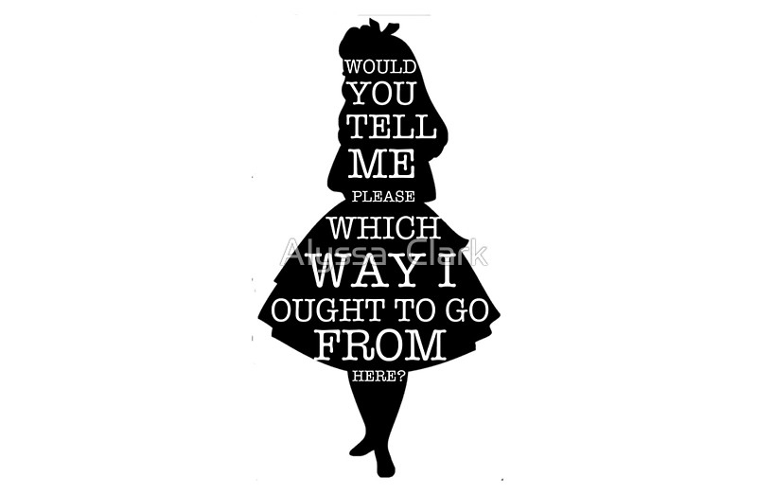
I look at the sculpture and I am sad. I don’t want to look at it. Is that really how I feel? Where did this feeling of being crushed, twisted and numb in my body come from? So I start to reflect and wonder.

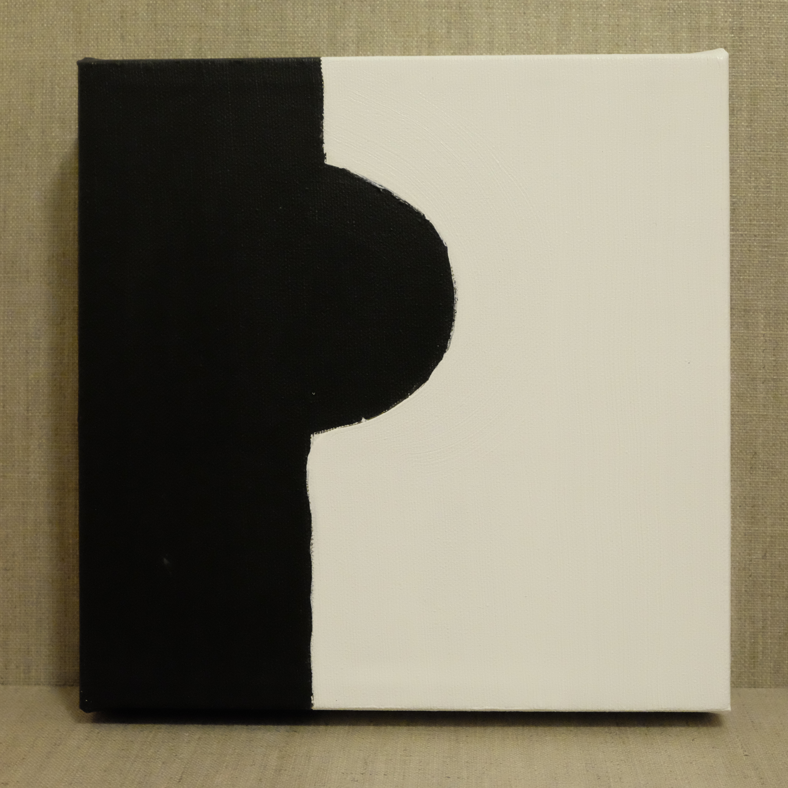
Part 3- Where did SHE come from?
Painting by Helen Kennett-Bacon. Acrylic on canvas
Where did SHE come from?!
Where did SHE come from?
Stealthlike, SHE appeared overnight
Curve,
Arch,
Round,
At the strike of 10
Eyes closed tight shut
Because that will stop HER, right?
1, 2,3 called out in class
“Ladies……
Because you are ladies now,
We thought you might want more privacy
Conspiratorial whispers,
“Where are they going?”
“Why?”
Change in here
Away from the others
Staring down a toilet stall
Segregated
Shamed
Branded on a seared cheek
Member of a club I did not invite myself to.

Dr. Kristen Neff and Brene Brown on self-criticism
https://www.instagram.com/p/BFg1f_hrx9e/

‘You look well. Have you lost weight?” a phrase or question greeted with ambivalence and confused feelings. Is this what is really important to you? What about all the other things I do with my brain? What about all my other achievements? I have watched you, as you watch TV and say “Ooh she’s put weight on hasn’t she?” “She’d be so much prettier if she lost a bit of weight”. How much is a bit? As I sit here, you don’t see me. See what these declarations do to me.”

Shame lives in Silence
According to Brene Brown’s work on Shame, when feelings of Shame are distilled down to the core beliefs we hold about ourself, there are 10 common core beliefs amongst everyone. So in fact, the experience of Shame is shared with others.

I don’t want to be silent anymore and so like Alice in Wonderland, I find myself staring down the Rabbit Hole. The Rabbit Hole of social media. I trawl through Magazines, Books, Facebook, YouTube, Instagram looking for“Herstory”. One by one I find HER. Each time she is bigger in size and sass.

Jes Baker TedTalk
Change your world, not your body- the social impact of body love
https://www.youtube.com/watch?v=iSjwdN9vW0g
(1.58min-9.57min)

4- Reaching for “Elegant Sufficiency”
Sculpture by Helen Kennett-Bacon. Red Mexican Clay
Letter to Self-Criticism
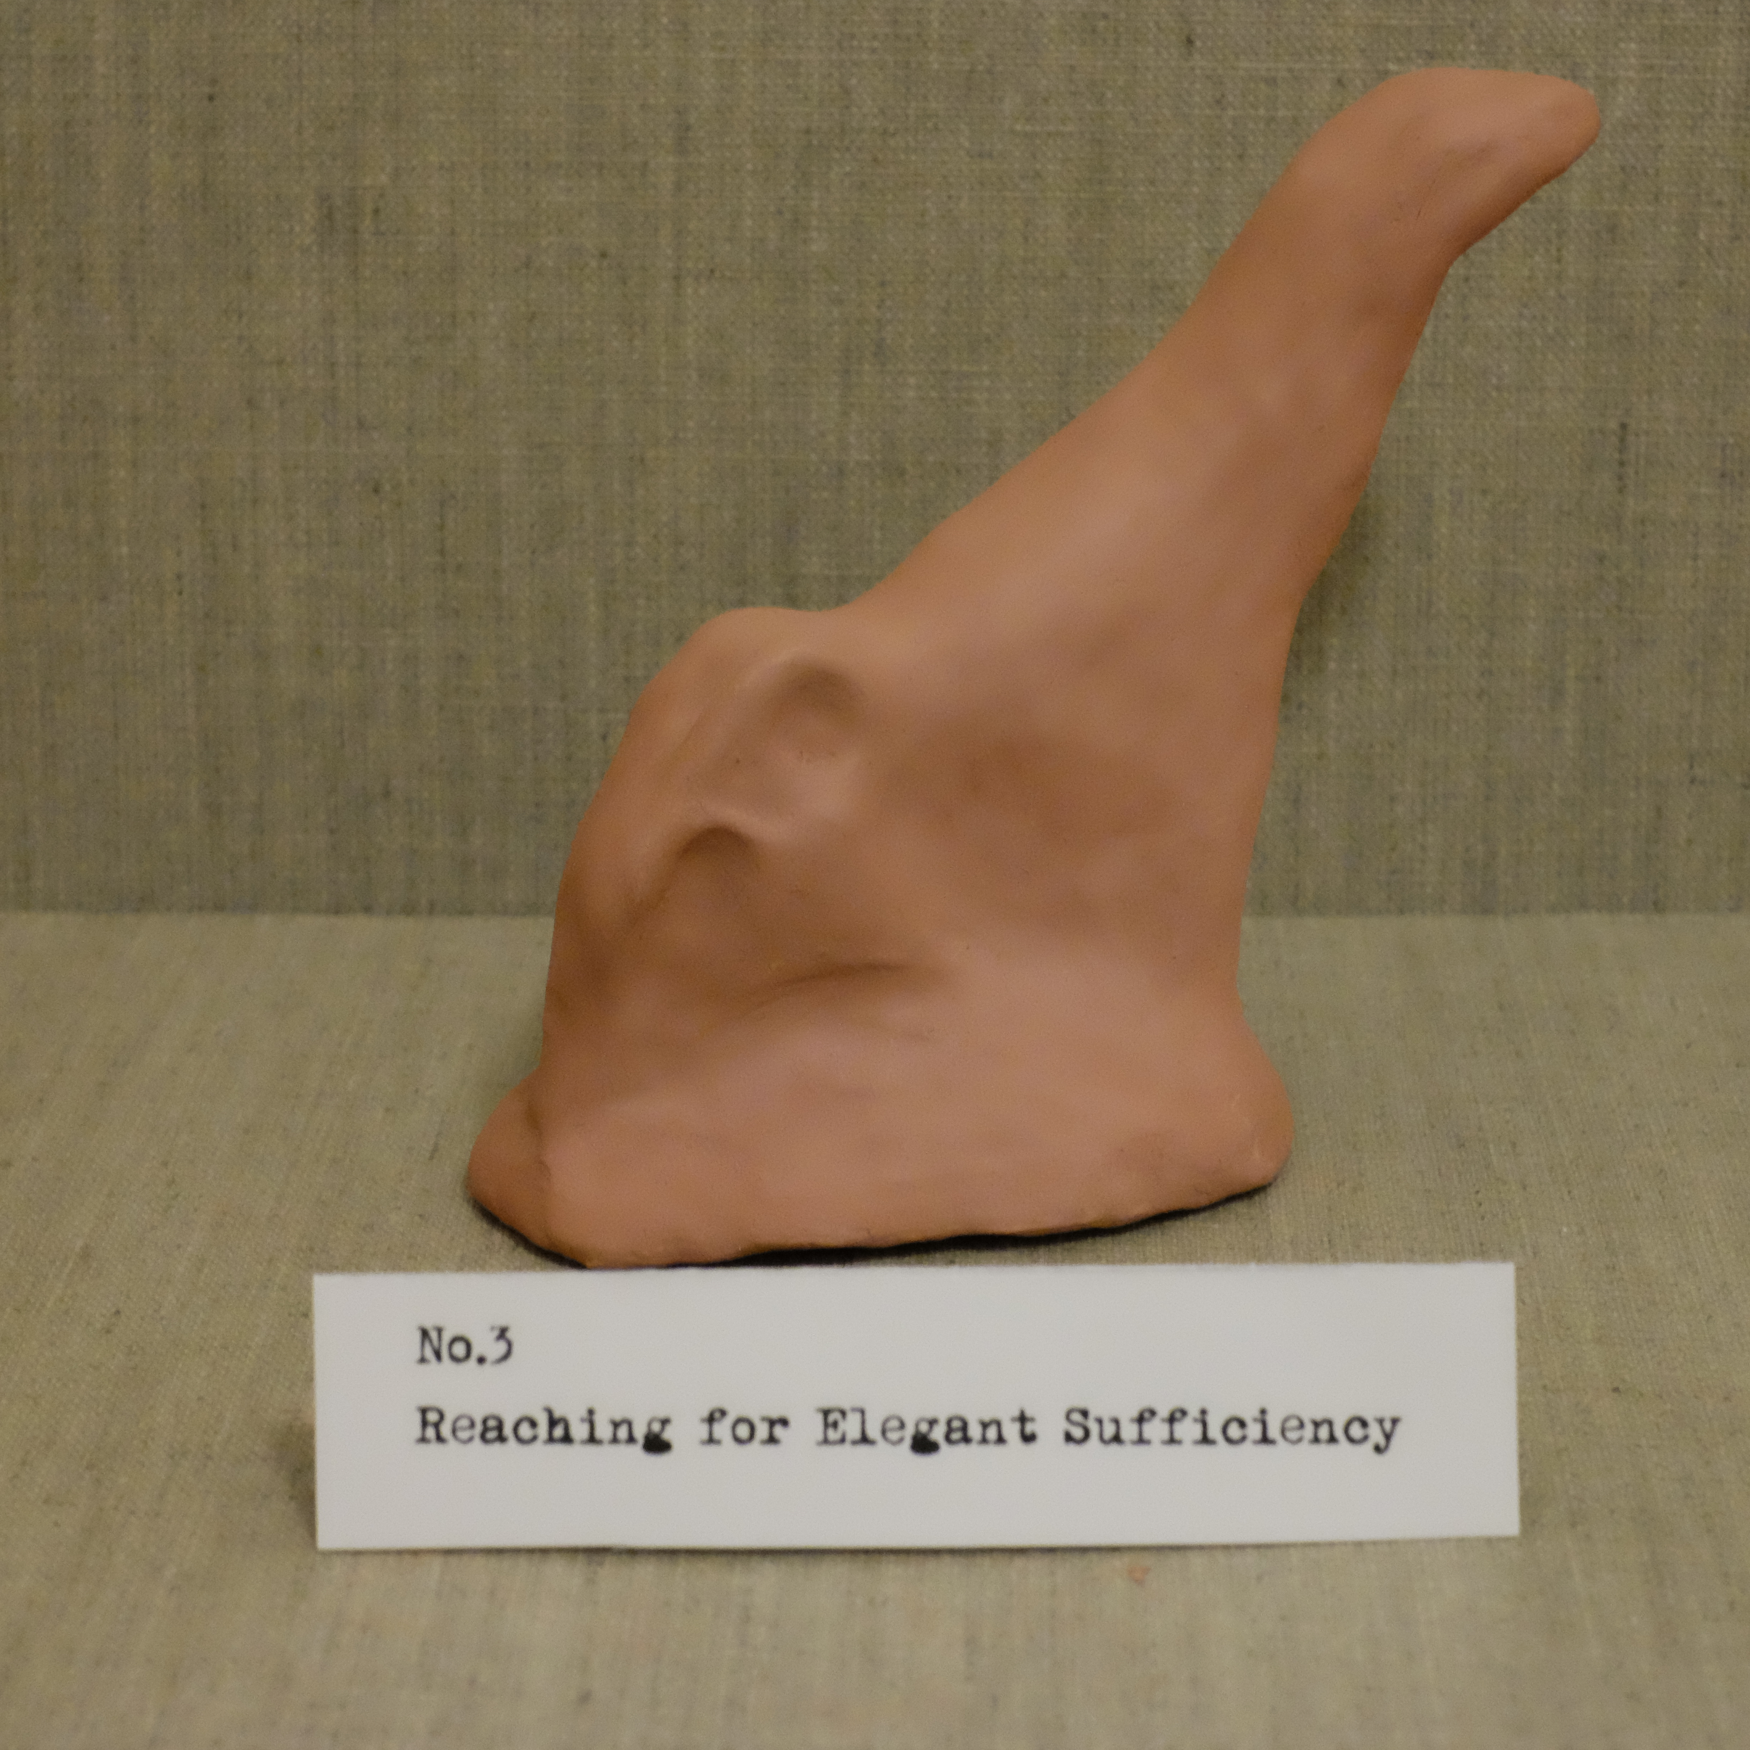
Thank you for trying to look out for me, for caring about my health and worrying about my future. Thank you for worrying about what other people will think of me. But…what you say doesn’t work, doesn’t help and has the opposite effect.

Lillian Bustle
Stripping away negative body image
https://www.youtube.com/watch?v=ME-c0l8oTkY
(0.00-1.20mins)

FAT
I have a secret.
You see,
I inherited more than madness and knitting
From my women
My ancestors
I inherited FAT
I inherited WEIGHT
I inherited MASS.
GIRTH
HEFT.
Yes. I. AM. FAT!
F-A-T
FFFFFAAAAAAAAATTTTTT

Fat is a Feminist issue
Reads my fourteen year old self
Really?
Yes!!!
BIG takes up more space
Claims it for it’s own
Not yours
Protects from unwanted advances
FAT says
“Don’t mess with me…
Or I’ll suffocate you with my …..
SOFTNESS!!!!!”
FAT says
"I'm harmless”
“Undisciplined”
“Ignore me”
“I’m no threat “
“Invisible”.

F-A-T
FFFFFAAAAAATTTTTT
Slowly said it loosens up the tongue,
The mouth
The willpower.

“You can not be what you can not see.”
Marion Wright Edelman cited in Bonney (2016, p.8)

After I came out as FAT, I began to wonder what if I want to dance or do yoga? Where are the other people like me doing those things? I began to find a whole group of women courageously breaking stereotypes and promoting body positivity.

Inspirational plus-size ballerina @lizzy.dances performs flawless foutte with ease.
https://www.youtube.com/watch?v=vv7nJtYXr_M
(0.00-0.30)

What would it feel like?
What would it feel like..
To be light
What would it feel like..
To glide
To be graceful
To float
To be fast
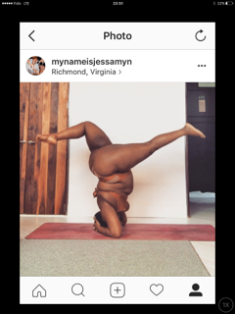
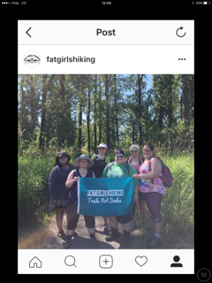
What would it feel like?

Dove and Shonda Rhimes present Cathleen Meredith, founder of FATGIRLSDANCE
https://www.facebook.com/fatgirlsdance/videos/1982833018617992
(2.47mins)

Jiggle
Jiggle
Wiggle
Wobble
Shake
Hips Bum Tits
Rotate
Twist
Round
Entice. Laughter. Delight
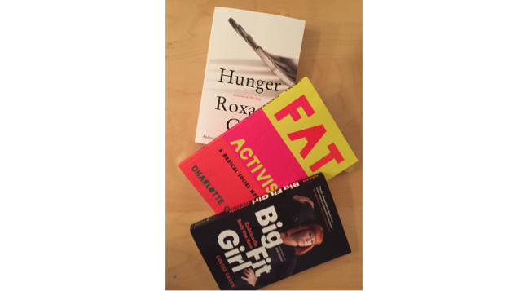
POWER
My inquiry is not over. I have further to go down the rabbit hole…
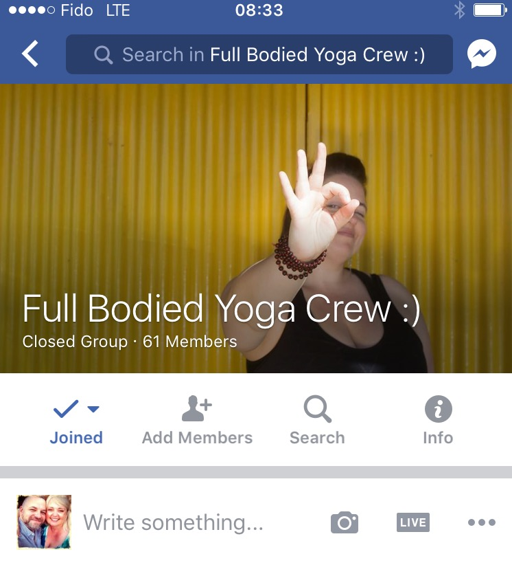
Note on Lovingkindness
Like gentle rain, it takes a while to soak through to the roots.
(From personal communication in Mindful Self-Compassion program)

References

Bonney, G (2016) In The Company of Women: Inspiration and Advice from over 100 Makers, Artists and Entrepreneurs. Artisan: New York:NY

Germer, C & Neff, K (2016) Mindful Self-Compassion. Center for Mindful Self-Compassion.

Kelly. V. (2015). To See, To Know, To Shape, To Show: The Path of an Indigenous Artist: In Arts-Based and Contemplative Practices In Research and Teaching: Honouring Presence. Eds. S.Walsh, B. Bickel and C. Leggo. Routledge: New York:NY

Snowber, C (2016) Embodied Inquiry : Writing, Living and Being through the Body. Sense Publishers: Rotterdam: The Netherlands

Thanas,K (1997) Hearing the Voice of the Body. In Being Bodies: Buddhist Women on the Paradox of Embodiment. Eds L.Friedman and S.Moon Shambhala Publications, Inc: Boston:MA

