SEPTEMBER 21, 2015

News for the Education Profession | SIGN UP | FORWARD | ARCHIVE | ADVERTISE

Learning and Teaching

10 Tips For Launching An Inquiry-Based Classroom
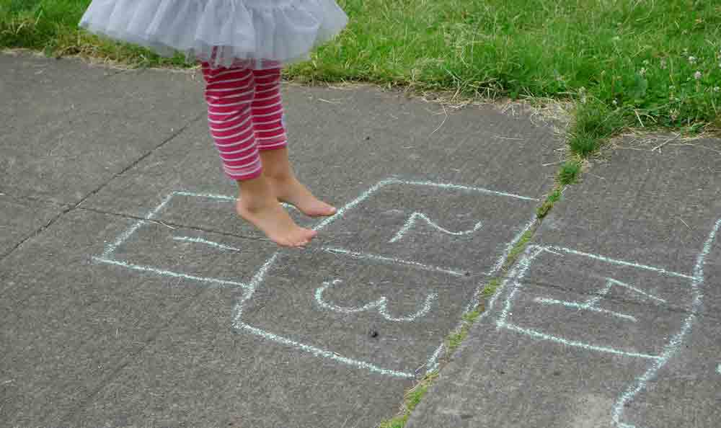
(ginny figlar/Flickr)
By Katrina SchwartzSEPTEMBER 21, 2015
SHARE
Transforming teaching practices is a long, slow road. But increasingly schools and teachers experiencing success are sharing their ideas online and in-person. Science Leadership Academy opened as a public magnet school almost ten years ago in Philadelphia. The educators that make up the school community have spent nearly half that time sharing best practices through a school-run conference each year and more recently by opening a second school in Philadelphia. Diana Laufenberg was one of the first SLA teachers and has gone on to help foster inquiry at schools around the country, most recently by starting the non-profitInquiry Schools.
It takes time to build up a strong inquiry-based teaching practice, to learn how to direct student questions with other questions, and to get comfortable in a guiding role. But when Laufenberg talks about what it takes, she makes it sound easy. We’ve broken her advice down into digestible tips for anyone ready to jump in and try for themselves.
1. Don’t teach the content standards; help kids find their own path towards the information they need to know.
Every teacher has a “bucket” of stuff she is responsible for teaching her students, known as standards. The best way to get students to understand and remember that content is to help them build their own path of questions towards the information they need to know.
“The brain is so primed for questions,” said Laufenberg, managing director of Inquiry Schools and a former 11th and 12th grade history teacher at SLA. “It learns better that way and remembers better that way.” Unfortunately, many educators and schools are so focused on achieving standardized outcomes that they don’t leverage the best tool at their disposal — students’ natural curiosity. School is full of questions, but for the most part those questions imply students should only know more about what teachers are asking them.
“At the end of it they may have consumed less content, but remember more of the sum total,” Laufenberg said. “And they end up in a better place.”
2. Don’t tell students what they should know; create the structure for them to experience it on their own.
“Inquiry at its best happens when the teacher is doing very little other than creating the architecture for the experience to happen,” Laufenberg said. “It’s asking the first question, putting up the provocative primary document or playing the two minute video.” After that, the room should be full of kid questions. And if a student gets truly stumped and asks for help from the teacher, her job is to ask another question that pushes the students’ thinking forward or raises new questions for the student to investigate.
Laufenberg has worked with well-intentioned, hard working teachers all over the country to infuse more inquiry into their teaching. Many of them find this model destabilizing because for a long time they believed their job was to teach content. To make inquiry-based learning work, teachers have to instead become experts at listening to how a student is thinking and then ask the one question that will “un-stick” the students’ thinking and set them off and running again.
“You know it’s happening when there’s very little telling of things, but rather leading of questions and experiences so the students discover those on their own,” Laufenberg said.
3. Use class time to make connections between pieces of information.
Especially with AP classes, students are motivated or else they wouldn’t be there. So give them a list of questions, tell them what to study and let them do so outside of class. They can use the textbook, the Internet and many other sources to find that information more efficiently and effectively than a lecture.
“Inside of class, use that time to make connections between information,” Laufenberg said. After all, what good are facts if they aren’t connected to anything else? “Give them [students] compelling things to do that have them analyze and talk to each other, and grapple with the difficulty of what’s going on in whatever it is you happen to be teaching. But stop using your minutes in class to just tell them things.” Teachers have the tremendously important role of helping students make sense of the facts they’ve learned and see connections to other issues.
4. Many kids struggle with reading, so hook them with the non-written word.
When Laufenberg taught at Science Leadership Academy she had a student in her class who was an advanced analytical processor, a great critical thinker and a wonderful problem solver, but she struggled to read and write because of learning differences. Laufenberg wanted her to be able to engage with the class content at the high level of which she was capable, and not be limited by her second grade reading level. She developed the habit of introducing lessons with something visual so the student wouldn’t be left out.
“I needed to do this because there was an acute situation I wanted to handle, but what it was doing was inviting all the kids to the table with a level playing field of comprehension, not putting the barrier in front of them to start with, which is the written word for comprehension,” Laufenberg said. She would show students something interesting or puzzling, even using 90 second videos to grab their attention. This strategy got students wondering and gave them a little background so that even if they were doing the reading Laufenberg assigned, they came to it with their own questions.
“Your reluctant readers are more likely to make an attempt,” Laufenberg said, because they are curious to find the answer to their questions. Laufenberg would often try to give students the baseline information they need to know in the quickest way possible. “We would background build, but it wouldn’t be, ‘I’m going to tell you a few things today,’” Laufenberg said.
If a complex idea can be imparted through a short video or other means, Laufenberg uses it so the majority of class time can be spent diving into deeper questions and analysis. Laufenberg always got at the background information through questions; she never just told students information.
“It isn’t less reading; it’s less reading of the least interesting information to yield the more in-depth reading and invested reading,” Laufenberg said. She still requires students to read, but if they aren’t reading for the background information then they can be engaging more complex and interesting texts.
5. Stop giving struggling kids the most boring version of the work to repeat over and over again.
“We do a really interesting thing in American education; when kids are struggling with something, we just give them the most boring version of it and more of it, over and over and over again,” Laufenberg said. There’s no way that tactic is going to get students excited about the subject they struggle to understand.
Math teachers commonly say they have to get through some basics in order to get to the interesting content. But if students aren’t interested in knowing, they’ll never get to the good stuff. “Getting kids to understand that math is not just computation, that math is this whole other thought process and way of thinking about the world, and really trying to understand the bigger picture of math,” is the key Laufenberg said. Kids have to care. “Give them a puzzle to figure out to then lead them towards the math that they need to know,” Laufenberg said. They need to figure it out on their own, or at least grapple with it to care.
She doesn’t think it’s that different from history. If the goal of teaching history is for kids to chronologically place events on a timeline, we’ve missed the full potential for the learning experience. If the purpose of math is only to compute, we’ve missed something.
And with reading, don’t give reluctant readers boring passages to read. Let them read whatever they want. No one wants to read things that are boring to them.
6. Surprise students.
Laufenberg would often start class by putting a primary source document up on the screen with no context. Students would come in and immediately get to work trying to figure out what the document was and where it came from. She says it was a great window into their thinking and questioning skills.
“Sometimes you can use really little projects to get their minds spinning on all the ways of knowing, and then model those for each other,” Laufenberg said. Not all the students will find the answer, but they’ll be curious to know how others did. Laufenberg calls activities like this “micro bursts of inquiry.”
7. The traditional model of imparting knowledge isn’t working very well, so don’t be afraid to try out inquiry.
“When people don’t want to do it I always tell them to pick the unit you know always falls flat,” Laufenberg said. “You’re not going to lose; they’re already not with you.” It’s a safe place to start because it can’t get worse and maybe some learnings will come out of the experiment that can inform other lessons.
8. Find the “bend” in the outcomes and abandon the prescriptive path.
Laufenberg recommends finding “the bend” by paring down the content to the most essential pieces and focusing on them thematically. That will help open up as many paths as possible for students to arrive at the big ideas that kids need to learn. When teachers assign a “project” that follows the pacing guide, has a definable outcome and which results in 30 assignments that all look the same, it’s not inquiry. SLA principal Chris Lehmann calls that “the recipe.” In a true inquiry-based assignment students will travel different paths to and produce different products, but learn along the way.
“In a non-inquiry classroom the kids will all walk the same path because the teacher has decided where everybody is going and nothing that anybody says all day long will alter that,” Laufenberg said.
9. Indulge interesting student questions even if it doesn’t fit the pacing guide.
Laufenberg has seen classrooms where a student asks a fascinating question that the teacher brushes off because there’s not enough time. Kids know when there’s nothing they can do to influence the direction of the lesson, a distinctly disempowering experience.
“Who that child is isn’t informing the path and that’s the most devastating part,” Laufenberg said. Listening to student questions and validating them by asking them of the whole group has the added value of building student confidence and highlighting the value of wondering.
10. Approach the practice of teaching with inquiry and use that meta-practice to improve.
“Most professional development has not asked the teachers to examine their own practice with inquiry,” Laufenberg said. But using inquiry to create inquiry-based practices is a great tactic to think through the essential questions teachers face.
EXPLORE: INQUIRY LEARNING, TEACHING STRATEGIES, DIANA LAUFENBERG, INQUIRY LEARNING, SCIENCE LEADERSHIP ACADEMY

